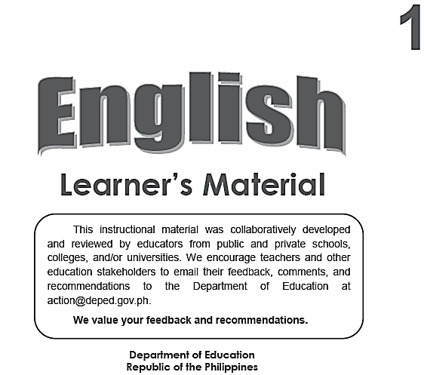
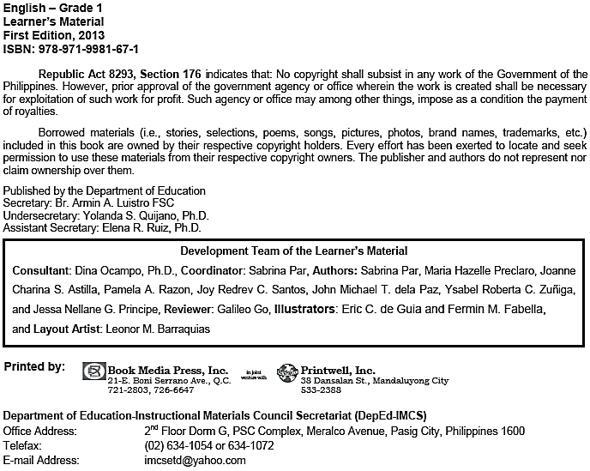
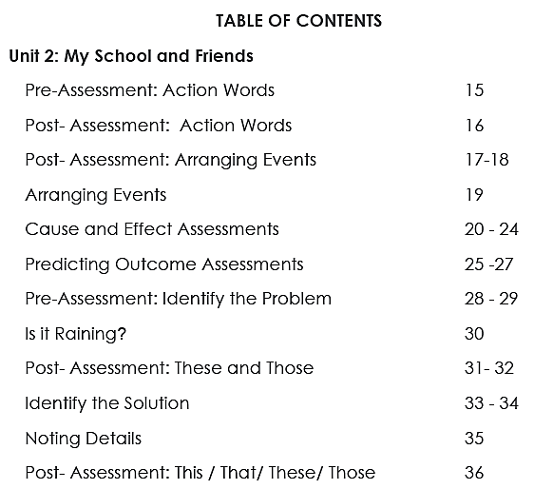
Unit I: Me and My Family
Name: ___________________________________________________________________ Grade & Section: _______________________ Date: _______________________

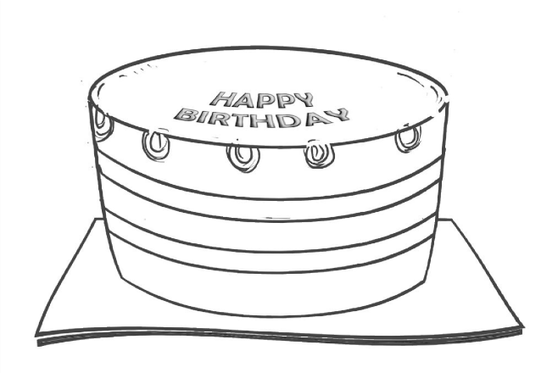

Name:_________________________________________________________________
Grade & Section: ___________________________ Date: _____________________

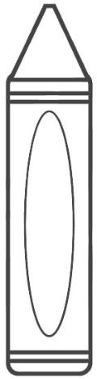
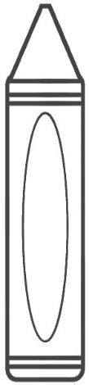
Listen to your teacher to know what color to use for each crayon.

Name: ___________________________________________________________________ Grade & Section: ___________________________ Date:________________________

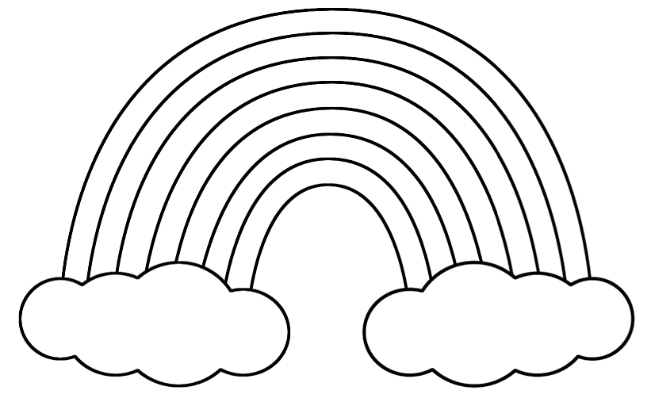
Color the rainbow.

Name:__________________________________________________________________
Grade & Section: ____________________________ Date:______________________

Listen to your teacher to know what color to use for each object.
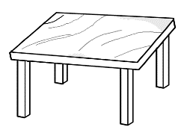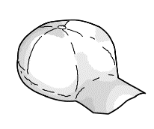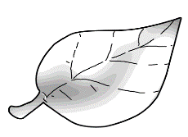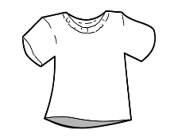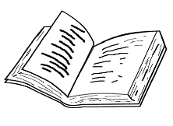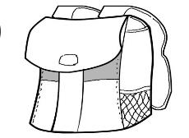

Name: ________________________________________________________________ Grade & Section: __________________________ Date: ______________________ Color the pictures that show ways to take care of the body.
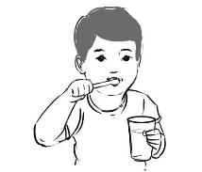
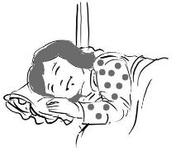
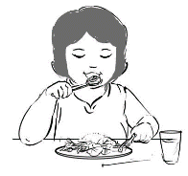
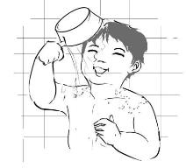
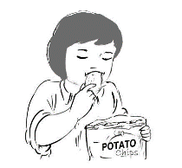
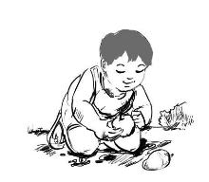

Name____________________________________________________________________ Grade & Section: ____________________________ Date: ______________________

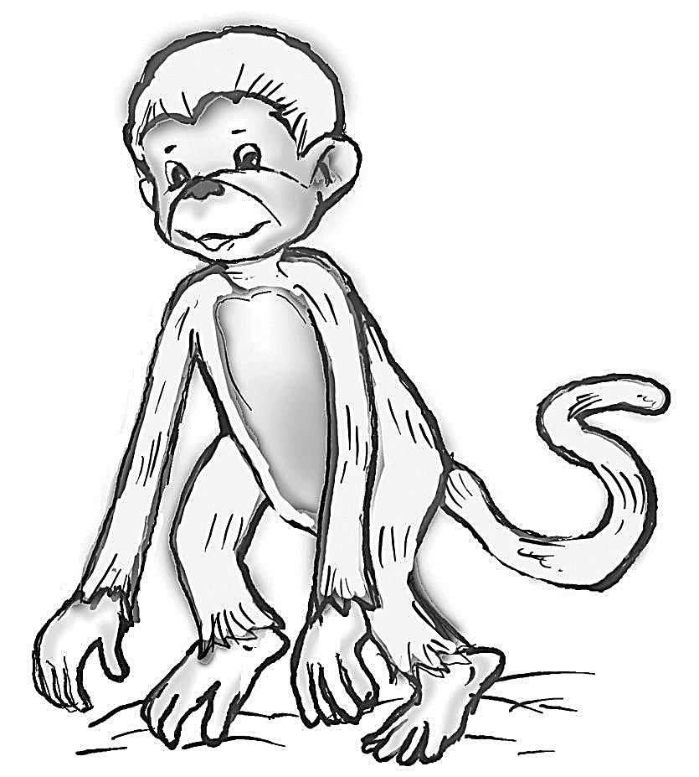
Listen to your teacher to know what color to use for each body part of the monkey.

Name: ___________________________________________________________________
Grade & Section: ____________________________ Date: ______________________

Color the picture that your teacher will tell you.
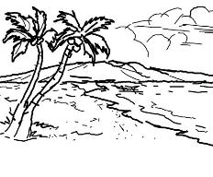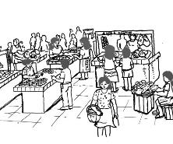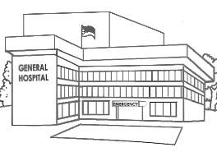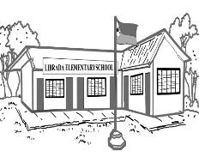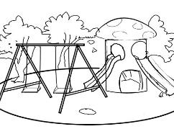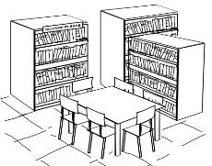

Name: ___________________________________________________________________ Grade & Section: ________________________________ Date: _________________

Draw an event that you enjoy with your family. Draw your family members with you. Complete the sentence below.

I enjoy going to the ________________________________________ with

______________________, ______________________ and _____________________.
Name:_________________________________________________________________
Grade & Section: ____________________________ Date: ______________________

Cut out the pictures below and paste them in the correct group.

Persons Animals Places Things
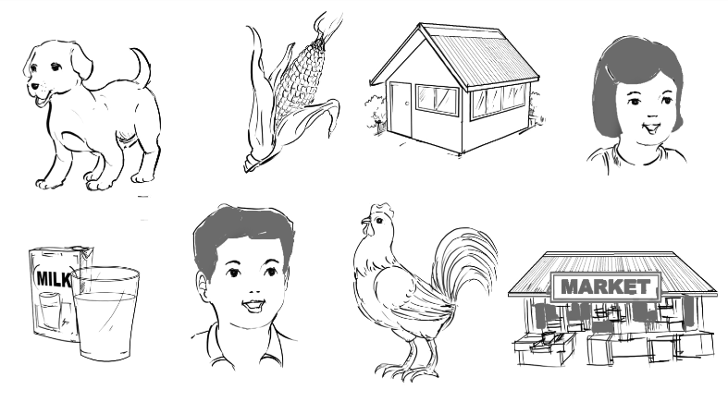
Name: ___________________________________________________________________ Grade & Section: ___________________________ Date: _______________________

Cut out the pictures and paste them in the correct group.

Persons Animals Places Things

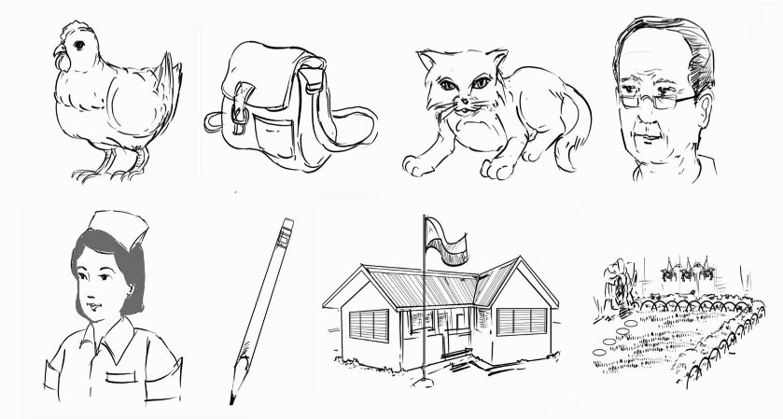
Name: ___________________________________________________________________
Grade & Section: ___________________________ Date: _______________________

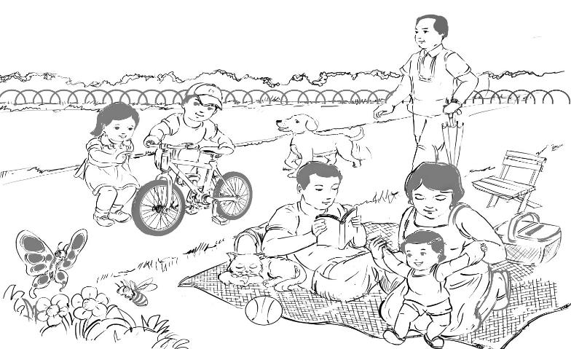
Color the picture that your teacher will tell you.

- Unit 1 Week 10 Day 5 * Waiting Activity

