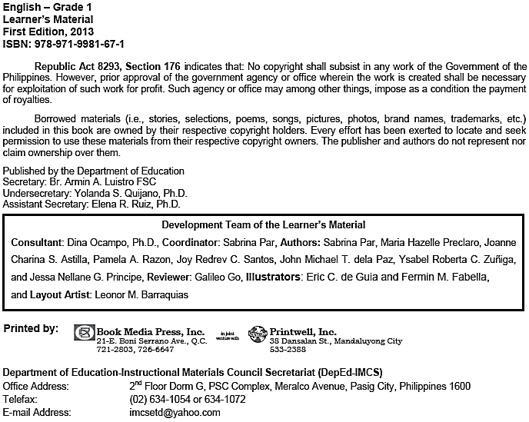
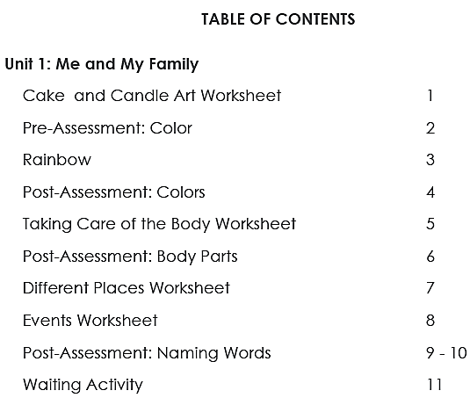
Unit 2: My School and Friends
Name:___________________________________________________________________
Grade & Section: ________________________ Date: __________________________

Draw in each box what you like to do in school

.

We love
to go to school!

Name: ___________________________________________________________________
Grade & Section: _______________________ Date: ___________________________

Draw and color in each box what you like to do with your family at home.

♥

Home Sweet Home

♥

Name: ___________________________________________________________________ Grade & Section: ____________________ Date: _____________________________

Color the pictures. Cut them out. Arrange them according to how the story happened.

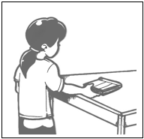
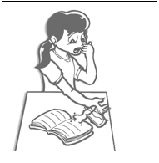
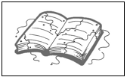

1.

2.

3.

Name: ___________________________________________________________________ Grade & Section: ________________________ Date: __________________________

Write the numbers 1, 2, or 3 according to how the story happened.

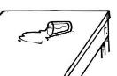
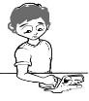
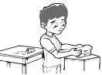

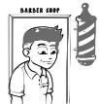
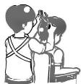
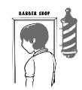

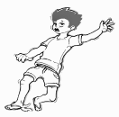

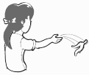

Name: __________________________________________________________________ Grade & Section: ___________________ Date: ______________________________

Match the pictures in column A to the pictures in column B.
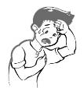
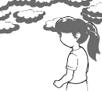
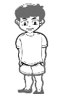
A B

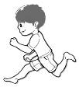
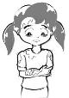

Name: ___________________________________________________________________ Grade & Section: _____________________ Date: ____________________________
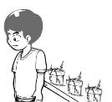
Cut the pictures below and paste them in Column B to match the causes in Column A.
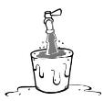

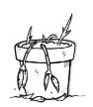
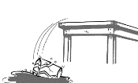
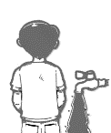
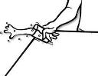

Name: __________________________________________________________________ Grade & Section: ____________________ Date: _____________________________

Cut the pictures below and paste them in Column B to match the causes in
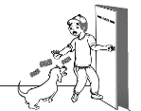
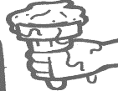
Column A. A B
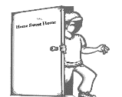
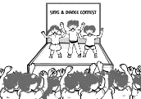
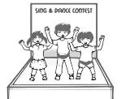

Note: Photocopy this worksheet.
Name: __________________________________________________________________ Grade & Section: ___________________ Date: ______________________________

Color the correct picture in column A to match the effects in Column B.

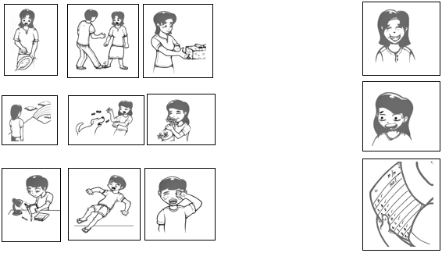
A B

Name: __________________________________________________________________
Grade & Section: ___________________ Date: _______________________________

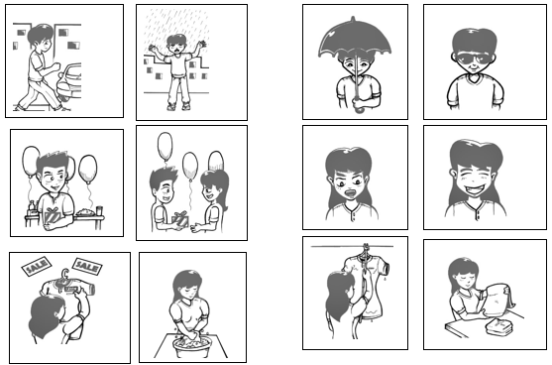
Look at the first two pictures in A. Color the event in B that you think will happen next. A B

Name: __________________________________________________________________ Grade & Section: ____________________ Date: _____________________________

Look at the pictures in Group A. Color the pictures in Group B that show what happens next.
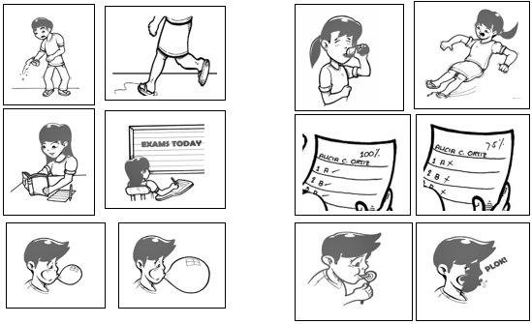
A B

Name: _________________________________________________________________
Grade & Section: __________________ Date: _______________________________

Match the pictures in A to the pictures in B.
A B
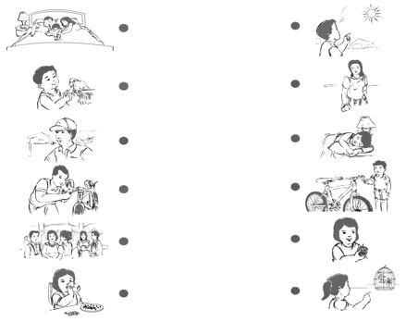

Name: __________________________________________________________________
Grade & Section: ___________________ Date: ______________________________

Listen to your teacher. Look at each picture. Identify the problem that each picture shows. Encircle your answer.
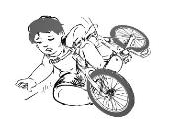
1
    - The boy's bike is new.
    - The boy fell down from the bike.
    - The boy is tired.

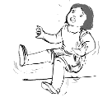
    - The girl slipped on the floor.

2

    - The girl is running.
    - The floor is wet.

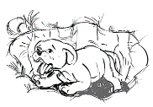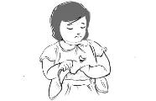

3

4

a. The dog is small.
b. The pit is big.
c. The dog fell into the pit.

a. The girl's dress is dirty.
b. The girl's dress has a hole.
c. The girl's dress is short.

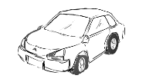
a. The car is brand new.
b. The car is color red.
c. The car has a flat tire.

Name:___________________________________________________________________
Grade & Section: _____________________ Date: _____________________________

Listen to the teacher. Encircle the letter of the answer.
1. What is the title of the story?
a. Is it Raining?  2. Who is the main character? |  | b. | Is it Runny? |  | c. | Is it Windy?
a. Jack |  | b. | Jam |  | c. | Jana

- What did she want to do?
  - She wanted to go home. b. She wanted to go to school.
c. She wanted to go to the beach.

- What is the problem in the story?
  - She forgot her bag. b. She forgot to do her homework.
c. She forgot to bring her umbrella.
- What did she do?
  - She danced and sang. b. She ran under the rain.
c. She waited for the rain to stop.

- What happened in the end?
  - She was able to go home. b. She was able to listen to her teacher.
c. She was able to swim and play in the beach.

Name:___________________________________________________________________ Grade & Section: _____________________ Date: ____________________________

Listen to the teacher read each sentence. Color the picture to match what each sentence tells.

- These are my shoes.
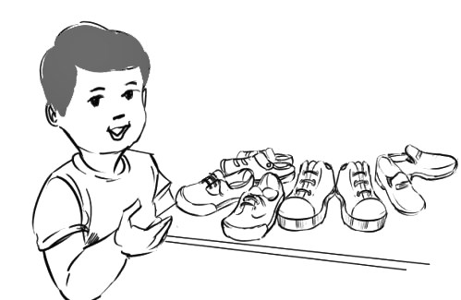
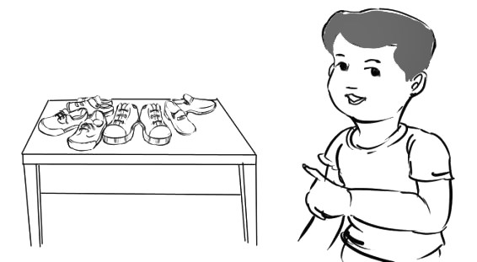

- Those are books.
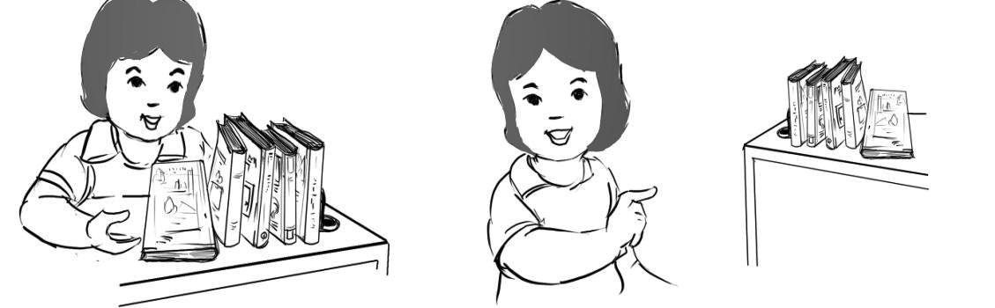

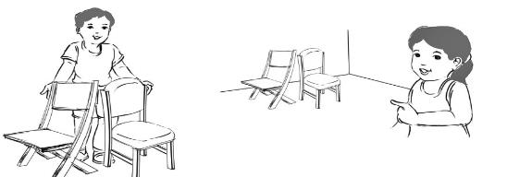
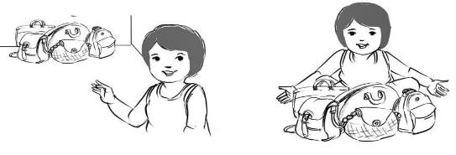
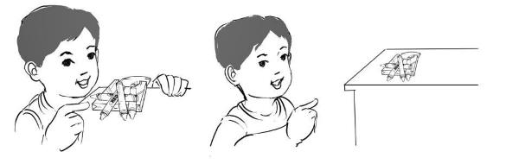
- Those are bags.

- These are crayons.

- Those are chairs.

Name: ___________________________________________________________________ Grade & Section: ____________________ Date: _____________________________

Look at the picture of the problem. Color the picture of the correct solution on the right.

PROBLEM SOLUTION
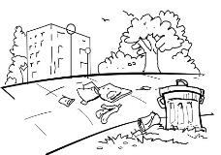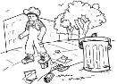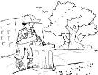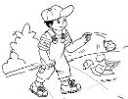
1)

Name:___________________________________________________________________ Grade & Section: _____________________ Date: ____________________________

Listen to the teacher read the questions. Encircle the letter of the correct answer.

1. What is the title of the story?
- The Duck and the Ducklings c) The Sad Duck
b) Are You My Mother?

2. Who is the main character?
a) a duckling b)  3. What is the problem? | a duck c) a family
- Duckling cannot swim.  - Duckling is sad.  4. So what did Duckling do? | c) Duckling couldn’t find his mother.
a) He learned to swim. | c) He looked for his mother.
- He looked for friends.
5. What happened in the end?
- He swam happily with his mother and the other ducklings.
- He swam on his own. c) He swam with the goose.

Name: ___________________________________________________________________
Grade & Section: ____________________ Date: _____________________________

Draw picture/s that would show what each sentence tells.

- This is ____________________.

- That is ____________________.

- These are _________________.

- Those are _________________.

