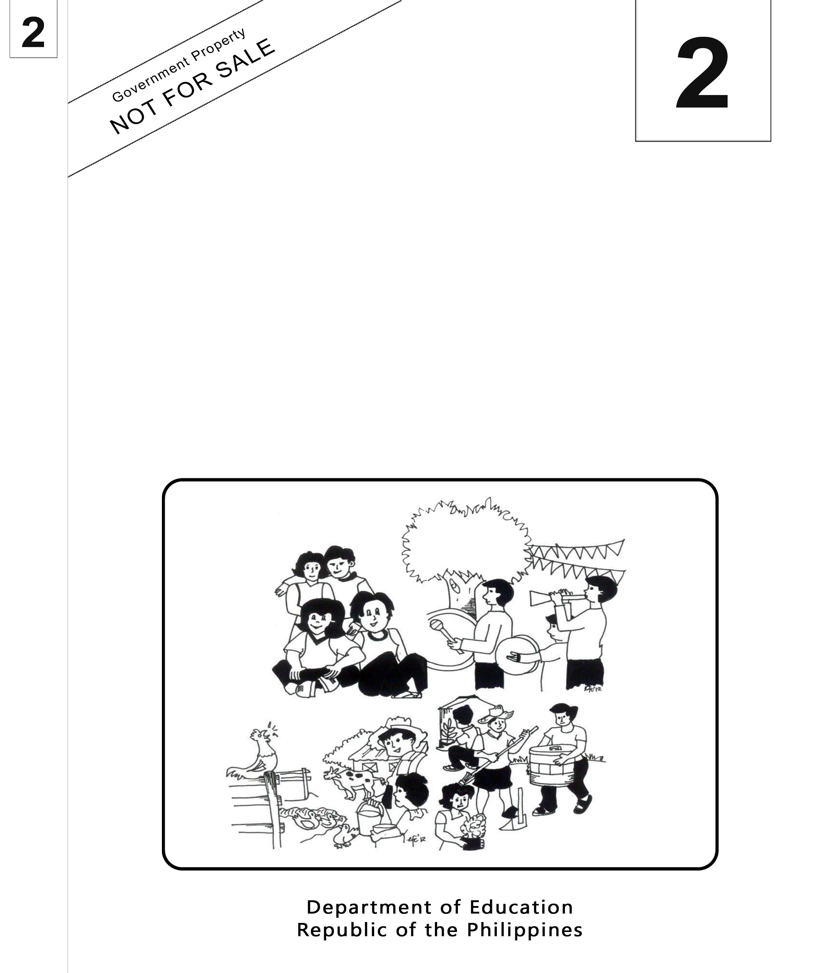
Mother Tongue-Based
Multilingual Education
(MTB-MLE)

Teacher’s Guide
Sinugbuanong Binisaya

Sinugbuanong Binisaya

2

Mother Tongue-Based Multilingual Education
(MTB-MLE)
Teacher’s Guide
(Unit 2- Week 11)
Sinugbuanong Binisaya

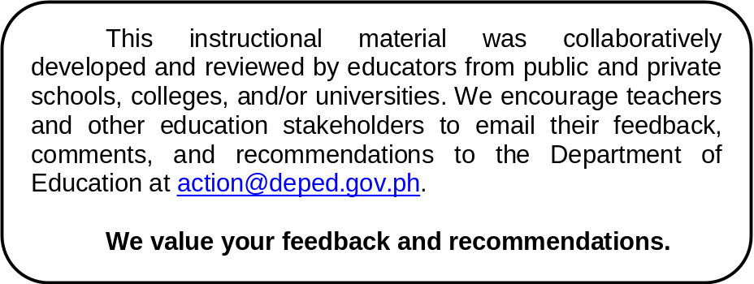

Department of Education
Republic of the Philippines
Mother Tongue Based Multilingual Education – Grade 2
Teacher’s Guide: Sinugbuanong Binisaya
First Edition, 2013
ISBN: ___________

Republic Act 8293, section 176 states that: No copyright shall subsist in any work of the Government of the Philippines. However, prior approval of the government agency or office wherein the work is created shall be necessary for exploitation of such work for profit. Such agency or office may, among other things, impose as a condition the payment of royalties.

Borrowed materials (i.e., songs, stories, poems, pictures, photos, brand names, trademarks, etc.) included in this book are owned by their respective copyright holders. Every effort has been exerted to locate and seek permission to use these materials from their respective copyright owners. The publisher and authors do not represent nor claim ownership over them.

Published by the Department of Education
Secretary: Br. Armin A. Luistro FSC
Undersecretary: Yolanda S. Quijano, Ph.D.
Development Team of the Teacher’s Guide

Consultant and Coordinators: Gurmensinda Sasam, Carmencita C. Denampo
Authors: Caren S. Selgas, Gea C. Alonso, Irene T. Pilapil, Ma. Mariza A. Manlangit, Lucia L. Zapanta, Rochelle L. Binoya, Jovelyn C. Quindao, Lorna C. Mahilum.

Reviewers: Nena V. Miñoza, Ma. Jesusa C. Despojo, Marcelita S. Dignos

Illustrators: Rosanna S. Andales

Layout Artist: Jocelyn M. Conta, Tomas T. Pastor, Sheila Marie Laurel, Alberto M. Adlawan

Printed in the Philippines by ____________

Department of Education-Instructional Materials Council Secretariat (DepEd-IMCS)
Office Address: 2nd Floor Dorm G, Philsports Complex
Meralco Avenue, Pasig City
Philippines 1600
Telefax: (02) 634-1054, 634-1072
E-mail Address: imcsetd@yahoo.com
Week 11
Objectives
- Oral Language
- Recite with ease and confidence 2 to 5 stanza chants in culturally appropriate manner.
- Distinguish between poetry, drama and short stories
- Grammar Awareness
- Use the degrees of adjectives in sentences in culturally appropriate manner
- Word Recognition
- Read a large number of regularly spelled multi-syllabic words;
- Spelling
- Correctly spell words in the list of content words in the vocabulary;
- Decode two or more nonsence and multi-syllabis words;
- Composing
- Compose a chant using appropriate words and coherent texts;
- Vocabulary and Concept Development
- Read aloud words(adjectives)
- Identify and sort common words in basic categories; (colors, shapes)
- Oral Language
- Listen to and interact with others in a group or class discussion on texts heard;
- Handwriting
- Write sentences and paragraphs about an experience from a group story/ situation
- Decode two or more nonsence and multi-syllabic words

Subject Matter
- Adjectives / Degrees of Adjectives
- Nonsense and Multi-Syllabic Words
- Differences among Poetry, Drama and Short Stories

Materials:
tag boards, objects, cartolina, pictures, manila paper, big book,
Song: “Asa”
Story: “Ang Maanindot nga Panimalay”
Balak: “Ang Bandera”
Theme: Community (Care of each home, surroundings and family safety)
Value Focus: Caring each home, surrounding and family safety
Procedure:
Day 1 1

Objectives
- Correctly spell words in the list of content words in the vocabulary
- Read aloud words(adjectives)
- Identify and sort common words in basic categories (colors and shapes)
- Listen to and interact with others in a group or class discussion on texts heard
Pre-Assessment Activity:
Conduct an oral examination.
Ask:
- What are nouns? Cite examples. (Unsa ang “nouns”? Maghatag og mga pananglitan.)
- Give simple sentences using singular or plural nouns. (Paghimo og pahayag gamit ang singular/tinagsa o plural/dinaghan nga “nouns”.)
- When do we use capital letters?(Kanus-a gamiton ang dagko nga letra?)
- What are the things you want to do in school?(Unsa ang mga butang nga gusto nimong buhaton sa eskuylahan?)
- Give a sample slogan on how to care our environment. (Paghatag og slogan bahin sa pag-atiman sa atong kalikopan.)

Preliminary activities:
- Attendance checking through a song/Acknowledge all the pupils.
Asa?
(Tune: Where is Thumbkin)

Asa ang mga lalaki? (babaye?)
Asa ang mga lalaki? (babaye?)
Ani-a ra, ani-a ra? (tubag)
Pila mo kabu-ok?
Pila mo kabu-ok?
Kompleto mi. (tubag)
Kompleto mi.
Kulang og_____. (tubag)

- Spelling Exercise – Horn Method (first day, test)
Let the pupils spell the given words for the pre-test.
- pula (red) Pula ang bag ni Vilma.
- bughaw (blue) Bughaw ang payong ni Lorna.
- dalag (yellow) Dalagang panyo ni Edward.
- lunhaw (green) Lunhaw ang dahon sa mangga.
- puti (white) Puti ang panganod.

- Gallery Walk
Group the pupils (5 members per group). Direct the groups to go around the classroom and list down the things they see on a tag board and classify them according to their color.
Ask:
What are the different colors found inside our classroom? (Unsa ang mga nagkalain-laing kolor nga makita sulod sa “classroom”?)

- Activity (Show and tell)
Instruct the pupils to get an object from their bag and let them describe the object. (Specifically its color)
Call volunteers to show and tell in front of the class.

Unlock the following terms usingconfiguration clues/pictures clues/word clues to unlock the given words.

- pagtinabangay (cooperation)
- pag-amping sa butang (caring things)
- kolor
- panghulagway (adjective)
- balak (poem)
- sugilanon (story)
- home (panimalay)
- house (balay)
- tagilhaw (unripe)

Motivation
Ask:
- What is the difference between a house and a home? Which one do you prefer to have? Why?
(Unsay kalainan sa panimalay ug sa balay?Kon ikaw ang papilion, unsa man ang imong pilion, panimalay o ang balay?Ngano man?)
- Do you consider your house a home? Why? Why not?
(Alang kanimo, ang inyong balay matawag ba nga usa ka panimalay? Ngano man?Nganong dili man?)

Presentation
Ask:
- What do you usually have in your homes? (refer to the things found inside and outside their homes)
(Unsa nga mga kagamitan ang makita ninyo sa sulod ug gawas sa inyong panimalay?)
- Are you happy to have them? Do you want them to last long?
(Malipayon ba kamo nga nakaangkon ug mga kagamitan?Gusto ba kamongamolungtadog dugay ang paggamit ninyo niini?)
- What will you do to make them last long?
(Unsa man ang mga angayang buhaton aron molungtad kini og dugay?)

Developing Purpose for Reading
Ask the pupils to open their LM, Unit II,Week 11 Unang Buluhaton
Show the big book and ask what they want to know about the story.
(Teacher models the reading of the story. Pupils read the story by whole group, small group, triads, dyads& by individual)

After reading, have the pupils answer the following questions:
- What can you tell about the family in the story?
Unsa ang imong ikasulti bahin sa pamilya sa sugilanon/istorya?
- Who are the members of the family?
Kinsa ang mga sakop/miyembro sa pamilya?
- How did the familykeep their house attractive, colorful and nice to the people in the community?
Gi-unsa sa pamilya nga nahimong maanindot ug madasigon ang ilang balay?
- What are the fruit trees planted in the backyard?
Unsa nga mga prutas ang ilang gipangtanom?
- How were the fruits described by the author?
Giunsa paghulagway sa nagsulat ang mga prutas?
- Do you have fruit trees at home? What are they? What are their colors?
Aduna ba kamoy mga tanom nga mga prutas sa inyong tugkaran? Unsa man kini?Unsa ang ilang mga kolor?
- What are the shapes found inside the house?
Unsay mga porma sa mga butang nga anaa sa sulod sa ilang balay?
- Can you also find different shapes of objects inside your house? Name them?
Sa sulod sa inyong balay, may makit-an ba kamo nga nagkalain-laing porma sa mga butang? Hinganli kini.
- How do you take care of your things at home?
Giunsa ninyo pag-amping ang inyong mga butang nga anaa sa inyong panimalay?
- What will you do to make your home attractive, colorful and nice?
Unsay inyong buhaton aron mahimong maanindot ug madasigon ang inyong panimalay?
- Is it important to plant trees? Why? Why not?
Importante ba nga mananom kita ug mga kahoy?Ngano man?Nganong dili man?

Evaluation (Making of a small book by groups)
Let the pupils make a summary of the short story read, “Ang Maanindot nga Panimalay”.
After the pupils have made their summary, guide the pupils in making a small book from the summary that they have made.

Assignment
Have the pupils mount a picture of their family on a short size bond paperand write two sentences that describe theirfamily.
Day 2 1

Objective
- Correctly spell words in the list of content words in the vocabulary
- Compose a chant using appropriate words and coherent texts
- Recite with ease and confidence 2 to 5 stanza chants in culturally appropriate manner
- Use the degrees of adjectives in sentences in culturally appropriate manner

Grammar Lesson/Spelling

Preliminary Activities
- Checking of assignment
- Spelling Exercise (Show Me Board)
Provide an activity that will allow the pupils to spell words using their tag boards. (The same list of words from Day 1)
- Review the different colors which were used to describe things.
- Ask the pupils to use the different colors in describing. (Pupils will make their own sentences.)
Discuss on how colors are used to describe and compare using pictures/realia.
- What words can we use to describeobjects?
- Give examples.
- Skeleton Outline. Let the pupils write the correct adjective to describe the pictures found on LM, Unit II, Week 11- Ikaduhang Buluhaton.

Generalization:
What words are used to describe the fruits? What do we call them? When do we use them? What happens to the adjective when it is used to compare two or more objects?
(Unsay mga pulong ang gigamit sa paghulagwaysa mga prutas? Unsay tawag nato aning mga pulonga? Kanus-a kininato gamiton?
Aduna bay kausaban sa mga pulong panghulagway kon kini gamiton sa pagkomparar ug duha o labaw sa duha ka mga butang?)

Guided Practice:
Present pictures and let pupils compose sentences that will form a chant. Example:
Kaon adlaw-adlaw, sa dalag nga saging, aron mohamis ang imong aping.
Ang pula-pula nga mansanas makaayo sa lawas.

Evaluation (Group Activity-10 members per group)
Instruct the groups to create a one-minute chant that uses the degrees of comparison (color).

Assignment
Let pupils cut out three pictures of fruits/objects and mount on a short-size bond paper and make sentences using adjectives of color in comparing the fruits/objects.
Day 3 1

Objectives
- Correctly spell words in the list of content words in the vocabulary;
- Decode two or more nonsence and multi-syllabic words;
- Distinguish between poetry, drama and short story
- Write sentences and paragraphs about an experience from a group story/ situation

Concept Development/ Handwriting

Preparatory Activities
- Checking of assignment.
- Spelling (Pencil and paper examination – the same spelling words with that of Day 1 and 2.)
Dictate the word, use it in a sentence and say the word again before the pupils spell the word on their writing notebook.
Present the real Philippine flag/flaglet and read the poem “Ang Bandera,” found on LM page 64.
- Then ask them to identify the colors and shapes found on LM, Unit II, Week 11 Ikaduha ug Ikatulong Buluhaton A& B.

Developmental Activities
Ask:
What is a poem? short story? (Unsaang usa ka balak? hamubong sugilanon/istorya?)
What is the difference between a poem and a short story?(Unsa ang kalainan sa balak ug sa hamobong sugilanon?)

Drama can be acted out or role played.
From the poem and short story presented, have them choose some lines to create a chant that can be memorized.

Fixing Skills
Ask:
- What makes up a poem? Short story?(Unsa ang gikinahanglan sa paghimo ug balak? hamubong sugilanon?)
- What stanzas in the poem and paragraphs in the short story contain two or more nonsense words and multi-syllabic words?(Unsa nga mga “stanza” sa balak ug hamubong sugilanon adunay duha o sobra pa nga mga “nonsense” ug “multi-syllabic” nga mga pulong?)

- What are these words? Why do you consider these words nonsense words or multi-syllabic words?(Unsa kining mga pulonga?Ngano nga gitawag kininga “nonsense” o “multi-syllabic”?)
- What is a poem, a drama and a short story about? (Bahin sa unsa ang balak? Ang drama? Anghamubong sugilanon?)
- Can you give the differences among them? (Unsa ang kalainan sa tulo?)

Provide samples where pupils will identify whether what is given isa poem, a drama or a short story.

Generalization
Give the difference of the following:
- poem
- short story
- drama

Guided Practice (Group Work)
Teacher shows the following pictures:
(Children playing, Family eating together, Family in the garden)

Instruction:
Choose one from the set of pictures and write a 2-stanza poem/5-sentence short story from the selected picture on your writing notebook using the cursive style. (Teacher models the correct handwriting positions before the pupils write on their writing notebook)
- What are the people in every illustration doing?
- How do they feel?
- What does each illustration tell us?

Evaluation (Individual output)
Write a 2-stanza poem/5-sentence short story on your writing notebook using the cursive style.

Assignment
Mount a family picture that you like best and make a poem or short story about the family.

Day 4 1

Objectives
- Correctly spell words in the list of content words in the vocabulary;
- Decode two or more nonsence and multi-syllabis word
- Compose a chant using appropriate words and coherent texts;

Preliminary activities

Spelling through a game (Pupils will be grouped into two where they will compete on forming correctly the appropriate spelling of jumbled words on colors)
itpu hawbug galad huwlna lupa
(puti) (bughaw) (dalag) (lunhaw) (pula)

Pupils will present the chants they have composed the previous day.

Presentation
Present a chant about a family, “Ang Akong Pamilya,” found on LM, Unit II, Week 11- Ikaupat nga Buluhaton.

Have the pupils think of a situation that reflects respecting one another in the family.Let them compose a chant that reflects respect in the family by group.
Example:
Sa pamilya importante nga magtinahuray ang usag-usa.
Si manoy mogiya sa mga manghud niya.
Si manay motabang aron ang tanan magkahiusa.
Sige sige na, magtinabangay kita aron makab-ot ang katuyoan ta.

Discussion
Discuss the lines in their chants that show respect to all the members in the family.
Let the pupils write their answers on the tag boards.

Generalization:
Have the pupils identify multi-syllabic words and write on their notebooks.
Allow pupils to share the chants they have composed.

Valuing:
Ask: Why is respect, caring and love important?

Evaluation: Group Activity
Group the pupils with ten members.
Let each group create a chant that shows respect in the family.
Presentation by group. (Teacher provides rubrics)

Assignment:
Review the lessons for an examinationtomorrow.

Day 5 1

Objectives
- Correctly spell words in the list of content words in the vocabulary
- Use the degrees of adjectives in sentences in culturally appropriate manner
Spelling Test
Let the pupils spell correctly the given words from the list of words from day 1 to 4. This will be recorded and graded.
pula (red) Pula ang bag ni Vilma.
bughaw (blue) Bughaw ang payong ni Lorna.
dalag (yellow) Dalag ang panyo ni Edward.
lunhaw (green) Lunhaw ang dahon sa mangga.
puti (white) Putiang panganod.

Evaluation
Let the pupils open LM, Unit II, Week 11-Ikalimang Buluhaton A, B& C and do the following:
- Identify the color of the following objects.
- Compare the following objects.
- Make a small book of the summary of the short story. (individual work)

Assignment
Say: Cut-out 5 different pictures of different shapes and mount it on a short-size bond paper.
(Maggunting ug lima(5) ka retrato sa nagkalain-laing porma ug ipapilit sa
“bondpaper”)

For inquiries or feedback, please write or call:

Instructional Materials Council Secretariat (IMCS)
Department of Education (DepEd)
2nd Floor, Dorm G, Philsports Complex, Meralco Avenue
Pasig City, Philippines 1600
Telefax: (632) 634-0901 or (632) 634-1072
e-mail: imcs@deped.gov.ph or depedimcs@gmail.com
DeTxt: Globe and Smart: 2622

ISBN No. _________________________

