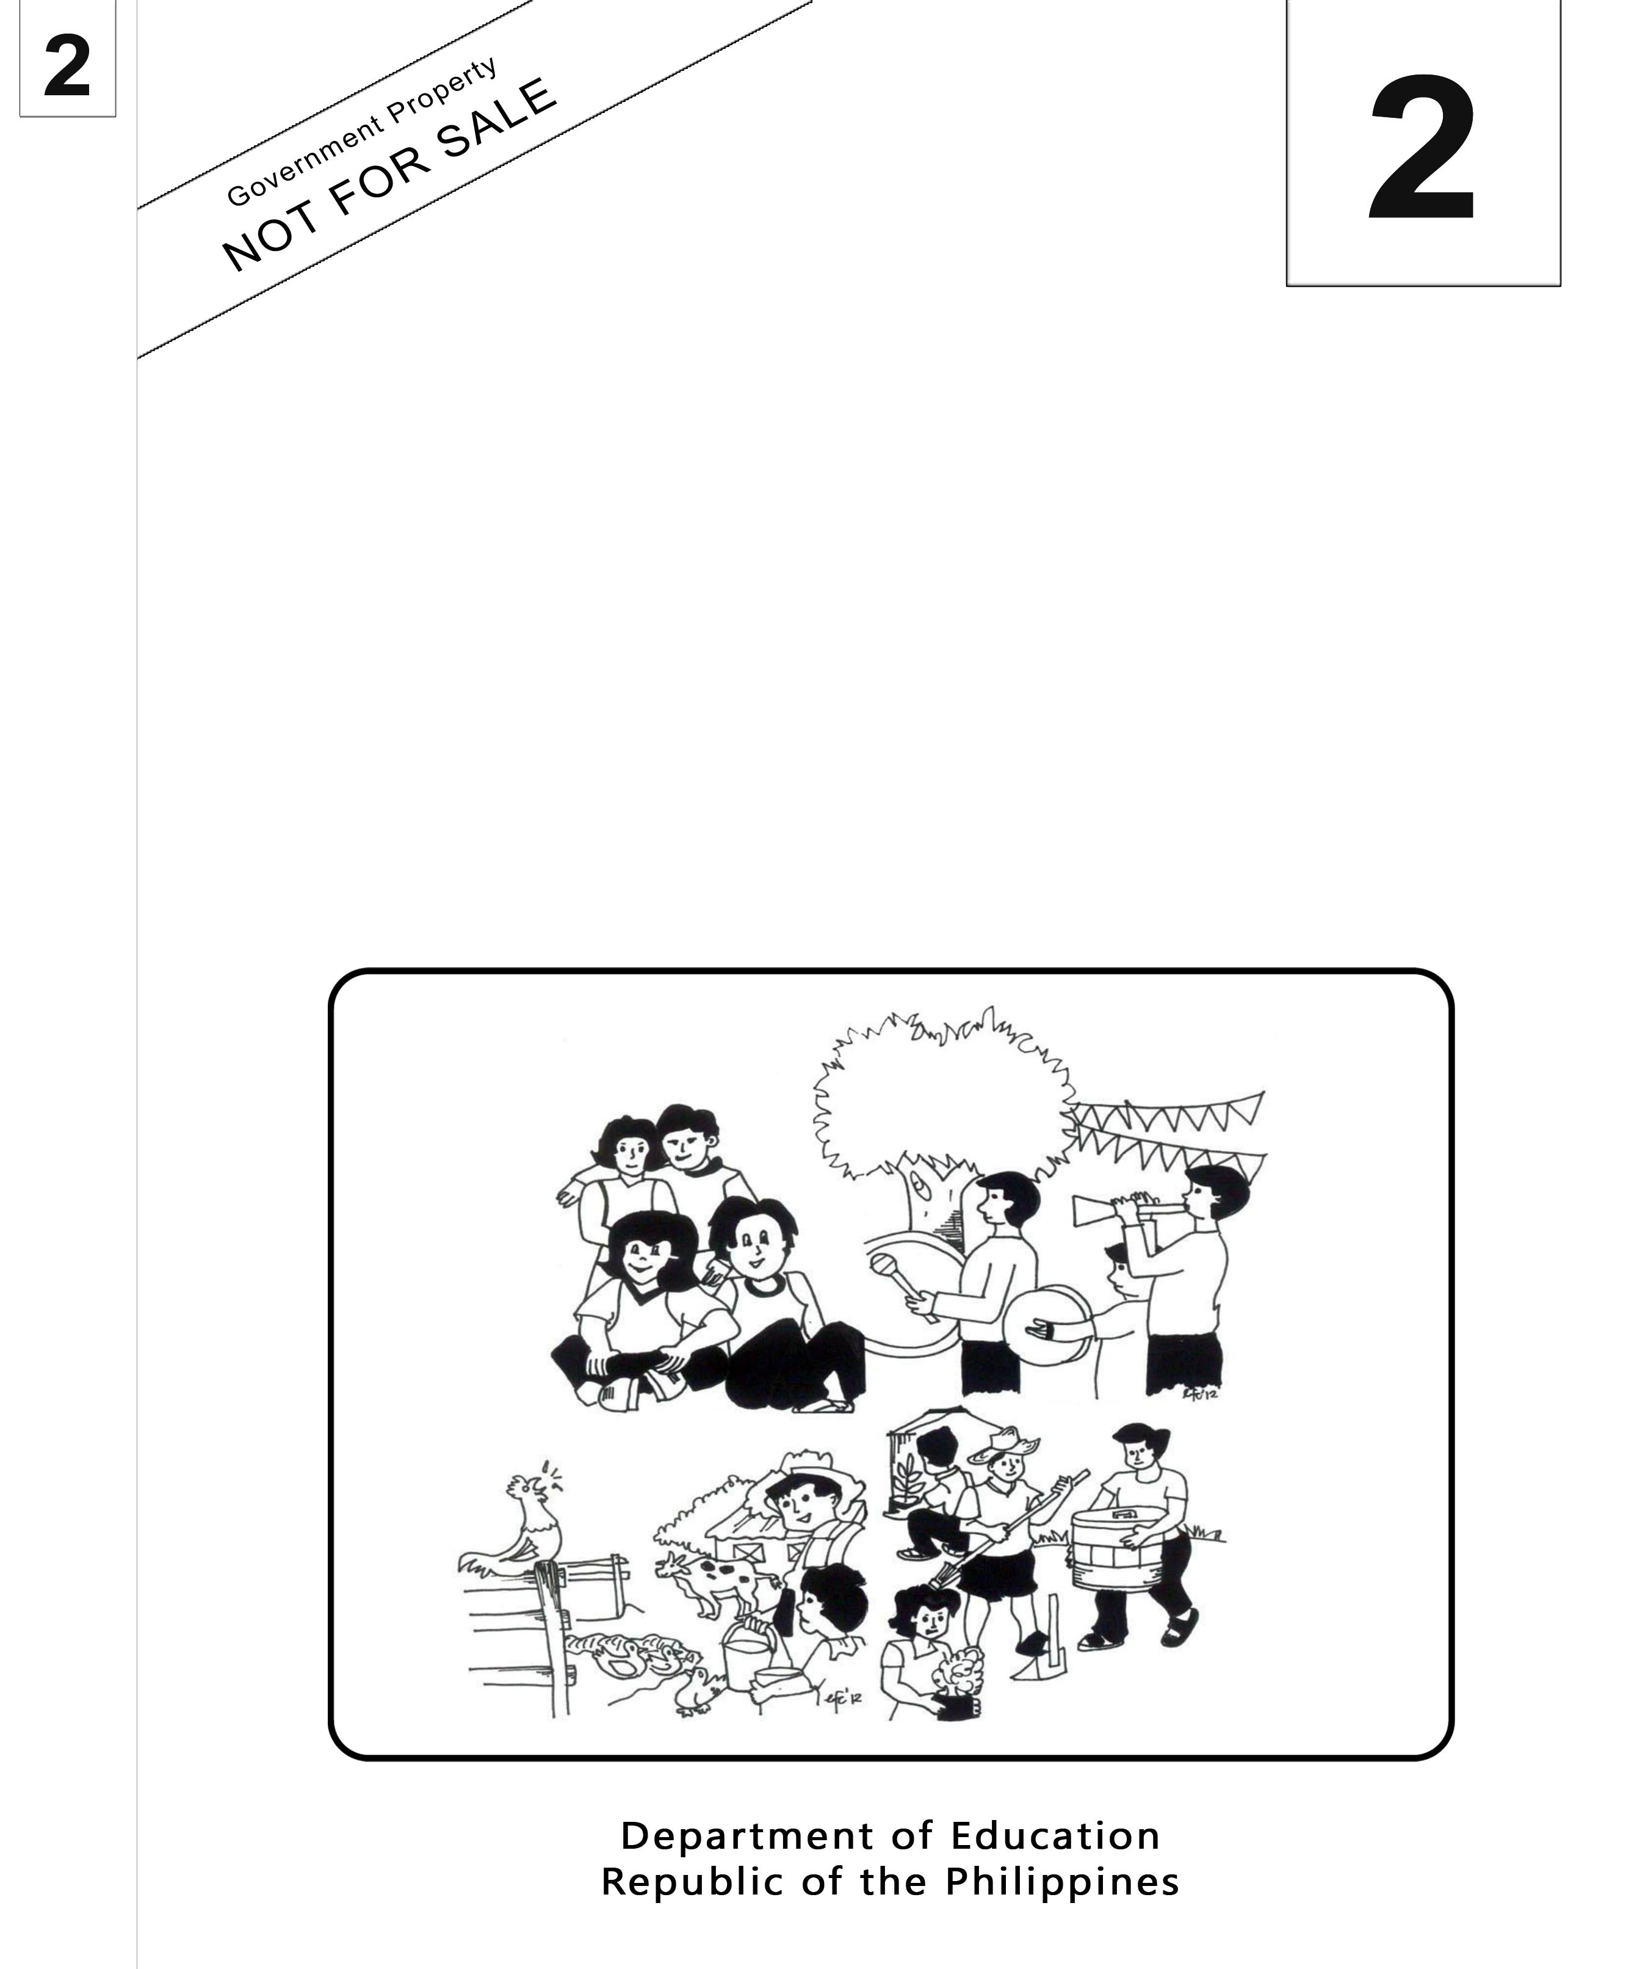
Mother Tongue-Based
Multilingual Education
(MTB-MLE)

Teacher’s Guide
Sinugbuanong Binisaya

Sinugbuanong Binisaya

2

Mother Tongue-Based Multilingual Education
(MTB-MLE)
Teacher’s Guide
(Unit 2- Week 14)
Sinugbuanong Binisaya



Department of Education
Republic of the Philippines
Mother Tongue Based Multilingual Education – Grade 2
Teacher’s Guide: Sinugbuanong Binisaya
First Edition, 2013
ISBN: ___________

Republic Act 8293, section 176 states that: No copyright shall subsist in any work of the Government of the Philippines. However, prior approval of the government agency or office wherein the work is created shall be necessary for exploitation of such work for profit. Such agency or office may, among other things, impose as a condition the payment of royalties.

Borrowed materials (i.e., songs, stories, poems, pictures, photos, brand names, trademarks, etc.) included in this book are owned by their respective copyright holders. Every effort has been exerted to locate and seek permission to use these materials from their respective copyright owners. The publisher and authors do not represent nor claim ownership over them.

Published by the Department of Education
Secretary: Br. Armin A. Luistro FSC
Undersecretary: Yolanda S. Quijano, Ph.D.
Development Team of the Teacher’s Guide

Consultant and Coordinators: Gurmensinda Sasam, Carmencita C. Denampo
Authors: Caren S. Selgas, Gea C. Alonso, Irene T. Pilapil, Ma. Mariza A. Manlangit, Lucia L. Zapanta, Rochelle L. Binoya, Jovelyn C. Quindao, Lorna C. Mahilum.

Reviewers: Nena V. Miñoza, Ma. Jesusa C. Despojo, Marcelita S. Dignos

Illustrators: Rosanna S. Andales

Layout Artist: Jocelyn M. Conta, Tomas T. Pastor, Sheila Marie Laurel, Alberto M. Adlawan

Printed in the Philippines by ____________

Department of Education-Instructional Materials Council Secretariat (DepEd-IMCS)
Office Address: 2nd Floor Dorm G, Philsports Complex
Meralco Avenue, Pasig City
Philippines 1600
Telefax: (02) 634-1054, 634-1072
E-mail Address: imcsetd@yahoo.com
Week 14
Objectives
- Oral Language
  - use expressions appropriate to the grade level to recall important details in a legend
  - retell familiar stories/legends by using appropriate gestures, expressions and illustrative objects
- Book and Print Knowledge
- tell the distinguishing features of a legend
- Word Recognition
- read large number of regularly spelled multi-syllabic words
- read at least 200-300 words appropriate to the grade level
- read with understanding paragraphs, stories, legends consisting of words being studied
- Fluency
- read with automaticity 200 grade two level high frequency sight words
- read aloud grade two level texts with an accuracy of 95-100%
- read stories and legends with ease and fluency
- Spelling
- use spelling knowledge and skills to correctly spell high frequency words appropriate to the grade level
- spell words correctly in the list of content words in the vocabulary
- Handwriting
- observe mechanics when coping and/or writing sentences, paragraphs and stories: capitalization, space between words, correct punctuation marks, indention and format in cursive form
- write sentences and paragraphs about an experience generated from a group story in cursive form
- write a short legend (narrative story) that include the elements of settings, characters in cursive form
- Composing
- write sentences and paragraphs about an experience generated from a group story
- write a legend observing correct punctuation marks, capitalization, indention and format
- compose a legend using appropriate words and coherent texts
- Grammar Awareness
- use adjectives in culturally appropriate manner in sentences and in paragraphs (words that describes persons, animals and things)
- Vocabulary and Concept Development
- read aloud words (adjectives)
- Reading Comprehension: Activating Schema and Prior Knowledge
- sequence three events in the legend by telling which happened first, second, and third or last
- Reading Comprehension: Comprehension of Informational Text
- locate specific information in the text to find answers to simple and higher level questions

Subject Matter
- Recall Important Details
- Legend
- Capitalization, Space Between Words, Correct Punctuation Marks, Indention and Format in Cursive Form
- Adjectives
- Sequence Events
- Literary Elements: Plot, Setting, Characters

Materials
Ilustrations, pictures
Story: Legend of Lapu-Lapu
Theme: History of Our Community
Value Focus: Love of Community
Procedure
Day 1

Objectives
- Read stories and legends with ease and fluency
- Correctly spell words in the list of the content words in the vocabulary
- Use adjectives in culturally appropriate manner in sentences and paragraphs ( words that describes person, animal and thing)
- Read and identifying the literary elements of a plot, setting, and characters of a literary piece
Preliminary Activities
Spelling (Horn Method)
Pencil and paper test
- ligdong  - maalamon  3. maisog | (honest)  (intelligent)  (brave) | Usa ka ligdong nga tawo si Luis. Mahadlok siya mangopya sa iyang katupad.  Maalamon si Jessica. Wala siyay sayop sa eksamin sa MTB.  Maisog si Manolo. Wala siyay kahadlok nga miatubang sa bangis nga bitin.

- Pre- reading(Refer to LM Unit II Week 14 Unang Buluhaton Kantaha)
- Have a warm –up activity by singing a song “Komunidad” (to the tune of Who Builds Community,
- Unlockdifficulties through picture clues: Present illustrations/pictures of Filipino warriors with kampilan (sword), kalansag/taming (shield), bangkaw (spear) pangulo, nakigbisog
- Use them in a sentence and let the pupils identify/point out from the picture the object that fits the description. Post the picture on the board.
- Ang kalansag/taming gigamit sa mga manggugubat sa pagsagang sa mga hinagiban sa kaaway.
- Ang kampilan usa ka mahait nga hinagiban nga susama sa usa ka dako nga sundang.
- Ang bangkaw usa ka taas nga kahoy o puthaw nga adunay mahait nga tumoy.
- Ang atong pangulo sa klase mao si ____________.
- Nakigbisog ang bata nga masakiton aron siya mabuhi.

Motivation
Show the picture of Lapu-Lapu. Let the pupils tell something about it to develop oral fluency.

During Reading(Refer to LM Unit II Week 14 Ikaduhang Buluhaton Si Lapu-Lapu)
Say: As we read, let us all think about what happens in the story: the beginning, middle and the last part.
- Let the pupils listen attentively to the legend read.
- Read the legend in an interesting and lively manner.
- Ask questions to check pupils’ comprehension regarding the story read.
- Let the pupils read the story in a lively and interesting manner. (whole group, triad, dyad, etc.)

Post Reading
Refer to LM, Unit II, week 14, Tubaga Kini
Agreement:
Let the pupils cut-out apicture of Lapu-Lapu. Let them paste the picture on a short size bond paper. Write three sentences that describe Lapu-Lapu.
Day 2

Objectives
- Correctly spell words in the list of the content words in the vocabulary
- Write short narrative (legend) that include elements of setting, characters in cursive form
- Use adjectives in culturally appropriate manner in sentences and paragraphs ( words that describes person, animal and thing)
- Sequence events in the legend by telling which happened first, second, and third or last
- Read and identify the literary elements of a plot, setting, and characters of a literary piece

Preliminary Activities
Spelling (Horn Method)
Spelling Game (same words as of day 1)
- create groups of five among the pupils in the class
- present jumbled letters of the five spelling words placed inside individual envelopes for each spelling word.
- let the pupils arrange the letters to form the spelling words.
- let the group write their answers on a tag board.
- discuss the answers with the group.

Engagement Activities
Picture Puzzle (Lapu-Lapu)
- Group the pupils into small groups (6 members in a group or more).
- Each member must have a piece of the puzzle.
- The teacher asks the pupils what is formed in the puzzle.
- Ask them what they know about Lapu-Lapu.
- Let them write descriptive words for Lapu-Lapu and use them in sentences
Carousel Brainstorming
- Provide a sheet of manila paper for each group with the following heading (Group I Lapu-Lapu, Group II Magellan, Group III sundalo, Group IV kampilan, Group V bangkaw, Group VI kalasag)
- Let the pupils select a leader, timer, reporter, secretary, runner, poster. The teacher gives the role of each member.
- Instruct each group that in just two minutes they have to write as many descriptive words they can think of about the heading e.g. Lapu-Lapu-maisog, maligdong, etc.; Magellan-maalam, etc). The teacher will stay GO to start the brainstorming.
- At the end of two minutes, the teacher will say STOP, the runner of the group will give the manila paper to the next group (Group I to Group II, Group II to Group III, Group III to Group IV, Group IV to Group V, Group V to Group VI, Group VI to Group I)
- When all the groups have written on all the sheets of manila paper the group reporter will publish their activity on the board.
- The leaders will present their group output to the class.
- Discussion of the group answers.

Reading Aloud
Group the pupils by two’s.
- Present the legend. (same as day 1)
- Read the legend orally to the pupils.
- Let all pupils read the legend orally.
- Call pairs to read the legend by lines.
- Ask higher order thinking skills questions about the legend.

Sequencing Events (Whole Group-Graphic Organizer)
- Present the legend and discuss the process of sequencing events by identifying what happened first, next, last. Write significant words or key words on the graphic organizer.
Event 1
*
*
*
*

Event 2
*
*
*
*
Event 3
*
*
*
*

Title
  - What is the title of the legend? (Unsa ang “title” sa kasugiran o “legend”?)
  - How many paragraphs or events are there in the legend? (Pila ka parapo o “paragraph” o panghitabo ang kasugiran o “legend”?)
  - What is the first event in the legend? Who was talked about in the first event? What did he do? (Unsa ang unang panghitabo sa kasugiran o “legend”? Kinsa ang gihisgutan kasugiran o “legend”? Unsa ang iya nga gibuhat sa una nga panghitabo?)
  - What is the second or next event in the legend? Who was talked about in the next event? What did he do? (Unsa ang ikaduha o sunod nga panghitabo sa kasugiran o “legend”? Kinsa ang gihisgutan kasugiran o “legend”? Unsa ang iya nga gibuhat sa ikaduha o sunod nga panghitabo?)
  - What is the third or last event in the legend? Who was talked about in the third or last event? What did he do? (Unsa ang ikatulo o katapusan nga panghitabo sa kasugiran o “legend”? Kinsa ang gihisgutan kasugiran o “legend”? Unsa ang iya nga gibuhat sa ikatulo o katapusan nga panghitabo?)
- Let the pupils make sentences out of the keywords or significant words written in the graphic organizer. Guide pupils in making sentences.
- Let the pupils find an event that you describe. Ask the pupils what happened before or what will happen after.
  - Before Lapu-Lapu fought Magellan, he ______.
  - After Lapu-Lapu and his men fought Magellan, there was____.
- Let the pupils sequence the events in the legend. Let them write in their writing notebook in cursive form.
- Explain to the pupils that they can make the story longer using the guide questions: “What do you think will happen next? or What will happen after____?”

Sequencing Events (Groups of 6 members per group)
Each group will receive the following strips.

Si Lapu-Lapu ang Datu sa Mactan sa wala pa maabot ang mga Espanyol o Katsila.
Giila si Lapu-Lapu isip ang kinaunahang bayaning Pilipinhon.
Siya ang kinaunahang lumad sa Pilipinas nga nakigsangka sa mga Espanyol.
Si Lapu-Lapu usa ka ligdong, maisog ug maalamon nga tigdumala sa usa ka islang gamay sa Mactan.
Sa buntag sa Abril 27, 1521 nakigbatok si Lapu-Lapu ug mga manggugubat sa sangka sa baybayon sa Mactan.
Napildi ni Lapu-Lapu ug mga kaubanan si Magallanes o Magellan ug iyang mga ginsakopan.

Groups will post the strips of flashcards on the board in a using the format.
Beginning | Middle | Last
- Process the activity of the pupils then let them read the whole legend based on the result of the activity.
- Discuss on the process of sequencing events by identifyingwhat happened first, next, last.

Day 3
Agreement:
Assign the pupils to make a list of the things that they do at home before going to school. Have pupils arrange the events according to when it happens.
Objectives
- Observe mechanics when copying, writing sentences, capitalization, write space between words and punctuation marks
- Correctly spell words in the list of the content words in the vocabulary
- Use adjectives in culturally appropriate manner in sentences and paragraphs ( words that describes person, animal and thing)
- Sequence events in the legend by telling which happened first, second, and third or last
- Read and identifying the literary elements of a plot, setting, and characters of a literary piece
Preliminary Activity
Let the pupils submit their assignments for checking.

Spelling (Pencil and paper examination-the same spelling words as of day 1-2)
The teacher dictates the word, use it in a sentence and say the word again before the pupils write the spelling word on their writing notebook.

Engagement Activities
- Present a short paragraph and ask questions.
- The pupils will identify the adjectives in the paragraph and write them on the flashcards.
- Post the flashcards on the board.
- Let the pupils read the written words on the flashcards.
- The teacher will discuss about adjectives and let the pupils give more examples.

Activity 1 (Let’s Find Out)(Refer to LM Unit II Week 14 Ikatulong Buluhaton)
Identify the adjectives in the paragraph. (Pangitaa ang mga panghulagway sa “paragraph”.)

Activity 2 (Writing an adjective for each picture)(Refer to LM Unit II Week 14 Ikaupat nga Buluhaton)
The teacher divides the class into four groups.
- Each group will write as many adjectives as they can based on the pictures presented on a manila paper.
- Presentation of their outputs.
- Analysis of the presentation will follow.

Activity 3 (Let’s Write!)
- Each group will write sentences based on the adjectives they have given as outputs in activity 2 on a manila paper.
- Each group will present their outputs.
- Analysis of the outputs.

Evaluation
(Refer to LM Unit II Week 14 ikalimang Buluhaton)
(Refer to LM Unit II Week 14 Ikaunom nga Buluhaton)
Assignment
Write a short legend about Lapu-Lapu on a short size bond paper. (Pagsulat ug usa ka “legend” o kasugiran sa usa ka “short size bond paper”.)
Day 4

Objectives
- Tell the distinguishing features of a legend
- Observe mechanics when copying,writing sentences, capitalization, write space between words and punctuation marks
- Read stories and legends with ease and fluency
- Use spelling knowledge and skills to correctly spell high frequency words appropriate to the grade level
- Correctly spell words in the list of the content words in the vocabulary
- Observe mechanics when coping and/or writing sentences, paragraphs and stories: capitalization, space between words, correct punctuation marks, indention and format (legend) in cursive form
- Write sentences and paragraphs about an experience generated from a group; story in cursive form
- Write short narrative (legend) that include elements of setting, characters in cursive form
- Use adjectives in culturally appropriate manner in sentences and paragraphs ( words that describes person, animal and thing)
- Sequence events in the legend by telling which happened first, second, and third or last
- Read and identifying the literary elements of a plot, setting, and characters of a literary piece
- Locate specific information in the texts to find answers to simple and higher level questions
Writing Engagement
Preliminary Activities
Spelling (Horn Method)
Spelling Game (Magic Tree)
Present the synonym of the five spelling words and uses it in a sentence. Call volunteer pupils to pick a fruit from the magic tree with the spelling word described. The spelling word is written on each fruit. Have additional fruits on the magic tree with words that are not included in the set of spelling words.
1. ligdong
2. maalamon
3. maisog

Present again the legend of “Lapu-Lapu”.
- Review the legend by reading the whole text to be done by the pupils.
- Let them observe some mechanics how the sentences of the legend written such as capitalization, proper spacing between words correct punctuation mark and proper indention between paragraphs.
- The teacher will highlight some important parts which tells capitalization, proper spacing between words, correct punctuation mark and proper indention between paragraphs.
- Discuss further these important mechanics in writing sentences and paragraphs.

Guided Writing Practice(Refer to LM Unit II Week 14 Ikapitong Buluhaton)
Let the pupils copy the legend of “Lapu-Lapu” with proper mechanics in writing.

Generalization(Refer to LM Unit II Week 14 Ikapitong Buluhaton Tubaga Kini)
Pupils will share insights on the following:
- mechanics in writing
- correct spacing between words and sentences
- use of punctuation marks
- proper indention and format

Evaluation (Group Activity)
Write a 5-sentence legend about Lapu-Lapu in your own words with capitalization, space between words, correct punctuation marks, indention and format.
Agreement
Study and prepare for a summative test on the next day.
Day 5
Objectives
- Correctly spell words in the list of the content words in the vocabulary
- Write short narrative (legend) that include elements of setting, characters in cursive form
- Use adjectives in culturally appropriate manner in sentences and paragraphs ( words that describes person, animal and thing)
- Sequence events in the legend by telling which happened first, second, and third or last
- Read and identifying the literary elements of a plot, setting, and characters of a literary piece
- Locate specific information in the texts to find answers to simple and higher level questions
Preliminary Activities
Spelling:Pencil and paper test

- honest  - intelligent  - brave | ligdong  maalamon  maisog | Usa ka ligdong nga tawo si Luis. Mahadlok siyang mangopya sa iyang katupad.  Maalamon si Jessica. Wala siyay sayop sa pasulit sa MTB.  Maisog si Manolo. Wala siyay kahadlok nga miatubang sa bangis na bitin.

Individual Work (using the pupil’s writing notebook)
- (Refer to LM Unit II Week 14 Ikasiyam nga Buluhaton)

- (Refer to LM Unit II Week 14 Ikanapulo nga Buluhaton)

For inquiries or feedback, please write or call:

Instructional Materials Council Secretariat (IMCS)
Department of Education (DepEd)
2nd Floor, Dorm G, Philsports Complex, Meralco Avenue
Pasig City, Philippines 1600
Telefax: (632) 634-0901 or (632) 634-1072
e-mail: imcs@deped.gov.ph or depedimcs@gmail.com
DeTxt: Globe and Smart: 2622

ISBN No. _________________________

