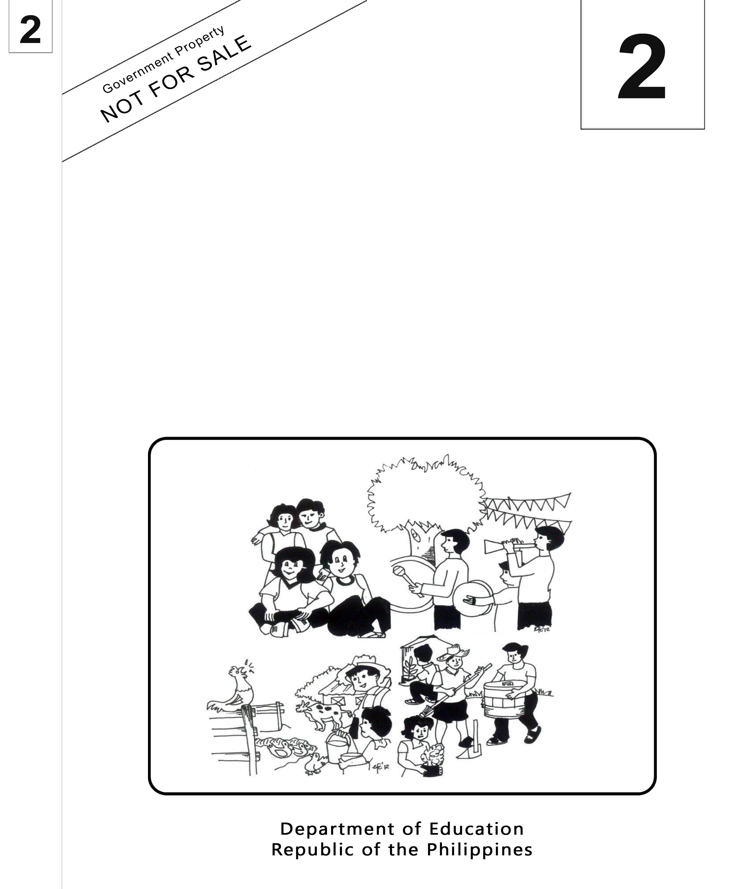
Mother Tongue-Based
Multilingual Education
(MTB-MLE)

Teacher’s Guide
Sinugbuanong Binisaya

Sinugbuanong Binisaya

2

Mother Tongue-Based Multilingual Education
(MTB-MLE)
Teacher’s Guide
(Unit 2- Week 16)
Sinugbuanong Binisaya

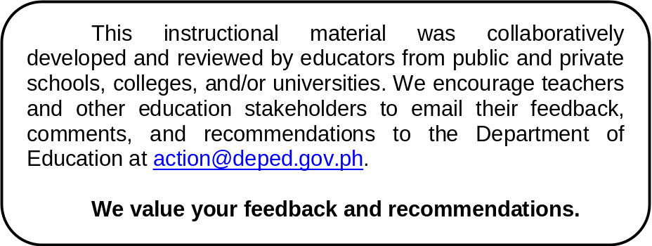

Department of Education
Republic of the Philippines
Mother Tongue Based Multilingual Education – Grade 2
Teacher’s Guide: Sinugbuanong Binisaya
First Edition, 2013
ISBN: ___________

Republic Act 8293, section 176 states that: No copyright shall subsist in any work of the Government of the Philippines. However, prior approval of the government agency or office wherein the work is created shall be necessary for exploitation of such work for profit. Such agency or office may, among other things, impose as a condition the payment of royalties.

Borrowed materials (i.e., songs, stories, poems, pictures, photos, brand names, trademarks, etc.) included in this book are owned by their respective copyright holders. Every effort has been exerted to locate and seek permission to use these materials from their respective copyright owners. The publisher and authors do not represent nor claim ownership over them.

Published by the Department of Education
Secretary: Br. Armin A. Luistro FSC
Undersecretary: Yolanda S. Quijano, Ph.D.
Development Team of the Teacher’s Guide

Consultant and Coordinators: Gurmensinda Sasam, Carmencita C. Denampo
Authors: Caren S. Selgas, Gea C. Alonso, Irene T. Pilapil, Ma. Mariza A. Manlangit, Lucia L. Zapanta, Rochelle L. Binoya, Jovelyn C. Quindao, Lorna C. Mahilum.

Reviewers: Nena V. Miñoza, Ma. Jesusa C. Despojo, Marcelita S. Dignos

Illustrators: Rosanna S. Andales

Layout Artist: Jocelyn M. Conta, Tomas T. Pastor, Sheila Marie Laurel, Alberto M. Adlawan

Printed in the Philippines by ____________

Department of Education-Instructional Materials Council Secretariat (DepEd-IMCS)
Office Address: 2nd Floor Dorm G, Philsports Complex
Meralco Avenue, Pasig City
Philippines 1600
Telefax: (02) 634-1054, 634-1072
E-mail Address: imcsetd@yahoo.com
Week 16
Objectives

- Oral Language
- express opinion on the news articles using culturally appropriate expressions
- participate in and initiate more extended social conversations with peers and adults on unfamiliar topics by asking and restating and soliciting information
- Word Recognition
- read phrases consisting of words being studied and answer higher order questions about them
- Fluency
- read aloud grade two level text with an accuracy of 95-100%
- Spelling
- spell correctly words in the list of content in the vocabulary
- Handwriting
- write news observing correct punctuation marks, capitalization, indentions and format in cursive form
- Composing Primer Lessons
- Compose news using appropriate words and coherent text
- Grammar Awareness
- use adjectives in culturally appropriate manner in sentences and paragraphs- synonyms
- Vocabulary and Concept Development
- Read aloud words (synonyms)
- explain common synonyms
- Reading Comprehension (Activating Schema and Prior Knowledge)
- predict what the news articles based on personal experiences and based on what one knows about
- Reading Comprehension (Comprehension on Informational Text)
- identify orally examples of fact and opinion and cause and effect in simple and familiar text
- readthe text and use detailed sentences to respond orally or in writing to factual comprehension questions about three forms of brief texts.
- Applythe knowledge of the language to analyze and derive meaning from informational text and comprehend them.
- identify and analyze the differences between various categories of informational materials (newspapers)
Subject Matter
- Express Opinion
- News Articles
- Capitalization, Space Between Words, Correct Punctuation Marks, Indention and Format in Cursive Form
- Adjectives
- Synonyms
- Inference
Materials
pictures of people in the community, newspapers, pocket chart, synonyms, bowl, rolled papers, charts
Theme:People in our Community
Procedure
Day 1
Objectives
- Correctly spell words in the list of content in the vocabulary
- Write news observing correct punctuation marks, capitalization, indentions and format in cursive form
- Use adjectives in culturally appropriate manner in sentences and paragraphs- synonyms
- Predict what the news articles based on personal experiences and based on what one knows about
- Identify and analyze the differences between various categories of informational materials (newspapers)

Preliminary Activities
Spelling: (Horn Method)
Pencil and paper test.
1. gifts | regalo | Karen receives gifts. | Nakadawat og mga regalo si Karen.
2. employees | kawani | The employees donate used clothing for the victims of the calamity. | Nihatag og mga sinina ang mga kawani para sa biktima sa katalagman.
3. activity | kalihukan | Pupils prepare for the Christmas activity. | Nangandam ang mga kabataan para sa kalihukan sa Pasko.

Sing a song "Mga Tawo Sa Lapu-Lapu" to the tune of "Sampung Mga Daliri."
(Refer to LM Unit II Week 16 Kantaha Mga Tawo sa Lapu-Lapu)
Ask:
- What line/lines in the song that you like most? Why?
(Unsa nga linya o mga linya sa kanta ang imong ganahan? Ngano man?)
- What were the words used to describe the people in Lapu-Lapu?
(Unsa ang mga pulong nga gigamit sa paghulagway sa mga tawo sa Lapu-Lapu?)
Unlock difficulties through contextual clues.
kawani (Ang mga kawani ang nanghatag og regalo. Sila mga empleyado
sa departamento sa himuanan sa relo.)
kalihukan(Adunay tinuig nga kalihukan ang mga kawani. Apil sa ilang aktibidad ang pagpanghatag og pinaskuhan sa mga kabataan.)
Motivation
Ask: Have you received gifts? (Nakadawat ba ka og regalo?)
How do you feel when you received the gifts?(Unsa ang inyo nga gibati
pagkadawat ninyo sa regalo?)
Say: Let us find out if you have the same feelings with that of the pupils of Lo-ok Elementary School. (Atong sutaon kon ang inyo nga gibati susama sa gibati sa mga tinun-an sa Lo-ok Elementary School.)
Presentation/Modelling
Read the news article found on LM Unit II Week 16 Unang Buluhaton
Discuss: (Refer to LM Unit II Week 16 Tubaga Kini)
  - gifts giving
  - recipients of the gifts
  - advantage of gift giving
  - synonyms
  - community members
Analysis of the news article
Say: Let us look at how the news article is written. (Tan-awon nato ang pagkasulat sa pahayag.)
Ask and discuss the following:
- the first word in the sentence presented - punctuation marks
- letter used in the first word of the sentence - sentence
- how the letter is written - fact and opinion
- Use of capital letters

Developmental Activity (Chart/Poster)
- Present keywords to the whole group. Let the pupils make predictions what the news article will be based on the keyword.
- Let the pupils read the news article. (whole group, triad, dyad, etc.)
- Point out significant phrases in the news article and let the pupils read aloud from the part of the article that contains the word.
e.g. kawani
Ang mga kawanisa TMX Philippines pinanguluhan ni G. Pat Niñal maghimo sa ilang tinuig nga kalihukan: ang pagpanghatag og sayong pinaskuhan sa mga kabataan.
Gidalit sa mga kawani sa TMX ang lami-an nga spaghetti ug burger human sa pasundayag.
- Lead/Guide the pupils to have a social conversation on topics about gift giving, helping the needy, etc.
- Let the pupils make their own news article base on the article presented.

Application
- Divide the children into 5 groups.
- Give a newspaper clipping in mother tongue. (e.g.Superbalita/Banat)
- Let each group choose a news report from the newspaper and from it they are going to pick up a phrase which they write in a manila paper.
- Let the reporter of the group present the group output.
- Discuss the answers of the groups.

Flipping My Pair (synonyms-kapulong)
- Divide the class into groups of five.
- Give an envelope to the group. The envelope contains word cards (adjectives).
- Let the pupils place the word cards on the table right face down (ikulob) on the sides of the table or desk.
- Let the pupils take turns in flipping the word cards to find its synonym.
- If the flipped cards are not pairs, the pupils are to put back to the bunch and try to flip again until the pair is found. (see to it that pupils take turns in flipping the cards).
- Let the pupil give his/her insight why he/she consider the pair synonyms.

da-ot | pobre | niwang | malipayon | gwapa | masadya-on
matahom | gusto | kabos | ganahan | husto | sakto
limpyo | potot | hinlo | mobo | daghan | abunda
habog | taas | dato | adunahan | maayo | buotan

Day 2
Objectives
- Express opinion on the news articles using culturally appropriate expressions
- Participate in and initiate more extended social conversations with peers and adults on unfamiliar topics by asking and answering questions restating and soliciting information
- Correctly spell words in the list of content in the vocabulary
- Write news observing correct punctuation marks, capitalization, indentions and format in cursive form
- Compose news using appropriate words and coherent text
- Use adjectives in culturally appropriate manner in sentences and paragraphs- synonyms
- Predict what the news articles based on personal experiences and based on what one knows about
- Orally identify examples of fact and opinion and cause and effect in simple and familiar text
- Identify and analyze the differences between various categories of informational materials (newspapers)

Preliminary Activities
Spelling
Spelling Game (same words as of day 1)
logare | inawak | hulihanka

- create groups of five among the pupils in the class
- present jumbled letters of the five spelling words placed inside individual envelopes for each spelling word.
- let the pupils arrange the letters to form the spelling words.
- let the group write their answer on a tagboard.
- discuss the answers with the group.

Sing a song: Ako Kabahin sa Komunidad (to the tune of “It's I Who Builds Community'')

Pre- Reading
Unlock difficulties through contextual clues.
matutuki paghatag og dako nga panahon
sangka pakigbatok
Raising of the Motive Question
Show a picture of Manny Pacquiao and let the pupils say something about it.
Ask:
- Do you know this person?(Kaila mo niining tawhana?)
- What has he done for the Filipinos?(Unsa ang iyang nahimo para sa mga Pilipino?)
- What article can be made from the picture presented?(Unsa nga artikulo ang mahimo gikan sa retrato?

During Reading
Group the pupils into 6. Let each group read the news article and discuss why Manny became a well known boxer.
Si Emmanuel “Manny” Pacquiao usa ka inila ug sikat nga Pilipinong boksingero. Daghan na nga higayon nga nihatag siya og dungog sa atong nasod. Ngano nga sa sangka nila ni Manuel Marquez, napilde man si Manny Pacquiao? Tungod ba kay wala niya matutuki og maayo ang iyang pangandam para sa boksing? Dako ang kasubo sa mga Pilipino sa kaparutan ug kapildihan ni Manny Pacquiao. Siguro sa sunod nga mga sangka ni Manny Pacquiao sa ring, hatagan na niya og dako nga panahon ang iyang pag-ensayo. Ang tanan nanghinaot nga sa sunod nga saka niya sa ring, mahatagan niya og kalipay ang mga Pilipino nga dako kaayo og pagsalig ngadto kang “People’s Champ” Manny Pacquiao.

Have a 3 minute creative presentation after the group discussions. It can be either, role playing; tv style news casting; radio style; jazz chant; short discussion; debate
(Note: see to it that each pupil participates)

Discussion
Let the pupils share ideas on the different presentations.
Let themidentify whether the sentences are facts or opinions.Call volunteers to
give the difference between a fact and opinion.
e.g. Manny Pacquiao is known as the People’s Champ.
Oliver says that Mr. Pacquiao is called the People’s Champ because he is
the best boxer in the world.
Manny Pacquiao lives in Sarangani, Philippines.

(Chart/Poster)
Reading of the news article. (whole group, triad, dyad, etc.)
Point out significant phrases in the news article and let the pupils read aloud from the part of the article that contains the word.
e.g. boksingero
Si Emmanuel “Manny” Pacquiao usa ka inila ug sikat nga Pilipinong boksingero.
Let the pupils give their opinion about the article presented.
Lead the pupils have a social conversation on topics about gift giving, helping the needy, etc.
Writing a news based on the article presented using correct punctuation marks and format.
Application
Divide the children into 5 groups.
Each group will be given a newspaper in mother tongue. (e.g.Superbalita/Banat)
Let each group choose a news report from the newspaper and from it they are going to pick up a phrase which they will write in a manila paper.
Let the reporter of the group present the group output.

Day 3
Objectives
- Participate in and initiate more extended social conversations with peers and adults on unfamiliar topics by asking and answering questions restating and soliciting information
- Correctly spell words in the list of content in the vocabulary
- Use adjectives in culturally appropriate manner in sentences and paragraphs- synonyms
- Read aloud words (synonyms)
- Explain common synonyms

Preliminary Activities
Spelling (Horn Method)
Use the spelling words in sentences. Arrangement of the words will vary.
Lights Camera Action
- Prepare rolled pieces of paper with names of community helpers written on it.
- Place the rolled paper in the bowl.
- Let a pupil pick out from the bowl a piece of paper.
- Let the pupil act out the word written on the sheet of paper.
- Let the whole group guess what the action is.
- Let the pupil who can guess the animal write its name on the board.
- Ask the pupils to give descriptions about the community presented.
- Let the pupils write the descriptions on their tag boards.
- Let the pupils give other words that mean the same as the word presented.
e.g. nindot – maayo, angay etc.
Flipping My Pair (synonyms-kapulong)
- Divide the class into groups of five.
- Give an envelope to the group that contains word cards (adjectives).
- Let the pupils place the word cards on the table right face down (ikulob) on the sides of the table or desk.
- Let the pupils take turns in flipping the word cards to find its synonym.
- If the flipped cards are not pairs, the pupils are to put back to the bunch and try to flip again until the pair is found. (see to it that pupils take turns in flipping the cards).
da-ot | pobre | niwang | malipayon | gwapa | masadya-on
matahom | gusto | kabos | ganahan | husto | sakto
limpyo | potot | hinlo | mobo | daghan | abunda
habog | taas | dato | adunahan | maayo | buotan
Generalization
What is a synonym? (Unsa ang kapulong?)
Fixing Skills
Inside-Outside Circle
- Let the pupils form two circles: one circle inside the other. See to it that each has similar number of pupils in the circle.
- Distribute word cards to the pupils. (synonyms)
- Pupils will sing the song “Ako Kabahin sa Komunidad”. When the song ends, the pupils in the outside circle show their word card to the pupil in front of him/her.
- If the words that the pupils are holding are synonyms, they place their word cards on the pocket chart.

Let’s Write it
- Group the pupils into five.
- Give each group word cards: (adjectives)
- Let the group write the synonyms of the words written on the word cards.
- Let the group compose a news article on the adjectives presented.
- Call groups to present their group outputs.

Day 4
Objectives
- Express opinion on the news articles using culturally appropriate expressions
- Write news observing correct punctuation marks, capitalization, indentions and format in cursive form
- Use adjectives in culturally appropriate manner in sentences and paragraphs- synonyms
- Predict what the news articles based on personal experiences and based on what one knows about
- Orally identify examples of fact and opinion and cause and effect in simple and familiar text
- Apply the knowledge of the language and derive meaning from informational text and comprehend them
- Identify and analyze the differences between various categories of informational materials (newspapers)

Preliminary Activities
Spelling Game (Magic Tree)
The teacher presents the meaning of the five spelling words and uses it in sentence. Call pupils to pick a fruit from the magic tree the spelling word described. The spelling word is written on each fruit. Have additional fruits on the magic tree with words that are not included in the set of spelling words.
- regalo 3. kalihukan 5. katinuoran
- kawani 4. lumolupyo

Developmental Activity (news clippings)
- Let the pupils cut out news articles from local newspapers.
- Let them mount it on a bond paper.
- Group the pupils into five groups.
- Distribute news clippings to each group.
- Let them analyze whether the news clippings contain fact or opinions.
- Let them identify the adjectives in the news clippings.
- Ask them give the synonyms of the adjectives found in the news clippings.
- Let the group write a parallel news article based on the news clipping presented on a manila paper.
- Present their group outputs

Day 5

Objectives
- Correctly spell words in the list of content in the vocabulary
- Write news observing correct punctuation marks, capitalization, indentions and format in cursive form
- Use adjectives in culturally appropriate manner in sentences and paragraphs- synonyms
- Predict what the news articles based on personal experiences and based on what one knows about
- Orally identify examples of fact and opinion and cause and effect in simple and familiar text
- Identify and analyze the differences between various categories of informational materials (newspapers)
\
Preliminary Activities
Spelling
1. gifts | (regalo) | Karen receives gifts. | (Nakadawat og mga regalo si Karen.)
2. employees | (kawani) | The employees donate used clothing for the victims of the calamity. | (Nihatag og mga sinina ang mga kawani para sa biktima sa katalagman.
3. activity | (kalihukan) | Pupils prepare for the Christmas activity. | Nangandam ang mga kabataan para sa kalihukan sa Pasko.

Valuing
Ask the pupils the things that they learned about fact and opinion, synonyms, correct usage of punctuation marks, capitalization, indentions and format.
Ask the pupils about the people in the community and their contribution in its development and progress

Developmental Activity (news clippings)
- Cut out a news article from local newspapers.
- Enlarge the news clipping or copy the news clipping on a chart.
- Let the pupils analyze whether the news clippings contain fact or opinions.
- Let the pupils identify the adjectives in the news clippings.
- Let the pupils give the synonyms of the adjectives found in the news clippings.
- Let the group write a parallel news article based on the news clipping presented on their writing notebook.
- Let the group present their group outputs and discuss.

For inquiries or feedback, please write or call:

Instructional Materials Council Secretariat (IMCS)
Department of Education (DepEd)
2nd Floor, Dorm G, Philsports Complex, Meralco Avenue
Pasig City, Philippines 1600
Telefax: (632) 634-0901 or (632) 634-1072
e-mail: imcs@deped.gov.ph or depedimcs@gmail.com
DeTxt: Globe and Smart: 2622

ISBN No. _________________________

