7
Science
Learner’s Material
Unit 4 – Earth and Space
Module 1: The Philippine Environment
This instructional material was collaboratively developed and reviewed by educators from public and private schools, colleges, and/or universities. We encourage teachers and other education stakeholders to email their feedback, comments, and recommendations to the Department of Education at action@deped.gov.ph.
We value your feedback and recommendations.

Department of Education
Republic of the Philippines

Science – Grade 7
Learner’s Material
First Edition, 2013
ISBN: 978-971-9990-58-1

Republic Act 8293, section 176 states that: No copyright shall subsist in any work of the Government of the Philippines. However, prior approval of the government agency or office wherein the work is created shall be necessary for exploitation of such work for profit. Such agency or office may, among other things, impose as a condition the payment of royalties.

Borrowed materials (i.e., songs, stories, poems, pictures, photos, brand names, trademarks, etc.) included in this book are owned by their respective copyright holders. Every effort has been exerted to locate and seek permission to use these materials from their respective copyright owners. The publisher and authors do not represent nor claim ownership over them.

Published by the Department of Education
Secretary: Br. Armin A. Luistro FSC
Undersecretary: Yolanda S. Quijano, Ph.D.
Assistant Secretary: Elena R. Ruiz, Ph.D.

Development Team of the Learner’s Material

Consultant: Merle C. Tan, Ph.D.
Authors: Alvie J. Asuncion, Maria Helen D.H. Catalan, Ph.D., Leticia V. Catris, Ph.D., Marlene B. Ferido, Ph.D., Jacqueline Rose M. Gutierrez, Michael Anthony B. Mantala, Cerilina M. Maramag, Ivy P. Mejia, Eligio C. Obille, Jr., Risa L. Reyes, Ph.D.,
Ma. Dulcelina O. Sebastian, Merle C. Tan, Ph.D., and Rodolfo S. Treyes, Ph.D.
Editors: Josefina Ll. Pabellon, Ph.D., Ma. Cristina D. Padolina, Ph.D., Risa L. Reyes, Ph.D., and Merle C. Tan, Ph.D.
Reviewers: Magno R. Abueme, Ruby D. Arre, Bonifacio D. Caculitan, Jr., Marivic Rosales, and Arnold Sinen
Illustrator: Alvin J. Encarnacion
Layout Artists and Encoders: Rosita R. Cruz, Aro R. Rara, and Cecile N. Sales

Printed in the Philippines by ____________

Department of Education-Instructional Materials Council Secretariat
(DepEd-IMCS)

Office Address: 2nd Floor Dorm G, Philsports Complex,
Meralco Avenue, Pasig City, Philippines 1600
Telefax: (02) 634-1054, 634-1072
E-mail Address: imcsetd@yahoo.com
Table of Contents

Unit 4: Earth and Space

Module 1: The Philippine Environment 1
Activity 1: Where in the world is the Philippines (Part I) 1
Activity 2: Where in the world is the Philippines (Part II) 4
Activity 3: What are some factors that will affect
the amount of water in watersheds 8
Activity 4: How are soils formed from rocks 9
Activity 5: Where are the mineral deposits in the Philippines 11
Activity 6: How do people destroy natural resources? 20
Activity 7: Are you ready for “Make-a-Difference” day 21

Suggested time allotment: 14 hours

Unit 4  MODULE 1 | THE PHILIPPINE ENVIRONMENT

Overview

Everything that we see around us makes up our environment. The landforms and bodies of water that make up the landscape, the mountains and valleys, rivers and seas; the climate, the rains brought by the monsoons, the warm, humid weather that we frequently experience; the natural resources that we make use of; every plant and animal that live around us. Truly, the environment is made up of a lot of things.

All these things that we find in our surroundings and all the natural phenomena that we observe are not due to some random luck or accident. What makes up our environment is very much related to where our country is on the globe. Or, to say it in a different way, the characteristics of our environment are determined by the location of the Philippines on the planet.

Latitude and Longitude

Before we learn about the characteristics of our environment, let us first talk about the location of the Philippines. Where is the Philippines? The Philippines is on Earth, of course, but where exactly is it located? To answer this question, you have to learn a new skill: locating places using latitude and longitude.

Activity 1
Where in the world is the Philippines? (Part I)

Objective

After performing this activity, you should be able to describe the location of the Philippines using latitude and longitude.

What to use
globes
What to do

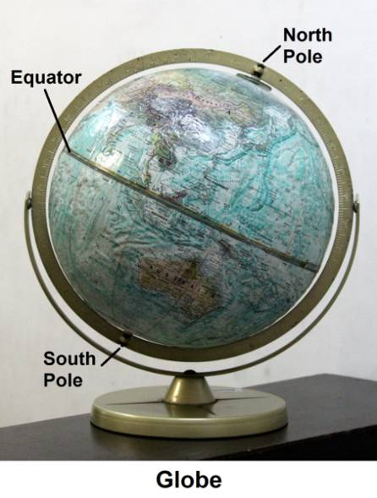
- Study the image of a globe on the right. Then get a real globe and identify the parts that are labelled in the image. Be ready to point them out when your teachers asks you.
Figure 1. What does the globe represent?

- After studying the globe and the image on the right, try to define “equator” in your own words. Give your own definition when your teacher asks you.

- The “northern hemisphere” is that part of the world between the North Pole and the equator. Show the northern hemisphere on the globe when your teacher asks you.

- Where is the “southern hemisphere”? Show the southern hemisphere on the globe when your teacher asks you.

- Study the drawing on the right. It shows the lines of latitude.

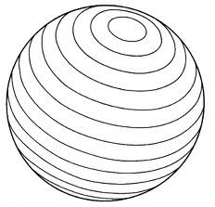
Q1. Describe the lines of latitude.
Figure 2. What is the reference line when determining the latitude?

Q2. Show the lines of latitude on the globe when your teacher asks you.

Q3. The starting point for latitude is the equator. The equator is at latitude 0° (0 degree). At the North Pole, the latitude is 90°N (90 degrees north). At the South Pole, the latitude is 90°S (90 degrees south). Show the following latitudes when your teacher calls on you: 15°N; 60°N; 30°S; 45°S.

Q4. The globe does not show all lines of latitude. If you wish to find 50°N, where should you look?
- Study the drawing on the right. It shows the lines of longitude.

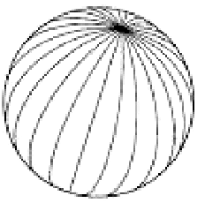
Q5. Describe the lines of longitude.
Figure 3. What is the reference line when determining the longitude?

Q6. Show the lines of longitude on the globe when your teacher asks you.

Q7. The starting point for longitude is the Prime Meridian. The Prime Meridian is at longitude 0°. Show the Prime Meridian on the globe when your teacher asks you.

Q8. To the right of the Prime Meridian, the longitude is written this way: 15°E (15 degrees east), 30°E (30 degrees east), and so on. To the left of the Prime Meridian, the longitude is written as 15°W (15 degrees west), 30°W (30 degrees west), and so on. On your globe, find longitude 180°. What does this longitude represent?

Q9. Not all lines of longitude are shown on a globe. If you want to find 20°W, where should you look?

Q10. The location of a place may be described by using latitude and longitude. To the nearest degree, what is the latitude and longitude of Manila?

Q11. Compared to the size of the world, Manila is just a tiny spot, and its location may be described using a pair of latitude and longitude. But how would you describe the location of an “area” such as the whole Philippines?

Now you know how to describe the location of a certain place using latitude and longitude. The lines of latitude are also known as parallels of latitude. That is because the lines of latitude are parallel to the equator and to each other. Five lines of latitude have special names. They are listed in the table below. The latitude values have been rounded off to the nearest half-degree.

Latitude | Name
0° | Equator
23.5°N | Tropic of Cancer
23.5°S | Tropic of Capricorn
66.5°N | Arctic Circle
66.5°S | Antarctic Circle

Get a globe and find the Tropic of Cancer and the Tropic of Capricorn. Trace the two lines of latitude with a red chalk. The part of the world between the two chalk lines is called the tropics. Countries that are located in this zone experience a tropical climate where the annual average temperature is above 18°C.
Now, find the Arctic Circle and the Antarctic Circle on the globe. Trace them with blue chalk. Between the Tropic of Cancer and the Arctic Circle is the northern temperate zone; between the Tropic of Capricorn and the Antarctic Circle is the southern temperate zone. Countries in these zones go through four seasons – winter, spring summer, and autumn.

Finally, the areas within the Arctic Circle and Antarctic Circle are called the polar regions or frigid zones. People who choose to live in these areas have to deal with temperatures that never go above 10°C. It is cold all year round and even during the summer months, it does not feel like summer at all.

To sum up, the closer the latitude is to the equator, the warmer the climate. The closer it is to the poles, the colder. Thus, it is clear that there is a relationship between the latitude of a place and the climate it experiences, and you will find out why in the next module.

Landmasses and Bodies of Water

Using latitude and longitude is not the only way that you can describe the location of a certain area. Another way is by identifying the landmasses and bodies of water that are found in that area. So, what are the landmasses and bodies of water that surround the Philippines? Do the following activity and get to know the surrounding geography.

Activity 2
Where in the world is the Philippines? (Part II)

Objective

After performing this activity, you should be able to describe the location of the Philippines with respect to the surrounding landmasses and bodies of water.

What to use

globe or world map

What to do

- Using a globe or a world map as reference, label the blank map below.

- Your labelled map should include the following:

A. Landmasses B. Bodies of water

Philippine archipelago Philippine Sea
Asian continent South China Sea
Malay peninsula Indian Ocean
Isthmus of Kra Pacific Ocean
Indonesian archipelago
Australian continent
Q1. Which bodies of water in the list are found to the west of the Philippines?
Q2. Which body of water in the list is located to the east of the Philippines?
Q3. Which large landmass is found to the north of the Philippines?

- Be ready to show the map with your labels when your teachers asks you.

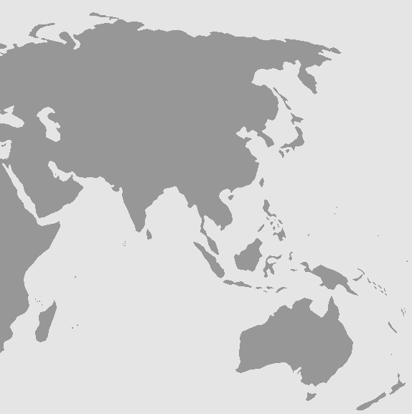
Figure 4. Where is the Philippines in the map? Why is the Philippines called an archipelago?

By now you can say that you really know where the Philippines is. You can now describe its location in two ways: by using latitude and longitude, and by identifying the landmasses and bodies of water that surround it. What then is the use of knowing where the Philippines is located? You will find out in the next section and also in the following module.

Are We Lucky in the Philippines?

Planet Earth is made up of different things - air, water, plants, animals, soil, rocks, minerals, crude oil, and other fossil fuels. These things are called natural resources because they are not made by people; rather they are gathered from nature. Sunlight and wind are also natural resources. We use all these things to survive or satisfy our needs.

The Philippines is considered rich in natural resources. We have fertile, arable lands, high diversity of plant and animals, extensive coastlines, and rich mineral deposits. We have natural gas, coal, and geothermal energy. Wind and water are also harnessed for electricity generation.

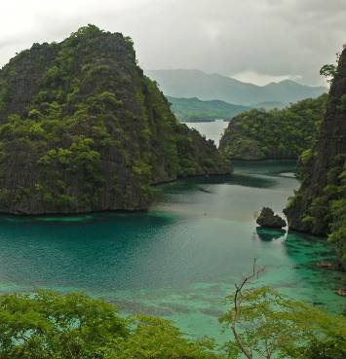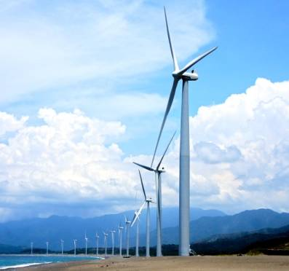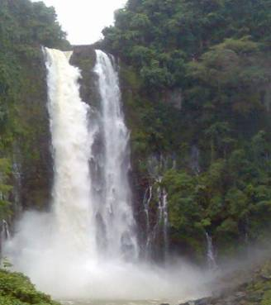
Photo: Courtesy of Michael C. Tan
Photo: Courtesy of Cecile N. Sales
Photo: Courtesy of Kit Stephen S. Agad

Figure 5: What kind of natural resources are shown in the pictures? Do you have similar resources in your area?

Why do we have rich natural resources? What geologic structures in the country account for these bounty? Is our location near the equator related to the presence of these natural resources?

The next lessons will help you find answers to some questions about natural resources in the country namely, rocks and minerals, water, soil, varied life forms, and energy.
- How does our latitude position affect the water, soil resources, and biodiversity in the country?
- What mineral deposits do we have in the country? Where are they located and why only in those places?
- Given our location, what energy resources are available?
- Which of our practices in using natural resources are sustainable? Which are not sustainable?
- How can we help conserve natural resources so that future generations can also enjoy them?

Hopefully, the knowledge and skills acquired in the lessons will help you value your responsibility as a productive citizen so that you can help prevent protected and vulnerable places from being mined, forests from being overcut, and natural resources like metals from ending up in a dumpsite.

Water Resources and Biodiversity

The Philippines boasts of many different kinds of natural water forms, such as bays, rivers, lakes, falls, gulfs, straits, and swamps. Because it is made up of islands, the country's coastline (seashore) if laid end-to-end, would measure around 17.5 thousand kilometers. And you know how we are proud of our coastlines! The bodies of water and its surrounding environment not only support the survival of diverse organisms for food but are also used for other economic activities. All these you learned in Araling Panlipunan.

In the previous activity you identified two big bodies of water on the west and east side of the country: the Pacific Ocean in the east and south China Sea in the west (sometimes referred to as the West Philippine Sea). These bodies of water are the origin of typhoons which on the average, according to Philippine Atmospheric, Geophysical and Astronomical Services Administration (PAGASA), is about 20 a year. Typhoons and the monsoons (amihan and habagat) bring lots of rain to the Philippines.

What is your association with too much rainfall? For some, rain and typhoons result in flooding, landslides, and health related-problems. But water is one of nature’s gifts to us. People need fresh water for many purposes. We use water for domestic purposes, for irrigation, and for industries. We need water to generate electricity. We use water for recreation or its aesthetic value. Many resorts are located near springs, waterfalls or lakes.

Where does water in your community come from? You collect them when the rain falls or get them from the river, deep well, or spring. But where does water from rivers, lakes, and springs originate?

They come from a watershed – an area of land on a slope which drains its water into a stream and its tributaries (small streams that supply water to a main stream). This is the reason why a watershed is sometimes called a catchment area or drainage basin. It includes the surface of the land and the underground rock formation drained by the stream.

From an aerial view, drainage patterns in a watershed resemble a network similar to the branching pattern of a tree. Tributaries, similar to twigs and small branches, flow into streams, the main branch of the tree. Streams eventually empty into a large river comparable to the trunk.

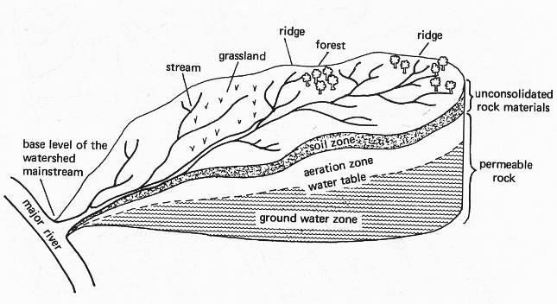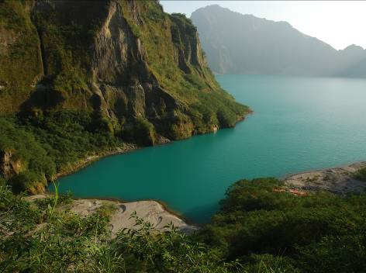
Photo: Courtesy of Michael C. Tan
Figure 6. The network of streams in a watershed area is illustrated on the left and a photo of a watershed area is on the right. How does the concept “water runs downhill” apply to a watershed?

Watersheds come in all shapes and sizes. They cross towns and provinces. In other parts of the world, they may cross national boundaries.

There are many watersheds in the Philippines basically because we have abundant rainfall. Do you know that Mt. Apo in Davao-Cotabato, Makiling-Banahaw in Laguna and Quezon, and Tiwi in Albay are watersheds? You must have heard about La Mesa Dam in Metro Manila, Pantabangan Dam in Pampanga, and Angat Dam in Bulacan. These watersheds are sources of water of many communities in the area. The Maria Cristina Falls in Iligan City is in a watershed; it is used to generate electricity. Locate these places in your map. Ask elders where the watershed is in or near your area? Observe it is used in your community.
But watersheds are not just about water. A single watershed may include combination of forest, grassland, marshes, and other habitats. Diverse organisms in the Philippines are found in these areas! Being a tropical country, the Philippines has abundant rainfall, many bodies of water, and lots of sunshine. The right temperature and abundant rainfall explain partly why our country is considered to be a mega-diverse country. This means that we have high diversity of plants and animals, both on land and in water (Philippine Clearing House Mechanism Website, 2012).

Reports show that in many islands of the Philippine archipelago, there is a high number of endemic plants and animals (endemic means found only in the Philippines). The country hosts more than 52,177 described species of which more than half is found nowhere else in the world. They say that on a per unit area basis, the Philippines shelters more diversity of life than any other country on the planet.

For now remember that the main function of a watershed is the production of a continuous water supply that would maintain the lifeforms within it and in the area fed by its stream. Later you will learn that besides supporting the survival of varied life forms, abundant water in the country is important in moderating temperature. This topic will be discussed later.

Have you ever asked yourself the following questions? If we have abundant rainfall to feed watersheds, why do we experience drought some parts of the year? What factors affect the health of a watershed? Is there a way of regulating the flow of water in watershed so that there will be enough for all throughout the year? What can people do to keep watersheds ‘healthy’? Find out about these in the next activity.

Activity 3
What are some factors that will affect the amount of water in watersheds?

Objective

You will design a procedure to show how a certain factor affects the amount of water that can be stored underground or released by a watershed to rivers, lakes and other bodies of water.

What to do

- In your group, choose one factor that you want to investigate.

- Vegetation cover
- Slope of the area
- Kind of soil
- Amount of rainfall

- Identify the variables that you need to control and the variable that you will change.

- Design a procedure to determine the effect of the factor you chose on watersheds.
- Be ready to present your design in the class and to defend why you designed it that way.

Soil Resources, Rainfall and Temperature

Recall in elementary school science that soil is formed when rocks and other materials near the Earth’s surface are broken down by a number of processes collectively called weathering. You learned two types of weathering: the mechanical breaking of rocks or physical weathering, and the chemical decay of rocks or chemical weathering.

Let us review what happens to a piece of rock when left under the Sun and rain for a long time. Do the next activity.

Activity 4
How are soils formed from rocks?

Objectives

- Using the information in the table, trace the formation of soil from rocks.
- Identify the factors acting together on rocks to form soil.

What to use

Drawing pens

What to do

1. Processes involved in soil formation are listed in the table below. Read the descriptions of the processes and make your own illustrations of the different processes. Draw in the designated spaces.

2. Use the descriptions and your drawings to answer the following questions.

Q1. What are the factors that act together on rocks to form soil?

Q2. What does the following sentence mean, “Soils were once rocks”?

Processes of soil formation | Illustrations of processes
When a piece of rock is exposed to the Sun, its outer part expands (becomes bigger) because it heats up faster than the inner part (Drawing A). | Drawing A
On cooling, at night time, the outer part of the rock contracts or shrinks because the outer part of the rock cools faster than the inner portion (Drawing B). The process of expansion and contraction are repeated over the years and produce cracks in the rock causing the outer surface to break off. | Drawing B
Once broken, water enters the cracks causing some minerals to dissolve. The rock breaks apart further. (Drawing C). | Drawing C
Air also enters the cracks, and oxygen in the air combines with some elements such as iron to produce iron oxide (rust or kalawang) which is brittle and will easily peel off. In a similar way, carbon dioxide from the air reacts with water to form an acid causing the rock to soften further. Once soft and broken, bacteria and small plants start to grow in the cracks of the rock (Drawing D).  After some time, the dead plants and animals die and decay causing the formation of more acidic substances which further breaks the rocks. The dead bodies of plants and animals are acted upon by microorganism and breakdown into smaller compounds while the minerals from the rock return to the soil. | Drawing D

Soil covers the entire Earth. Temperature, rainfall, chemical changes, and biological action act together to continuously form soil. Climate, expressed as both temperature and rainfall effects, is often considered the most powerful soil-forming factor.

Temperature controls how fast chemical reactions occur. Many reactions proceed more quickly as temperature increases. Warm-region soils are normally more developed or more mature than cold-region soils. Mature soils have more silt and clay on or near the surface. Thus, soils in the tropical areas are observed to sustain various farming activities and account for why the primary source of livelihood in the Philippines and other countries in the tropical region is their fertile land. What is the effect of very little rainfall on food production?

Climate (temperature and rainfall) is a significant factor not only in soil formation but also in sustaining diversity of plants and animals in the country. On the other hand, water also directly affects the movement of soluble soil nutrients from the top soil to deep under the ground (leaching). These nutrients may no longer be available to shallow rooted plants. Acidic rainwater may also contribute to the loss of minerals in soil resulting in low yield. So rainfall determines the kind of vegetation in an area. In turn, the degree of vegetation cover, especially in sloping areas, determines how much soil is removed. Are there ways to protect soil resources?

Rocks and Mineral Resources

History tells us that rocks have been used by humans for more than two million years. Our ancestors lived in caves; they carved rocks and stones to make tools for hunting animals, cultivating crops, or weapons for protection. Rocks, stones, gravel, and sand were and are still used to make roads, buildings, monuments, and art objects.

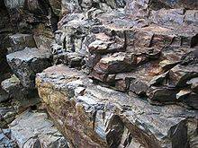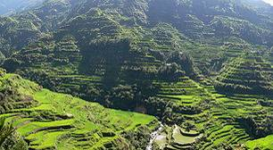
http://commons.wikimedia.org/wiki/File:DirkvdM_rocks.jpg

Figure 7. What are the features of the rocks? What environmental factors may have caused such features?
http://en.wikipedia.org/wiki/File:Pana_Banaue_Rice_Terraces.jpg
Figure 8. What kind of tools do you think were used to build the Rice Terraces? Why are terraces useful?

The mining of rocks for their metal content has been considered one of the most important factors of human progress. The mining industry has raised levels of economy in some regions, in part because of the kind of metals available from the rocks in those areas.

Activity 5
Where are the mineral deposits in the Philippines?

Mineral deposits can be classified into two types: metallic and non-metallic. You have already learned the symbols of some metals and nonmetals. Review them before you do the activity.
Objectives

After performing this activity, you will be able to

  - locate the metallic mineral deposits across the country;

  - find out what geologic features are common in areas where the deposits are found;
  - give a possible reason/s for the association between metallic mineral deposits and geologic features in the country; and
  - infer why your area or region is rich or not rich in metallic mineral deposits.

What to use

Figure 9: Metallic Deposits Map of the Philippines
Figure 10: Map of Trenches and Faults in the Philippines
Figure 11: Map of Volcanoes in the Philippines
2 pieces of plastic sheet used for book cover, same size as a book page
Marking pens (two colors, if possible)

What to do

Part I

- Familiarize yourself with the physical map of the Philippines. Identify specific places of interest to you in the different regions.

- In your notebook, make a four-column table with headings similar to Table 1.

Table 1: Metallic Minerals in the Philippines and Their Location
Metal, in Symbols  (Example: Au)  (1) | Metal, in Words  (2) | Province/Region Where the Metals are Found  (3) | Geologic Structure Near the Location of the Metallic Deposits  (4)

- As a group, study the Metallic Deposits Map of the Philippines. See Figure 9. In the map you will see symbols of metals. Fill in the information needed in Columns 1 and 2 of your own table.

- Check with each other if you have correctly written the correct words for the symbol of the metals. Add as many rows as there are kinds of metals in the map.

- Analyze the data in Table 1.

Q1. Identify five metals which are most abundant across the country. Put a number on this metal (1 for most abundant, 2 next abundant, and so on).
Q2. Record in Column 3 where the five most abundant metals are located.

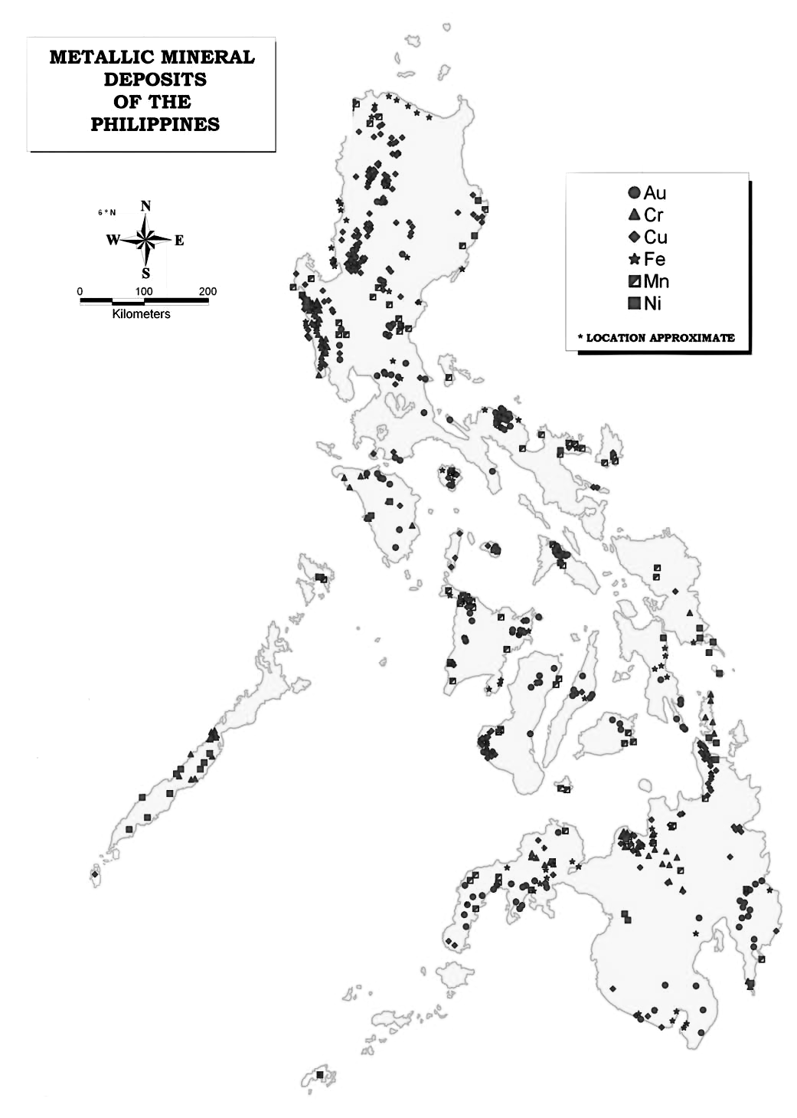

Figure 9. Metallic Deposits in the Philippines
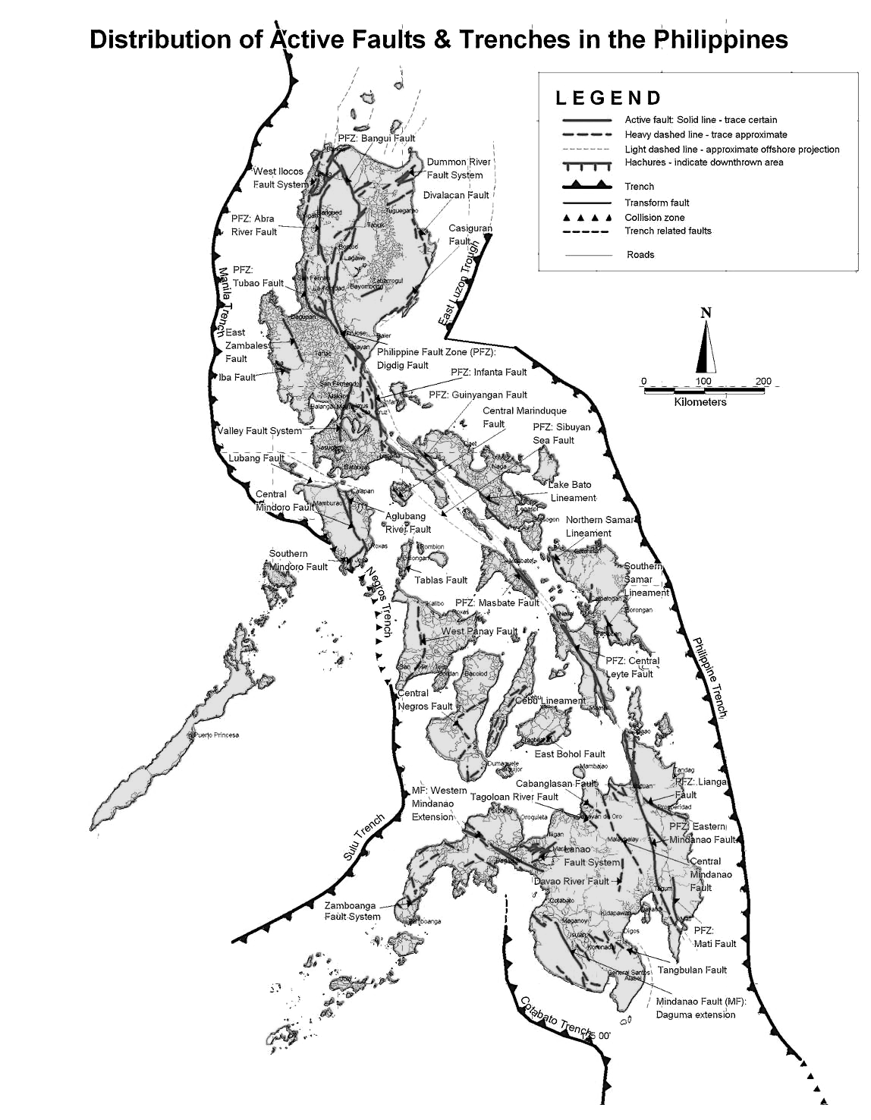

Figure 10. Trenches and Faults in the Philippines
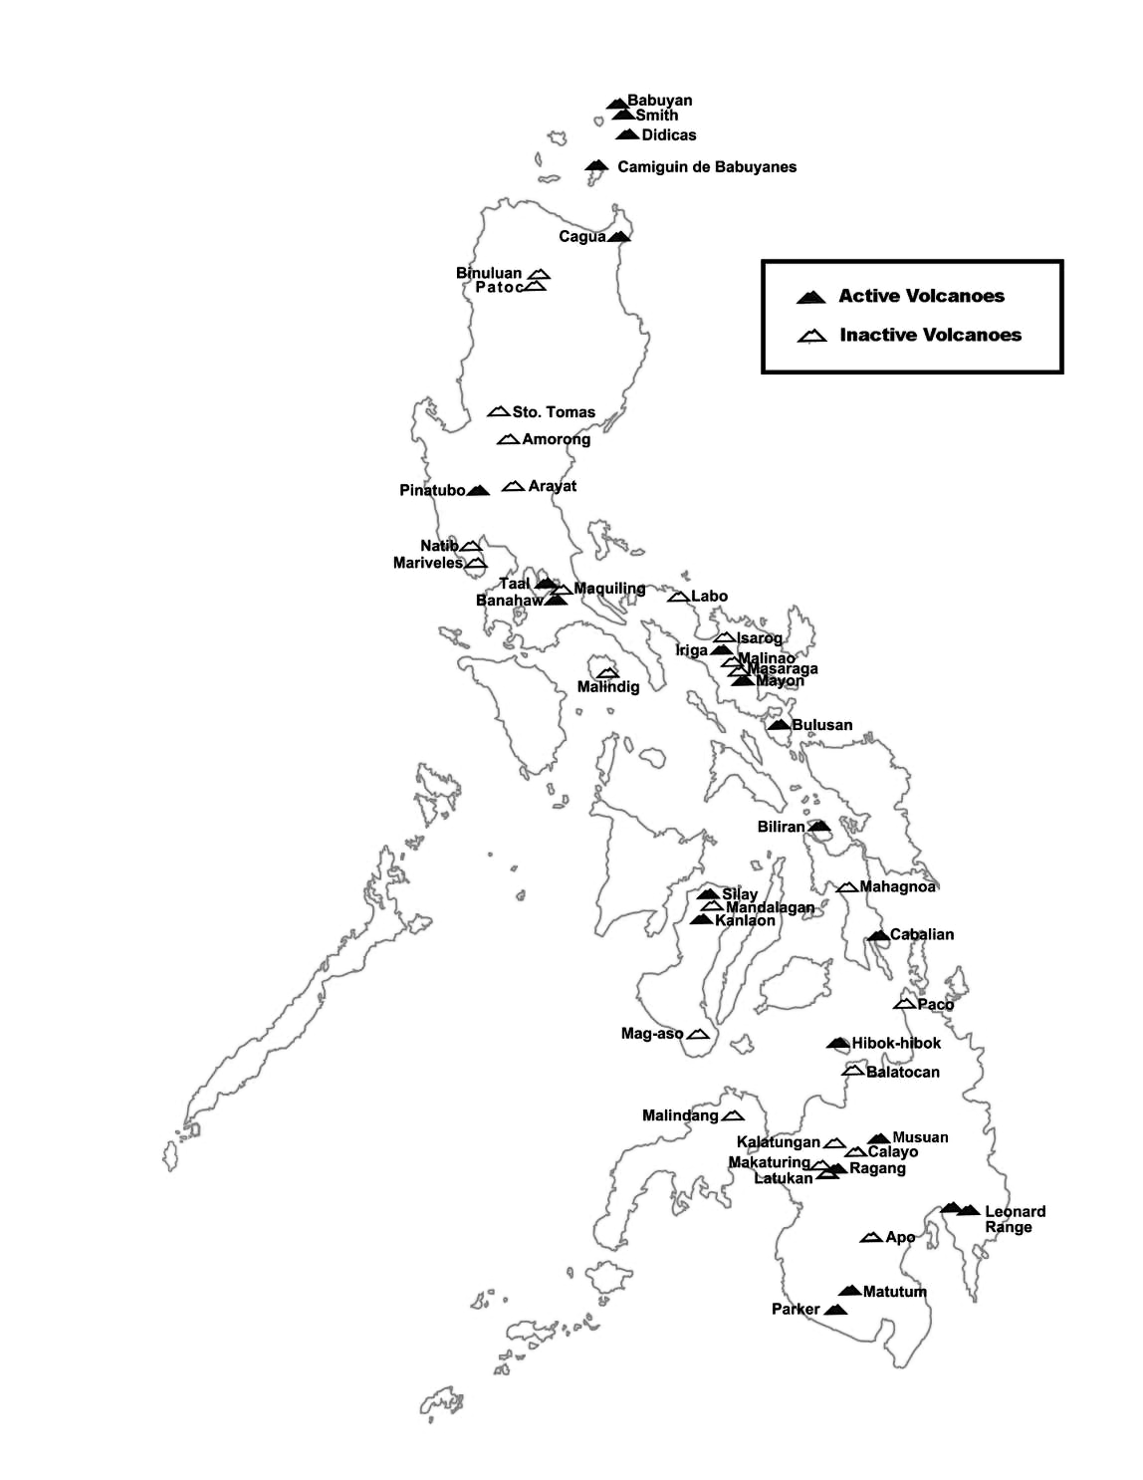

Figure 11. Volcanoes in the Philippines
Part II

- Get two plastic sheets. On one sheet, trace the outlines of the trenches and faults from Figure 10. On the other sheet, trace the location of volcanoes from Figure 11.

- Place the Trench and Fault plastic sheet over the Metallic Deposits map.

- Place the Volcanoes plastic sheet over the two maps.
Q3. What geologic structures are found near the location of the metallic deposits? Write trenches, faults or volcanoes in column 4 of Table 1.
Q4. Write a statement to connect the presence of metallic deposits with trenches or volcanic areas.
Q5. Why do you think are metallic deposits abundant in places where there are trenches or volcanoes?

- Look for your province in the map.
Q6. Are there metallic deposits in your area?
Q7. What could be reason for the presence or absence of metallic deposits in your area? You can download the detailed map of Trenches, Faults and volcanoes in the Philippines from the website of Phivolcs.
Q8. If there are metallic deposits, what activities tell you that there are indeed deposits in or near your area/province?

The important metallic minerals found in various parts of the Philippines include gold, copper, iron, chromite (made up of chromium, iron, and other metals), nickel, cobalt, and platinum. The most productive copper and gold producers in the Philippines are found in Baguio, the province of Benguet, and in Surigao-Davao areas. Major producers of nickel are in Palawan and Surigao (DENR Website, 2012).

Metals are important. The properties of metals make them useful for specific purposes. You learned these in Quarter 1. Iron is the main material for steel bars used in buildings and road construction. Copper is used in making electrical wires. Tin is the material for milk cans and other preserved food products. Nickel is mixed with copper or other metals to form stainless cooking wares. Gold is important in making jewelry.

What other metals are you familiar with? What are the uses of aluminum? What metal is used to make GI sheets for roofing? What metals are used to make artificial arms or legs? Are metals used in chairs and other furniture? Do you know that some dentists use gold for filling teeth cavities? Look around and find how versatile metals are.

The Philippines has also varied nonmetallic resources including sand and gravel, limestone, marble, clay, and other quarry materials. Your teacher will show you a map of the nonmetallic deposits in the Philippines. Locate your area and determine what nonmetallic deposits are found there. How are these deposits recovered? How are they used in your community? For example: What are the uses of sand, gravel, or clay? How are marble stones used? Think of other nonmetals and their uses!
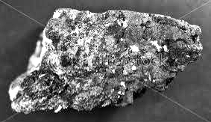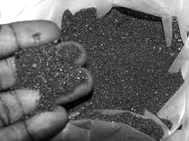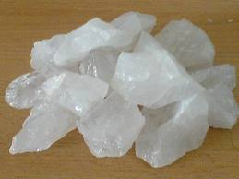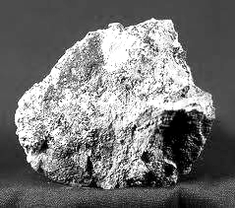
Quartz
Copper ore
Copper – iron ore
Iron filings

Figure 12. From the drawing, what are ores? Have you noticed that a piece of ore can have more than one kind of mineral in it?
Iron-ore

Do you know that the Philippines is listed as the 5th mineral country in the world, 3rd in gold reserves, 4th in copper, and 5th in nickel! The ores (mineral-bearing rocks) are processed out of the country to recover the pure metal. We buy the pure metal. Is this practice advantageous to the Philippines? Why or why not?

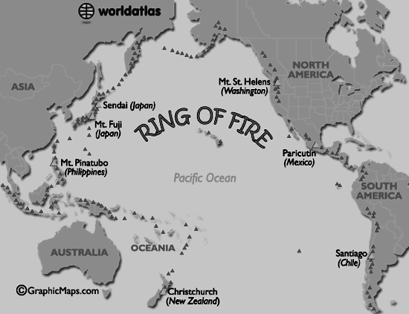
The richness of the Philippines in terms of mineral resources is being attributed to its location in the so-called Pacific Ring of Fire. See Figure 13. This area is associated with over 450 volcanoes (small triangles in the map) and is home to approximately 75% of the world's active volcanoes. Why are there minerals where there are volcanoes?
Figure 13. Besides the Philippines, what other countries are in the Ring of Fire? Do you think they are also rich in mineral resources?

Geologists (scientists who study the Earth and the processes that occur in and on it) explain that there is a continuous source of heat deep under the Earth; this melts rocks and other materials (link to usgs website).The mixture of molten or semi-molten materials is called magma. Because magma is hotter and lighter than the surrounding rocks, it rises, melting some of the rocks it passes on the way. If the magma finds a way to the surface, it will erupt as lava. Lava flow is observed in erupting volcanoes.

But the rising magma does not always reach the surface to erupt. Instead, it may slowly cool and harden beneath the volcano and form different kinds of igneous rocks. Under favorable temperature and pressure conditions, the metal-containing rocks continuously melt and redeposit, eventually forming rich-mineral veins.

Though originally scattered in very small amounts in magma, the metals are concentrated when magma convectively moves and circulates ore-bearing liquids and gases. This is the reason why metallic minerals deposits such as copper, gold, silver, lead, and zinc are associated with magmas found deep within the roots of extinct volcanoes. And as you saw in the maps, volcanoes are always near trenches and faults! You will learn more of this later.

For now you must have realized that the presence of mineral deposits in the Philippines is not by accident. It is nature’s gift. If before, your association with volcanoes and trenches is danger and risk to life and property, now you know that the presence of volcanoes, trenches and other geological structures is the reason for the rich mineral deposits in the country.
The existence of volcanoes also explains why the Philippines is rich in geothermal energy (heat from the Earth). Energy resources will be discussed in the next section.

Energy Resources

The abundance of some metal resources in the Philippines is related to geologic structures, specifically the presence of volcanoes and trenches in the country. The year-round warm temperature and availability of water are effects of our geographic location.

The tropical climate and the geological conditions also provide several possibilities to get clean and cheap energy. Do you know which energy resources are due to these factors? Were the following included in your list- solar energy, heat from the ground (geothermal energy), hydrothermal energy from falling water), wind energy, and natural gas?

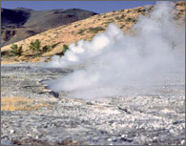
Solar energy is free and inexhaustible. This energy source will be discussed in a later science subject.
http://commons.wikimedia.org/wiki/File:Hot_Spring.jpg

Figure 14. Do you know that heat from the Earth may escape as steam in a hot spring?

Geothermal energy was briefly introduced in the lesson on mineral resources and their location. The Philippines ranked second to the United States in terms of geothermal energy deposits. Geothermal power plants are located in Banahaw-Makiling, Laguna, Tiwi in Albay, Bacman in Sorsogon, Palimpinon in Negros Occidental, Tongonan in Leyte, and Mt. Apo side of Cotabato.

Try to locate places with geothermal power plants in your map? Does your area have geothermal energy deposits? How do you know?

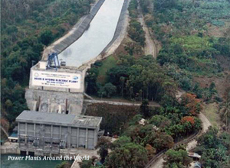
Hydrothermal or hydroelectric power plants use water to generate electricity. They provide for 27% of total electricity production in the country. Ambuklao in Benguet, Mt Province, Agus in Lanao del Sur and Agus in Lanao del Norte are large hydrothermal power plants. Small hydroelectric power plants are in Caliraya, Laguna, Magat in Isabela, Loboc in Bohol, and other places. Used water from hydropower plants flows through irrigation systems. Many of the reservoir areas are used for sport activities.
Photograph courtesy of National Power Corporation, retrieved from http://www.industcards.com/hydro-philippines.htm
Figure 15. How is water used to generate electricity?

Again, locate places with hydroelectric power plants in your map? Does your area have hydroelectric power plants? What other uses do you have for water in these areas?

Natural gas is a form of fossil fuel, so are coal and crude oil (sometimes called petroleum). Fossil fuels were formed from plants and animals that lived on Earth millions of years ago. They are buried deep in the Earth. Natural gas and oil are taken from the deep through oil rigs while coal is extracted through mining. Fossil fuels are used to produce electricity and run vehicles and factory machines. Did you know that petroleum is the raw material for making plastics?

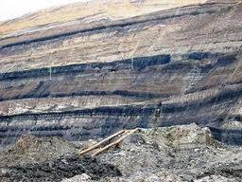
In the Philippines, we have coal and natural gas deposits. Coal is a black or brownish black, solid rock that can be burned. It contains about 40% non-combustible components, thus a source of air pollution when used as fuel. Coal deposits are scattered over the Philippines but the largest deposit is located in Semirara Island, Antique. Coal mines are also located in Cebu, Zamboanga Sibuguey, Albay, Surigao, and Negros Provinces.
Figure 16. The black bands in the picture are coal deposits. Coal is not like the charcoal you use for broiling fish or barbecue. What do you think is the difference?

Our natural gas deposits are found offshore of Palawan. Do you know where this place is? The Malampaya Deepwater Gas-to-Power Project employs ‘state-of-the-art deepwater technology’ to draw natural gas from deep beneath Philippine waters. The gas fuels three natural gas-fired power stations to provide 40-45% of Luzon's power generation requirements. The Department of Energy reports that since October 2001, the Philippines has been importing less petroleum for electricity generation, providing the country foreign-exchange savings and energy security from this clean fuel.

Natural gas is considered clean fuel because when burned, it produces the least carbon dioxide, among fossil fuels. CO₂ is naturally present in air in small amounts. However, studies show that increase in carbon dioxide in the atmosphere results in increase in atmospheric temperature, globally. You will learn about global warming in the next module.

Did you know that in Ilocos Province, giant wind mills as shown in Figure 5 of this module are used to generate electricity? In Quirino, Ilocos Sur the electricity generated from wind mills runs a motorized sugarcane press for the community's muscovado sugar production? This project is a joint effort between the local farmers and local organizations with support from Japan. In Bangui, Ilocos Norte, the windmills as high as 50 meters not only help improve the tourism in Ilocos but it also provides 40% of the energy requirements for electricity in the entire province. This proves that we do not have to be dependent on fossil fuel in our country.

What do you think are the environmental conditions in Ilocos Sur and Ilocos Norte that allow them to use wind power for electricity? Do you think there are places that have these conditions? Support your answers.
Conserving and Protecting Natural Resources

There are two types of natural resources on Earth - renewable and nonrenewable. What is the difference between these two kinds of resources?

The food people eat comes from plants and animals. Plants are replaced by new ones after each harvest. People also eat animals. Animals have the capacity to reproduce and are replaced when young animals are born. Water in a river or in a well may dry up. But when the rain comes the water is replaced. Plants, animals, and water are resources that can be replaced. They are renewable resources.

Most plants grow in top soil. Rain and floods wash away top soil. Can top soil be replaced easily? Soil comes from rocks and materials from dead plants and animals. It takes thousands of years for soil to form. Soil cannot be replaced easily, or it takes a very long time to replace. It is a nonrenewable resource.

Metals like copper, iron, and aluminum are abundant on Earth. But people are using them up fast. They have to dig deeper into the ground to get what they need. Coal, oil and natural gas (fossil fuels) were formed from plants and animals that lived on Earth millions of years ago. It takes millions of years for dead plants and animals to turn into fossil fuels. Soil, coal, oil and natural gas are nonrenewable resources.

Before you do Activity 6, think of these sentences: “Too much is taken from Earth!" and "Too much is put into Earth." You may write up a short essay about your understanding of the sentences.

Activity 6
How do people destroy natural resources?

Objectives

1. Identify the effects of some human activities on natural resources.
2. Suggest ways to reduce the effects.

What to Do

- Study Table 2 and tell if you have observed the activities listed in your locality.

Table 2. Ways People Destroy Natural Resources

Activities  (1) | Effects on Natural Resources  (2)
When roads are built, mountains are blown off using dynamite. | Damage natural habitats and/or kill plants and animals.
Rice fields are turned into residential or commercial centers.
People cut too many trees for lumber or paper or building houses.
More factories are being built to keep up with the demands of a fast growing population and industrialization.
Too much mining and quarrying for the purpose of getting precious metals and stones and gravel.
Some farmers use too much chemical fertilizers to replenish soil fertility. | Too much fertilizer destroys the quality of the soil and is harmful to both human and animals.
Plastics and other garbage are burned.
Cars, trucks, and tricycles that emit dark smoke (smoke belchers) are allowed to travel.
Other activities

- Discuss the effects of these activities on natural resources.

- Write the effects on the column opposite the activities. An activity may have more than one effect. Some of the effects have already been listed in the table.

- Do you know of other activities that destroy or cause the depletion of natural resources? Add them to the list and fill the corresponding effect in column 2.

- What can you do to conserve resources?

Protecting Resources in Your Own Way

All resources used by humans, including fuels, metals, and building materials, come from the Earth. Many of these resources are not in endless supply. It has taken many thousands and millions of years to develop and accumulate these resources.

To conserve natural resources is to protect or use them wisely without wasting them or using them up completely. Conserving natural resources can make them last and be available for future generations. This is what sustainability of natural resources means. Each one of us should think about how to make things sustainable. Remember: The lives of future generations depend on how we use natural resources today.

Activity 7
Are you ready for “Make-a-Difference” Day?

This activity involves you in hands-on activities that help you learn more about reducing waste, reusing materials instead of throwing them away, recycling, composting, and conserving natural resources and energy. There are many activities that you can include: conducting a "waste-free lunch" or building art materials out of cans, bottles, and other recyclable trash. Depending on the location and nature of your school, you might want to include river cleanup, trail maintenance, or tree planting. Or, you can mix these activities with a poster making contest for use in the campaign on non-use of plastic bags for shopping and/or marketing.
What to do

- In your group, make a list of what is done in your school that help conserve natural resources. Discuss your list before finalizing the report.

- Make another list of what is done in your school that do not help conserve natural resources. For example, do you still have lots of things in the trash can or on the ground? What are they? What is being done with them?

- Come up with a one-day plan on what else can be done in school to conserve natural resources. Present your plan to the class.

- Based on the group presentation, decide which part in the plans will be adopted or adapted to make a class plan. The plan should consider the following:
- Easy to follow
- Who will be responsible for making the plan happen
- What should be done if the people responsible for making the plan happen will not or cannot do it
- What natural resources will be conserved
- Schedule of activities to include monitoring
- Why you think this plan is the best idea

- With your teacher’s permission, make an appointment with your principal to present your plan and to solicit support. Maybe she might recommend the “Make-a-Difference” Day for the whole school!

Hopefully, the “Make-a-Difference” Day will engage you in a variety of environmental activities that help foster not only an appreciation for the environment and the resources it provides but also develop a life-long environmental stewardship among your age group.

Links and Other Reading Materials

gdis.denr.gov.ph (Geohazard Map)
http://www.phivolcs.dost.gov.ph
http://www.jcmiras.net/surge/p124.htm (Geothermal power plants in the Philippines)
http://www.industcards.com/hydro-philippines.htm (Hydroelectric power plants in the Philippines)

