7
Science
Learner’s Material
Unit 4 – Earth and Space
Module 2: Solar Energy and the Atmosphere
This instructional material was collaboratively developed and reviewed by educators from public and private schools, colleges, and/or universities. We encourage teachers and other education stakeholders to email their feedback, comments, and recommendations to the Department of Education at action@deped.gov.ph.
We value your feedback and recommendations.

Department of Education
Republic of the Philippines

Science – Grade 7
Learner’s Material
First Edition, 2013
ISBN: 978-971-9990-58-1

Republic Act 8293, section 176 states that: No copyright shall subsist in any work of the Government of the Philippines. However, prior approval of the government agency or office wherein the work is created shall be necessary for exploitation of such work for profit. Such agency or office may, among other things, impose as a condition the payment of royalties.

Borrowed materials (i.e., songs, stories, poems, pictures, photos, brand names, trademarks, etc.) included in this book are owned by their respective copyright holders. Every effort has been exerted to locate and seek permission to use these materials from their respective copyright owners. The publisher and authors do not represent nor claim ownership over them.

Published by the Department of Education
Secretary: Br. Armin A. Luistro FSC
Undersecretary: Yolanda S. Quijano, Ph.D.
Assistant Secretary: Elena R. Ruiz, Ph.D.

Development Team of the Learner’s Material

Consultant: Merle C. Tan, Ph.D.
Authors: Alvie J. Asuncion, Maria Helen D.H. Catalan, Ph.D., Leticia V. Catris, Ph.D., Marlene B. Ferido, Ph.D., Jacqueline Rose M. Gutierrez, Michael Anthony B. Mantala, Cerilina M. Maramag, Ivy P. Mejia, Eligio C. Obille, Jr., Risa L. Reyes, Ph.D.,
Ma. Dulcelina O. Sebastian, Merle C. Tan, Ph.D., and Rodolfo S. Treyes, Ph.D.
Editors: Josefina Ll. Pabellon, Ph.D., Ma. Cristina D. Padolina, Ph.D., Risa L. Reyes, Ph.D., and Merle C. Tan, Ph.D.
Reviewers: Magno R. Abueme, Ruby D. Arre, Bonifacio D. Caculitan, Jr., Marivic Rosales, and Arnold Sinen
Illustrator: Alvin J. Encarnacion
Layout Artists and Encoders: Rosita R. Cruz, Aro R. Rara, and Cecile N. Sales

Printed in the Philippines by ____________

Department of Education-Instructional Materials Council Secretariat
(DepEd-IMCS)

Office Address: 2nd Floor Dorm G, Philsports Complex,
Meralco Avenue, Pasig City, Philippines 1600
Telefax: (02) 634-1054, 634-1072
E-mail Address: imcsetd@yahoo.com
Table of Contents

Unit 4: Earth and Space

Module 2: Solar Energy and the Atmosphere 1
Activity 1: What is the basis for dividing Earth’s atmosphere into layers 1
Activity 2: Does a greenhouse retain or release heat 3
Activity 3: What happens when air is heated? 9
Activity 4: What happens to the air in the surroundings
as warm air rises? 11
Activity 5: Which warms up faster? 13
Activity 6: In what direction do winds blow – from high
to low pressure area or vice versa? 16

Suggested time allotment: 12 hours

Unit 4  MODULE 2 | SOLAR ENERGY  AND THE ATMOSPHERE

In the previous module, you learned that the presence of different natural resources in the Philippines is related to the country’s location. It was also mentioned that the climate in a certain area depends on its latitude. In this module, you are going to learn more about how the location of the Philippines influences its climate and weather. To prepare you for this lesson, you must first learn about the envelope of air that surrounds the Earth where all weather events happen – the atmosphere.

Activity 1
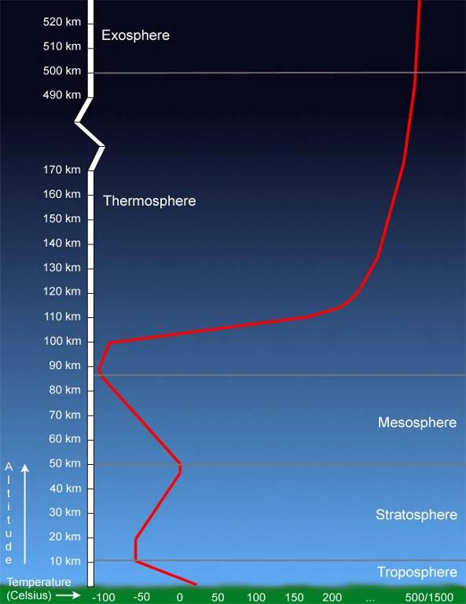
What is the basis for dividing Earth’s atmosphere into layers?
Figure 1. What are the layers of the atmosphere?

Earth’s atmosphere is divided into five layers. What is the basis for subdividing the atmosphere?

Objectives

You will be able to gather information about Earth’s atmosphere based on a graph. Specifically, you will:

- describe the features of each of the five layers;
- compare the features of the five layers; and
- explain the basis for the division of the layers of the atmosphere.
What to use

- Graph in Figure 1
- A ruler, if available

What to do

- Study the graph.

Q1. What are the five layers? Estimate the height of each layer.
Q2. Describe the graph for each layer.
Q3. In which layer is temperature increasing with increasing altitude?
Q4. In which layer is temperature decreasing with increasing altitude?
Q5. What is the relationship between temperature and height in the
- troposphere?
- stratosphere?
- mesosphere?
- thermosphere?
- exosphere?
Q6. Observe the whole graph. What is the basis for the division of Earth’s atmosphere?
Q7. From the graph, can you generalize that the higher the layer of the atmosphere (that is closer to the Sun), the hotter the temperature? Why or why not?
Q8. What other information about Earth’s atmosphere can you derive from the graph?

- Read the succeeding paragraphs and think of a way to organize and summarize the data about the atmosphere from the graph and the information in the discussion that follows.

The troposphere is the layer closest to Earth’s surface. The temperature just above the ground is hotter than the temperature high above. Weather occurs in the troposphere because this layer contains most of the water vapor. Remember the water cycle? Without water, there would be no clouds, rain, snow or other weather features. Air in the troposphere is constantly moving. As a result, aircraft flying through the troposphere may have a very bumpy ride – what we know as turbulence. People who have used the airplane for travelling have experienced this especially when there is a typhoon in areas where the plane passes through.

The stratosphere is the layer of air that extends to about 50 km from Earth’s surface. Many jet aircraft fly in the stratosphere because it is very stable. It is in the stratosphere that we find the ozone layer. The ozone layer absorbs much of the Sun’s harmful radiation that would otherwise be dangerous to plant and animal life.

The layer between 50 km and 80 km above the Earth’s surface is called the mesosphere. Air in this layer is very thin and cold. Meteors or rock fragments burn up in the mesosphere.
The thermosphere is between 80 km and 110 km above the Earth. Space shuttles fly in this area and it is also where the auroras are found. Auroras are caused when the solar wind strikes gases in the atmosphere above the Poles. Why can we not see auroras in the Philippines?

The upper limit of our atmosphere is the exosphere. This layer of the atmosphere merges into space. Satellites are stationed in this area, 500 km to 1000 km from Earth.

To summarize what has been discussed: More than three quarters of Earth’s atmosphere is made up of nitrogen while one fifth is oxygen. The remaining 1% is a mixture of carbon dioxide, water vapor, and ozone. These gases not only produce important weather features such as cloud and rain, but also have considerable influence on the overall climate of the Earth, through the greenhouse effect and global warming.

What is the Greenhouse Effect?

In order to understand the greenhouse effect, you need to first understand how a real greenhouse works.

In temperate countries, a greenhouse is used to grow seedlings in the late winter and early spring and later, planted in the open field when the weather is warmer. Greenhouses also protect plants from weather phenomena such snowstorm or dust storms. In tropical countries, greenhouses are used by commercial plant growers to protect flowering and ornamental plants from harsh weather conditions and insect attack.

Greenhouses range in size from small sheds to very large buildings. They also vary in terms of types of covering materials. Some are made of glass while others are made of plastic.

Activity 2
Does a greenhouse retain or release heat?

Objectives

The activity will enable you to

- construct a model greenhouse.
- find out if your model greenhouse retains heat
- relate the concept of greenhouse to the increasing temperature of Earth’s atmosphere.
What to use
- 2-liter plastic soft drink bottle
- 2-plastic containers to serve as base of the bottles
Be careful when handling sharp objects like knife or scissors and breakable equipment like thermometer.

CAUTION
- knife or scissors
- transparent tape
- two alcohol thermometers
- one reading lamp (if available), otherwise bring the setups under the Sun

What to do

Constructing the model greenhouse

For each model greenhouse you will need a two-liter plastic soft drink container (with cap) and a shallow plastic container for the base.

- Remove the label of the soft drink bottle but keep the cap attached.

- Cut off carefully, the end of the bottle approximately 5-6 cm from the bottom. Dispose of the bottom piece.

- Place the bottle with cap in the plastic base. This is your model greenhouse. Label it Bottle A.

- Use scissors or knife to cut several elongated openings or vents (1.5 x 5.0 cm) on the sides of Bottle B. Leave Bottle A intact.

- Tape a thermometer onto a piece of cardboard. Make sure that the cardboard is longer than the thermometer so that the bulb will not touch the plastic base. Make two thermometer setups, one for Bottle A and another for Bottle B. Place one thermometer setup in each bottle.

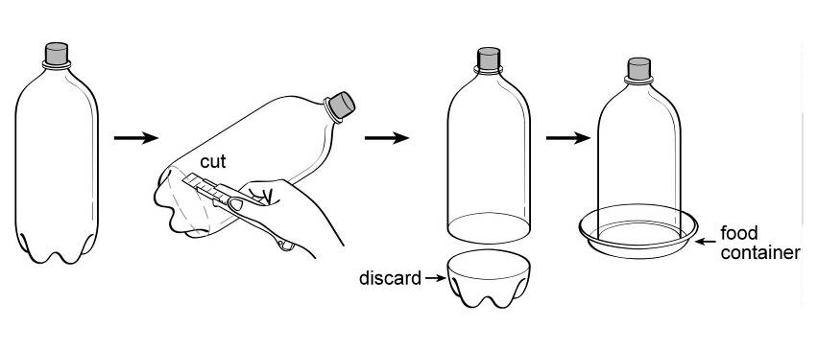
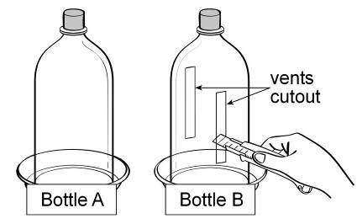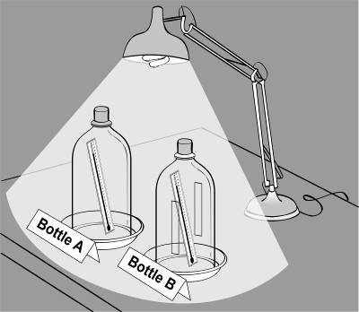
Figure 2. How to construct a model greenhouse

- Place both bottles approximately 10 cm away from the lamp. DO NOT turn on the lamp yet.
NOTE:
If you have no lamp, bring the setups outside the classroom under the Sun where they will not be disturbed.

Q1. Predict which bottle will get hotter when you turn on the light or when they are exposed to the Sun. How will you know that one bottle is hotter than the other?
Q2. Write down your prediction and the reason why you predicted that way.
- Turn on the light and begin collecting data every five minutes for 25 minutes. (Note: But if you have no lamp, place the setups under the Sun. Read the temperature every 20 minutes for over two hours.)

- Record the temperature readings of Bottle A and Bottle B in your notebook.

- Graph your data separately for Bottles A and B.
Q3. What variable did you put in the x-axis? In the y-axis?
Q4. Why did you put these data in the x and y axes, respectively?
Q5. Describe the graph resulting from observations in Bottle A.
Q6. Describe the graph resulting from observations in Bottle B.
Q7. Explain the similarities in the graphs of Bottles A and B.
Q8. Explain the differences in the graphs of Bottles A and B.
Q9. Does this activity help you answer the question in the activity title: Do greenhouses retain heat? What is the evidence?

Greenhouses allow sunlight to enter but prevent heat from escaping. The transparent covering of the greenhouse allows visible light to enter without obstruction. It warms the inside of the greenhouse as energy is absorbed by the plants, soil, and other things inside the building. Air warmed by the heat inside is retained in the building by the roof and wall. The transparent covering also prevents the heat from leaving by reflecting the energy back into the walls and preventing outside winds from carrying it away.

The Earth’s atmosphere is compared to a greenhouse. You know that besides nitrogen and oxygen, Earth’s atmosphere contains trace gases such as carbon dioxide, water vapor, methane, and ozone. Like the glass in a greenhouse, the trace gases have a similar effect on the Sun’s rays. They allow sunlight to pass through, resulting in the warming up of the Earth’s surface. But they absorb the energy coming from the Earth’s surface, keeping the Earth’s temperature suitable for life on Earth. The process by which the Earth’s atmosphere warms up is called ‘greenhouse effect,’ and the trace gases are referred to as ‘greenhouse gases.’

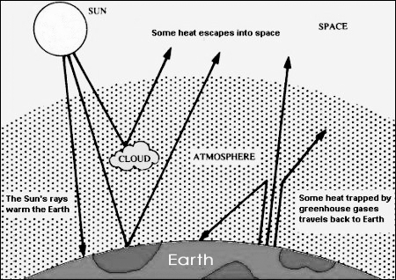
https://sites.google.com/site/glowar88/all-about-global-warming/1-what-is-global-warming

Figure 3. Why are greenhouse gases like the glass in the greenhouse?

The ‘greenhouse effect’ is a natural process and it warms the Earth. Without the greenhouse effect, Earth would be very cold, too cold for living things, such as plants and animals.

To further understand the effect of greenhouse gases look at Figure 4. It contains some data about Venus and Earth, planets that are almost of the same size and if you remember from elementary school science, are near each other, so they are called twin planets. The composition of atmosphere and the average surface temperature of the two planets are also given. Why is the average temperature of Venus very much higher than that of Earth? What could have caused this phenomenon?

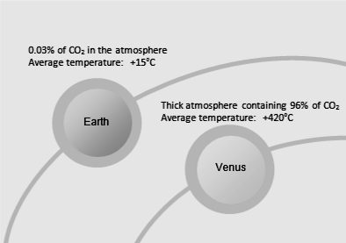
Both Earth and Venus have carbon dioxide, a greenhouse gas, in their atmospheres. The small amount of carbon dioxide on Earth’s gives the right temperature for living things to survive. With the high surface temperature of Venus due to its high carbon dioxide concentration, do you think life forms like those we know of could exist there? Why or why not?
Figure 4. What gas is present in the atmosphere of Venus that explains its high surface temperature?

Is Earth Getting Warmer? What is the Evidence?

Studies have shown that before 1750 (called the pre-industrialization years), carbon dioxide concentration was about 0.028 percent or 280 parts per million (ppm) by volume. The graph below shows the concentration of carbon dioxide from 1958 to 2003. What information can you derive from the graph?

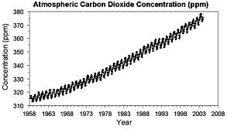
Recent studies report that in 2000-2009, carbon dioxide rose by 2.0 ppm per year. In 2011, the level is higher than at any time during the last 800 thousand years. Local temperatures fluctuate naturally, over the past 50 years but the average global temperature has increased at the fastest rate in recorded history.
http://en.wikipedia.org/wiki/File:Mauna_Loa_Carbon_Dioxide-en.svg#file
Figure 5. Carbon dioxide measurements in Mauna Loa Observatory, Hawaii

So what if there is increasing emission of greenhouse gases like carbon dioxide into the atmosphere? What is the problem with a small increase in carbon dioxide concentration in the atmosphere?

More carbon dioxide means that more heat is trapped in Earth’s atmosphere. More heat cannot return back into space. More heat trapped by the carbon dioxide means a warmer Earth.

The increasing temperature phenomenon is known as ‘global warming’. Global means that all countries and people around the world are affected even if that country is not a major contributor of greenhouse gases. Many scientists now agree that many human activities emit more greenhouses gases into the atmosphere, making the natural greenhouse effect stronger. Scientists are also saying that if we carry on polluting the atmosphere with greenhouse gases, it will have a dangerous effect on the Earth.

Sources of Greenhouse Gases

Carbon dioxide is naturally produced when people and animals breathe. Plants and trees take in and use carbon dioxide to produce their own food. Volcanoes also produce carbon dioxide. Methane comes from grazing animals as they digest their food and from decaying matter in wet rice fields. Ozone is also naturally present in the stratosphere.

But human activities emit a lot of greenhouse gases into the atmosphere.
Study Figure 7.

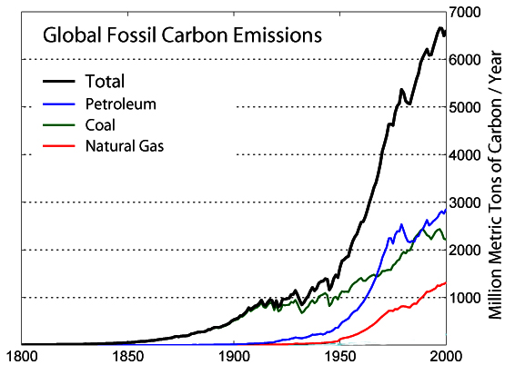
http://en.wikipedia.org/wiki/File:Global_Carbon_Emission_by_Type.png
Figure 6. Does burning of fossil fuels raise the carbon dioxide concentration in the atmosphere?

Which fossil fuel has the highest contribution to carbon dioxide concentration in the atmosphere?

What human activities use this fuel? List at least three.

Recall Module 1. What kind of fossil fuels are used in the Philippines?

Are we also contributing to the increase in carbon dioxide concentration in the atmosphere? Why or why not?

Carbon dioxide comes from the burning of fossil fuel such as coal, crude oil and natural gas. Cutting down and burning of trees releases carbon dioxide. Methane can also be released from buried waste. For example, the left-over food, garden wastes, and animal wastes collected from our homes are thrown into dumpsites. When lots of wastes are compressed and packed together, they produce methane. Coal mining also produces methane.

Another group of greenhouse gases includes the chlorofluorocarbons or CFCs for short. CFCs have been used in spray cans as propellants, in refrigerators as refrigerants, and in making foam plastics as foaming agents. They become dangerous when released into the atmosphere, depleting the ozone layer. For this reason, their use has been banned around the world.

What have you learned about the atmosphere? There are natural processes in the atmosphere that protect and sustain life on Earth. For example, the greenhouse effect keeps temperature on Earth just right for living things. For as long as the concentration of greenhouse gases are controlled, we will have no problem.

But human beings activities have emitted greenhouse gases into the atmosphere, increasing their levels to quantities that have adverse effects on people, plants, animals and the physical environment. Burning of fossil fuels, for example, has increased levels of carbon dioxide thus trapping more heat, increasing air temperature, and causing global warming. Such global phenomenon is feared to melt polar ice caps and cause flooding to low-lying areas that will result to reduction in biodiversity. It is even feared that global warming is already changing climates around the globe, causing stronger typhoons, and creating many health-related problems. You will learn more about climate change later.

Common Atmospheric Phenomena

In the next section, you will learn two concepts that will help you understand common atmospheric phenomena: why the wind blows, why monsoons occur, and what is the so-called intertropical convergence zone. All of these are driven by the same thing: the heat of the Sun or solar energy. Thus, we begin by asking, what happens when air is heated?

Activity 3
What happens when air is heated?

Objective

After this activity, you should be able to explain what happens when air is heated.

What to use

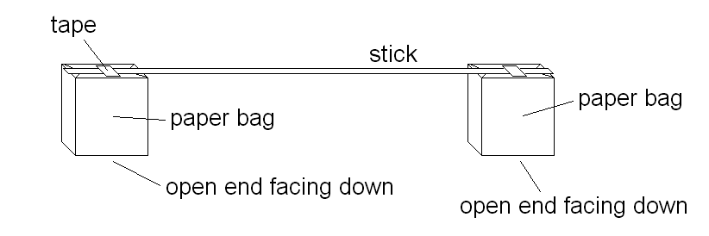
two paper bags
Figure 7. Setup for Activity 3
candle
long straight stick
match
masking tape
chair

What to do

1. Attach a paper bag to each end of the stick (see drawing above). The open end of each bag should be facing down.

2. Balance the stick with the paper bags on the chair (see drawing below.)

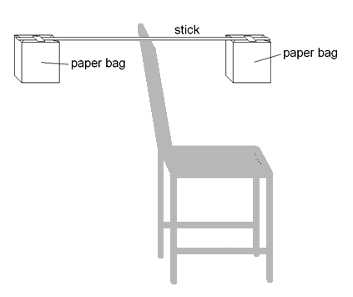
- Make a prediction: what do you think will happen if you place a lighted candle under the open end of one of the bags?

- Now, light the candle and place it below one of the bags. Caution: Do not place the candle too close to the paper bag. It may catch fire. Be ready with a pail of water or wet rag just in case.

Figure 8. Balance the stick with paper bags on a chair.

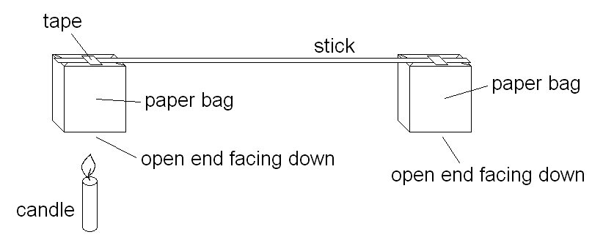
Q1. Was your prediction accurate? Describe what happened.

Q2. Can you explain why?

Figure 9. What will happen when a lighted candle is placed under one of the bags?

This is the first concept that you need to know: Warm air rises. Now, try to answer the following question. When warm air is rising, what is its effect on the air in the surroundings? Will the air in the surroundings stay in place? Or will it be affected in some way by the rising air? Do the following activity and find out.

Activity 4
What happens to the air in the surroundings as warm air rises?

Objective

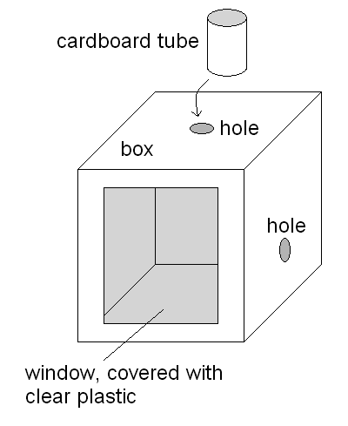
After performing this activity, you should be able to explain what happens to the air in the surroundings as warm air rises.

What to use

box candle
scissors match
cardboard tube smoke source
clear plastic (ex. mosquito coil)

Figure 10.
Setup for Activity 4
What to do

Pre-activity

Make two holes in the box: one hole on one side and another hole on top (see drawing). Place the cardboard tube over the hole on top and tape it in place. Make a window at the front side of the box so you can see inside. Cover the window with clear plastic to make the box airtight.

Activity proper

1. Open the box and place the candle directly below the hole on top. Light up the candle and close the box.

2. Make a prediction: What do you think will happen if you place a smoke source near the hole?

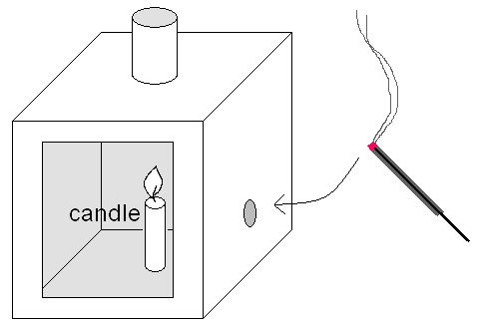
3. Now, place the smoke source near the hole.

Q1. Was your prediction accurate?

Q2. What happened?

Q3. Can you explain why?

Figure 11. What happens to the smoke when the source is placed near the hole?

What Makes the Air Move?

As you have seen in the activity, air in the surroundings can be affected by rising warm air. The drawing below shows how this happens. First, the air above the candle becomes warm because of the flame. What happens to this warm air? It rises. As warm air rises, what happens to the air in the surroundings? It will move toward the place where warm air is rising. But you cannot see air, how can you tell that it is moving? Did you see smoke from the mosquito coil? The movement of the smoke shows the movement of the air.

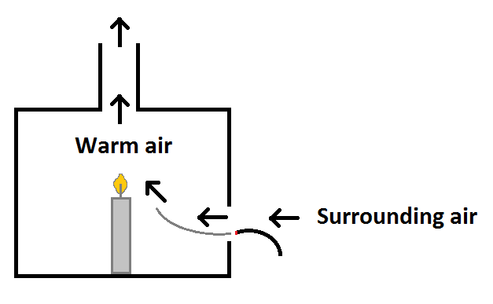

Figure 12. Air in the surroundings move toward the place where warm air is rising.

Let us now relate what happened in the activity to what happens in nature. During the day, the surface of the Earth becomes warm because of the Sun. Some parts of the Earth will warm up more quickly than others. Naturally, the air above the warmer surfaces will also become warm. What happens to the warm air? Just like in the activity, it will rise. How is the air in the surroundings affected? It will move toward the place where warm air is rising. This is the other concept that you need to know: Air moves toward the place where warm air is rising.

Whenever we feel the air moving, that means that somewhere, warm air is rising. And the air around us moves toward the place where warm air is rising. Do you remember that ‘moving air’ is called wind? Every time you feel the wind, it means that air is moving toward the place where warm air is rising. Strictly speaking, wind is air that is moving horizontally.

Let us use now the two concepts you have learned to explain other things. You know that the surface of the Earth is made basically of two things: land and water. When the Sun’s rays strike land and water, do they heat up as fast as each other? Do land and water absorb heat from the Sun in the same way? Or is there a difference? Perform the next activity and find out.

Activity 5
Which warms up faster?

Objectives

After performing this activity, you should be able to

- compare which warms up faster: sand or water
- compare which cools faster: sand or water
- use the results of the activity to explain sea breeze and land breeze

What to use

2 identical plastic containers
2 thermometers
2 iron stands with clamps
string
water
sand

What to do

  - In the shade, set up everything as shown below. The bulbs of the thermometer should be 2 cm below the surface of the water and sand.

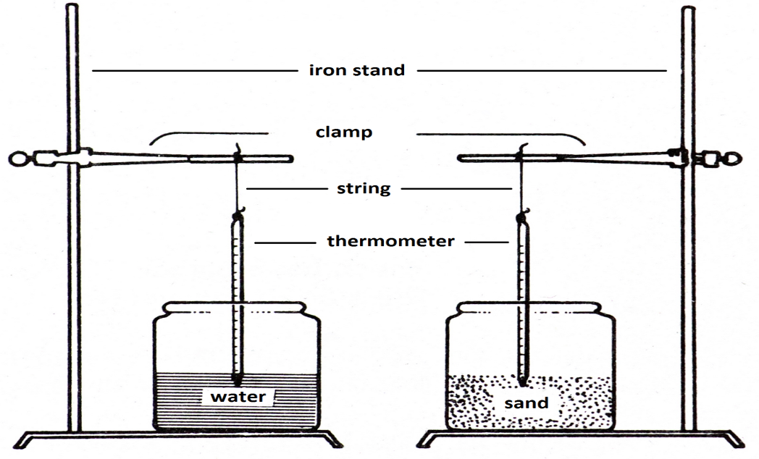

Figure 13. Setup for Activity 5

- Wait for 5 minutes, then read the initial temperature of the water and sand. Record the temperature readings below.

Initial temperature reading for water: __________
Initial temperature reading for sand: __________
- Now, place the setup under the Sun. Read the thermometers again and record the temperature readings in Table 1. Read every 5 minutes for 25 minutes.

Table 1. In the Sun
Observation time (minutes) | Water | Sand
0
5
10
15
20
25

- After 25 minutes, bring the setup back to the shade. Read the thermometers and record the temperature readings in Table 2. Read every 5 minutes for 25 minutes.

Table 2. In the shade
Observation time (minutes) | Water | Sand
0
5
10
15
20
25

- Study the data in the tables and answer the following questions.

Q1. Which has a higher temperature after 25 minutes in the Sun, water or sand?
Q2. After 25 minutes, how many Celsius degrees was the increase in the temperature of the water? Of the sand?

6. Make a line graph using the temperature readings taken while the setup was in the Sun.

Q3. Based on the graph, which became hot faster, water or sand?
Q4. What happened to the temperature of the water and sand when brought to the shade?
Q5. How many Celsius degrees was the decrease in temperature of the water after 25 minutes? Of the sand?

7. Make a line graph using the temperature readings taken when the setup was in the shade.
Q6. Based on the graph, which cooled down faster, water or sand?

Sea Breeze and Land Breeze

The sand and water in the previous activity stand for land and water in real life. From the activity, you have learned that sand heats up faster than water, and that sand cools down faster than water. In the same way, when land surfaces are exposed to the Sun during the day, they heat up faster than bodies of water. At night, when the Sun has set, the land loses heat faster than bodies of water. How does this affect the air in the surroundings?

Imagine that you are standing by the sea, along the shore. During the day, the land heats up faster than the water in the sea. The air above land will then become warm ahead of the air above the sea. You know what happens to warm air: it rises. So the warmer air above the land will rise. The air above the sea will then move in to replace the rising warm air. (See drawing below.) You will then feel this moving air as a light wind—a sea breeze.

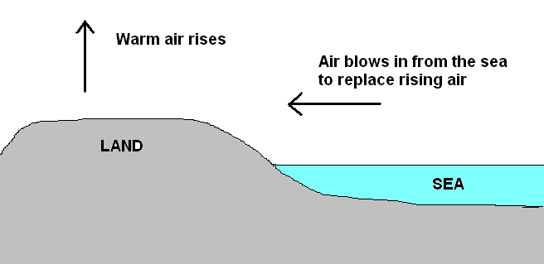

Figure 14. When does sea breeze occur?

What will happen at night, when the Sun is gone? The land and sea will both cool down. But the land will lose heat faster than the water in the sea. In other words, the sea will stay warm longer. This time the air above the sea will be warmer than that above land. The warm air above the sea will then rise. Air from land will move out to replace the rising warm air. (See drawing below.) This moving air or wind from land is called a land breeze.

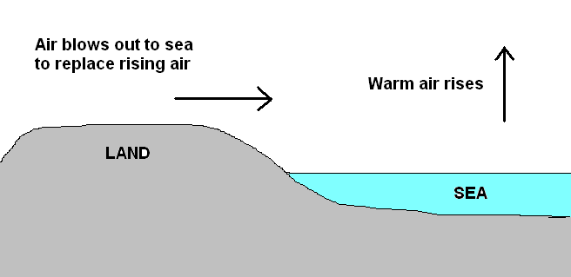

Figure 15. When does land breeze occur?

In the illustration above, you can see an arrow pointing upward. This represents rising warm air. The place where warm air rises is a place where air pressure is low. In other words, the place where warm air is rising is a low-pressure area. In contrast, cold air is dense and tends to sink. The place where cold air is sinking is a high-pressure area. Based on what you learned so far, in what direction does air move, from a low-pressure area to a high-pressure area or the other way around? You probably know the answer already. But the next section will make it clearer for you.
Monsoons

Do you know what monsoons are? Many people think that monsoons are rains. They are not. Monsoons are wind systems. But these winds usually bring abundant rainfall to the country and this is probably the reason why they have been mistaken for rains. In Filipino, the monsoons are called amihan or habagat, depending on where the winds come from. Find out which is which in the following activity.

Activity 6
In what direction do winds blow–from high to low pressure area or vice versa?

Objectives

After performing this activity, you should be able to

- Interpret a map to determine direction of wind movement
- Explain why it is cold around in December to February and warm around July.
- Illustrate why habagat brings lots of rain
- Give examples how the monsoons (amihan and habagat) affect people.

What to use

Figure 16: Pressure and Winds in January
Figure 17: Pressure and Winds in July
pencil

What to do

Part I.

Study Figure 16. It shows the air pressure and direction of winds in different parts of the world in January. Low-pressure areas are marked by L and high-pressure areas are marked by H. Broken lines with arrowheads show the direction of the wind.

Q1. Choose a low-pressure area and study the direction of the winds around it. Do the winds move toward the low-pressure area or away from it?

Q2. Choose a high-pressure area and study the direction of the winds around it. Do the winds move toward the high-pressure area or away from it?

Q3. In what direction do winds blow? Do winds blow from high-pressure areas to low-pressure areas? Or, from low-pressure areas to high-pressure areas?
Q4. Where is North in the map? South? West? East? Write the directions on the map.

Q5. Where is the Philippines on the map? Encircle it.
Q6. Study the wind direction near the Philippine area. From what direction does the wind blow near the Philippines in January?

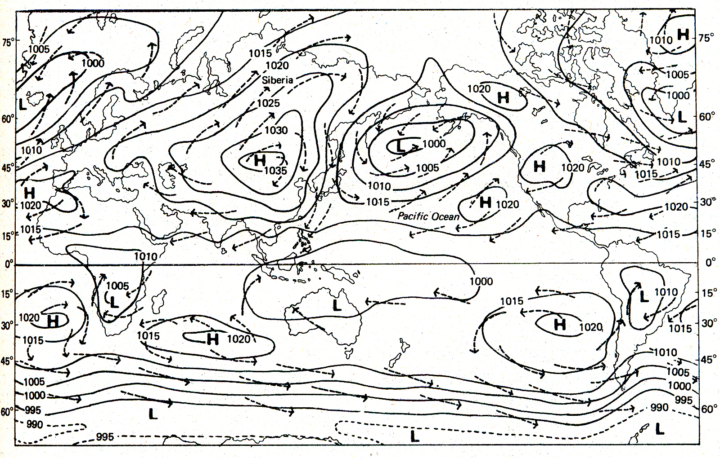
Figure 16. Pressure and Winds in January

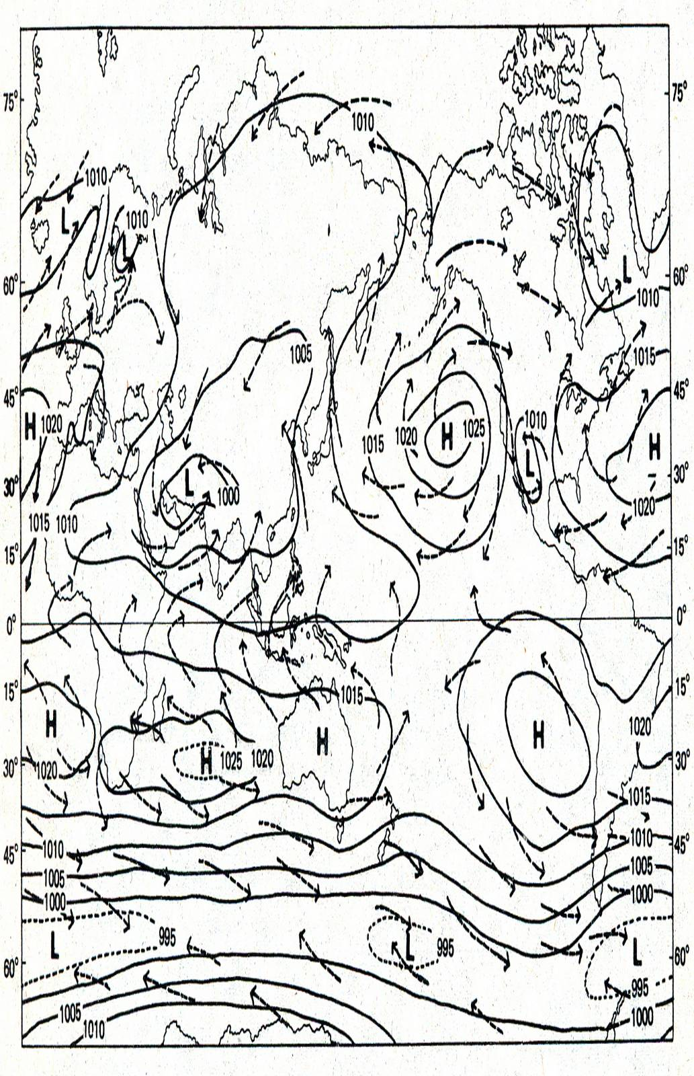
Figure 17. Pressure and Winds in July
Part II.
Study Figure 18. It shows the air pressure and direction of winds in different parts of the world in July.

Q7. Study the wind direction near the Philippine area. From what direction does the wind blow in the vicinity of the Philippines in July?

Figure 16 shows what happens during the colder months. The wind blows from the high-pressure area in the Asian continent toward the low-pressure area south of the Philippines. The cold air that we experience from December to February is part of this wind system. This monsoon wind is locally known as amihan. As you can see from Figure 16, the wind passes over some bodies of water before it reaches the Philippines. The wind picks up moisture along the way and brings rain to the eastern part of the Philippines.

Now, what happens during the warmer months? Study Figure 17 carefully. What do you observe about the low-pressure area and high-pressure area near the Philippines? They have changed places. (You will learn why in the next module.) As a result, the direction of the wind also changes. This time the wind will move from the high-pressure area in Australia to the low-pressure area in the Asian continent. This monsoon wind is locally called habagat. Trace the path of the habagat before it reaches the Philippines. Can you explain why the habagat brings so much rain? Which part of the Philippines does the habagat affect the most?

The monsoons, habagat and amihan, affect people in different ways. Try to explain the following. Why do farmers welcome the monsoons? Why are fisherfolk not so happy about the monsoons? Why do energy providers appreciate the monsoons? Why are fishpen owners worried about the monsoons? How do the monsoons affect your own town?

In the next section, you will apply the two concepts once more to explain another weather event.

The Intertropical Convergence Zone (ITCZ)

Many people who listen to weather forecasts are confused about the intertropical convergence zone. But it is easy to understand it once you know that warm air rises, and air moves toward the place where warm air is rising. Take a look at the drawing below.

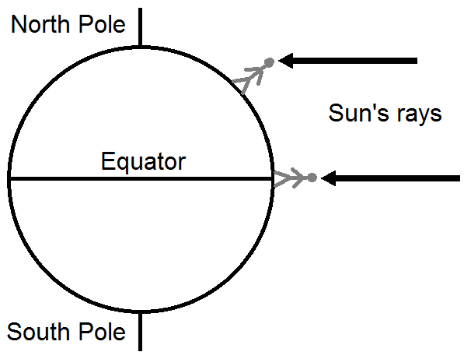

Figure 18. Sun’s rays at the equator and
at a higher latitude
Figure 18 shows the rays of the Sun at two different places at noon. Study the drawing carefully. Where would you observe the Sun directly above you? When you are at the equator? Or when you are at a higher latitude?

As you can see, the position of the Sun at midday depends on where you are. At the equator, the Sun will be directly overhead and the rays of the Sun will hit the ground directly. At a higher latitude, the Sun will be lower in the sky and the Sun’s rays will strike the ground at a lower angle. Where do you think will it be warmer?

It is clear that it is warmer at the equator than anywhere else. Because of that, the air over the equator will be warmer than the air over other parts of the Earth. And you already know what happens to warm air. It rises. And when warm air rises, air in the surroundings will then move as a result.

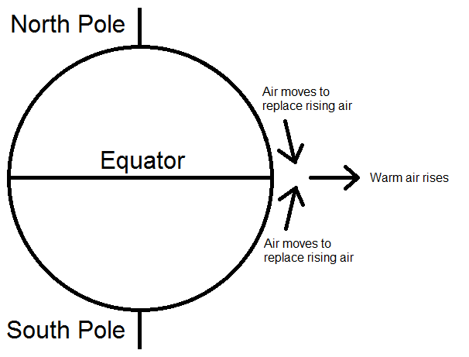

Figure 19. How does the air move at the equator?

As you can see from Figure 19, air from north of the equator and air from south of the equator will move toward the place where warm air is rising. Thus, the intertropical convergence zone is the place where winds in the tropics meet or converge. (Recall that the area near the equator is called the tropics.) In time the rising warm air will form clouds, which may lead to thunderstorms. Now you know why weather forecasters often blame the ITCZ for some heavy afternoon rains. The band of white clouds in the following picture shows the location of the ITCZ.

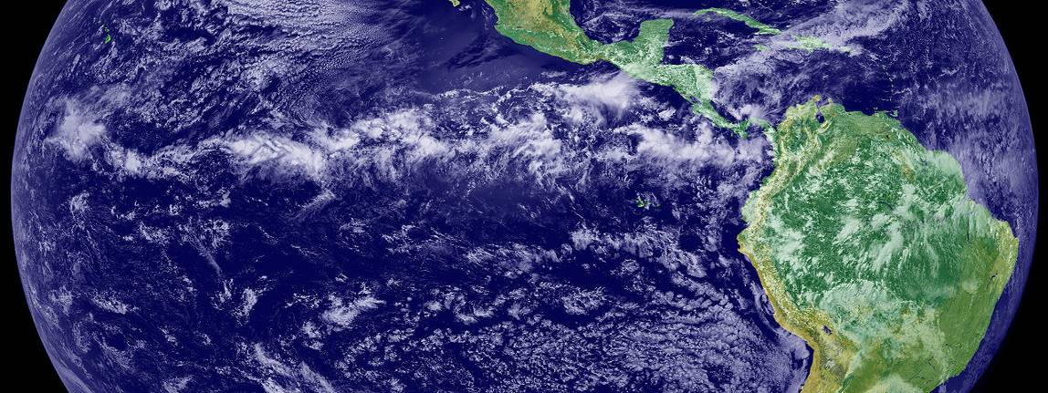

Figure 20. Satellite photo showing the location of ITCZ
Summary

This module discussed global atmospheric phenomena like the greenhouse effect and global warming (including ozone depletion) that affect people, plants, animals and the physical environment around the world. And though the greenhouse effect is a natural phenomenon, there is a growing concern that human activities have emitted substances into the atmosphere that are causing changes in weather patterns at the local level.

Highlighted in this module are concepts used to explain common atmospheric phenomena: why the wind blows, why monsoons occur, and what is the so-called inter tropical convergence zone.

It is important for everyone to understand the varied atmospheric phenomena so that we can all prepare for whatever changes that occur in the environment and cope with these changes.

There are still many things to learn about the atmosphere, specifically on weather and climate. You have just been provided with the basic concepts. You will learn more as you move to Grade 8 and onwards.

