FOOD, FISH AND VEGGIES
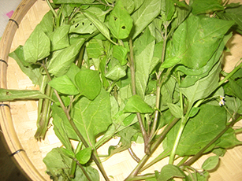
Vegetables:
Al’lom- a vegetable that is commonly grown in Mandaya farms. It is dark green in color with a dark-shaded stalk. It tastes a little bitter, but not as bitter as the bitter gourd.
: dark-green, indigenous vegetable; wild and endemic; Mandaya, farms, hinterlands, ancestral domain

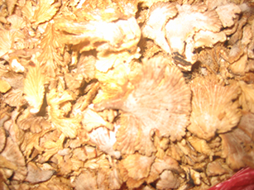
Kul’lopan - The lowlanders call this kujaje. This fungus grows anywhere where trees are felled, and rampant after rain. It is small, brown in color. When eaten, it is pounded and mixed with indigenous spices and cooked with a little water for 1-3 minutes. The fungus and spices combined produces a flavorful and sweet-smelling food. It is said to be good for lactating mothers and people doing farm work because it sustains energy.
: food, mushroom, felled trees, endemic, energy, lactating mother, Mandaya, IP community
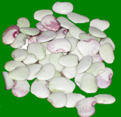
Laysan - the lowlanders call this patani. It is a green, vine plant, spear-shaped, and with seeds that vary in color, flat and indented on top. Sometimes the seeds are white, magenta or a combination of maroon and shades of violet in color. It is considered a seed vegetable or bean variety in Mandaya community. This is also common in other Indigenous communities in Mindanao.
: bean, spear-shaped, vegetable, vine, patani, indigenous, Mandaya community
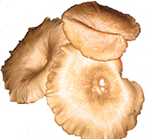
Tinibo - a mushroom variety that grows on felled and standing tree bark. It is light brown to white in color and about 1-3 inches in width. Best when cooked alone as soup with indigenous spices. It can however be cooked with other vegetables and mushroom varieties.
: mushroom, tree bark, soup, indigenous, Mandaya

Food:
Dangay - Is a pancake like food made from natuk a whitish flour, which is the product of pounding of the inner part of the Lumbiya palm. Dangay is made by mixing this flour with coconut milk and honey and serves as one staple carbohydrate food for many indigenous people in Mindanao when there is scarcity of rice.
: flour, food, palm, coconut milk, pancake; pasty, indigenous menu, Mandaya

River shell and fish
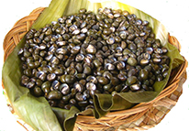
Kuyog - is small a small, shiny black-brown colored river shellfish. It is endemic to the Davao Oriental region, found only in the rivers in the municipalities of CARAGA region, Manay provinces and the headwaters of the Cateel river. It has not been found elsewhere in the Philippines. It is cooked with only a little water and salt. This is very special to the Mandaya people in these municipalities. It is a dish that every household would love to prepare for visitors.
: river, fish, CARAGA region, Mandaya, freshwater, water, river, ancestral domain
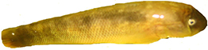
Sal’lognon (also pronounced as sawgnon) - a dark-brown chest- flatted fish from rivers and creeks in CARAGA, Davao Oriental, Casal’lman (Casawman) river in Manay, Davao Oriental, and in the headwaters of Cateel river, also in Davao Oriental. This is 4-6 inches in length and an inch or two in diameter.
: river, CARAGA, Mandaya, Manay, Cateel, creeks, ancestral domain

