Ang Kanding ni Pedro
STAPLE HERE
STAPLE HERE
STAPLE HERE
BIND TAPE UNTIL HERE
BIND TAPE UNTIL HERE
BIND TAPE UNTIL HERE

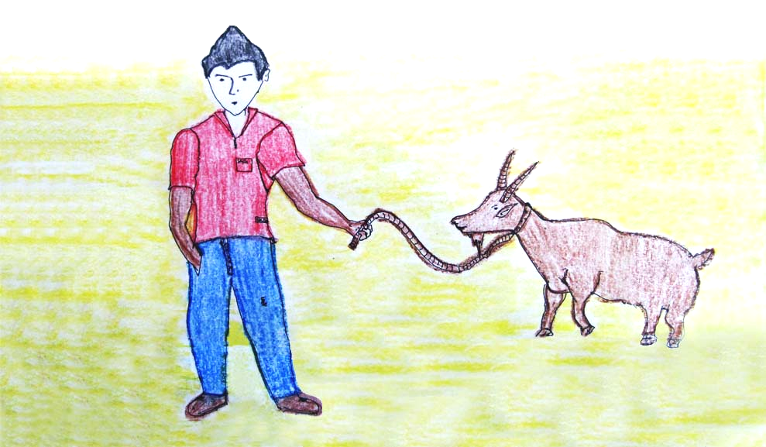

GISULAT NILA:
MARIA TERESA C. LIM
KLAIRE M. MENGUEZ
MARY JEAN R. CONIENDO

GIHULAGWAY NI:
JEROME FABURADA
GIHUBAD NI:
ANJEANETTE A. CALUMPITA

CEBUANO
STAGE 1

ANG KANDING NI PEDRO
GISULAT NILA:
MARIA TERESA C. LIM
KLAIRE M. MENGUEZ
MARY JEAN R. CONIENDO

GIHULAGWAY NI:
JEROME FABURADA

GIHUBAD NI:
ANJEANETTE A. CALUMPITA
CEBUANO
STAGE 1


Published by the
LEARNING RESOURCES MANAGEMENT AND DEVELOPMENT SYSTEM (LRMDS)
Department of Education
Region VI, Western Visayas
Iloilo City
Copyright 2011
Section 9 of Presidential Decree No. 49 provides:

“No copyright shall subsist in any work of the Government of the Republic of the Philippines. However, prior approval of the government agency of office wherein the work is created shall be necessary for exploitation of such work for profit.”

This material has been developed within the Project in the Mother Tongue-Based Multilingual Education (MTB-MLE) implemented by Curriculum and Learning Management Division (CLMD) of the Department of Education Region VI (DepED RO6). It can be reproduced for educational purposes and the source must be clearly acknowledged. The material may be modified for the purpose of translation into another language but the original work must be acknowledged. Derivatives of the work including creating an edited version, an enhancement or a supplementary work are permitted provided all original work is acknowledged and the copyright is attributed. No work may be derived from this material for commercial purposes and profit.
This first digital edition has been produced for print and online distribution within the Department of Education, Philippines via the Learning Resources Management Development Systems (LRMDS) Portal by Region VI.
Gisulat nila:
MARIA TERESA C. LIM
KLAIRE M. MENGUEZ
MARY JEAN R. CONIENDO

Gihulagway ni:
JEROME FABURADA
Gihubad ni
ANJEANETTE A. CALUMPITA
http://lrmds.deped.gov.ph
Para sa Bata nga Mubasa:

Gihimo ning libroha para sa imo.

Nahinungod ni sa mga butang nga makit-an sa imong palibot ug mga bata sama kanimo.

Mahamuot ka unta ini. Malipayon nga pagbasa!

Ang mga Tag-sulat
iii
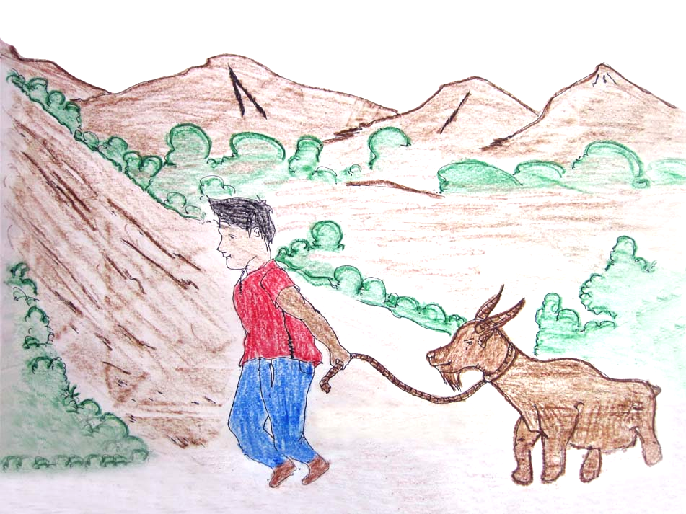
1
May usa ka bata nga ginganlag Pedro ug buntag sayo gamata siya aron manugway.
2
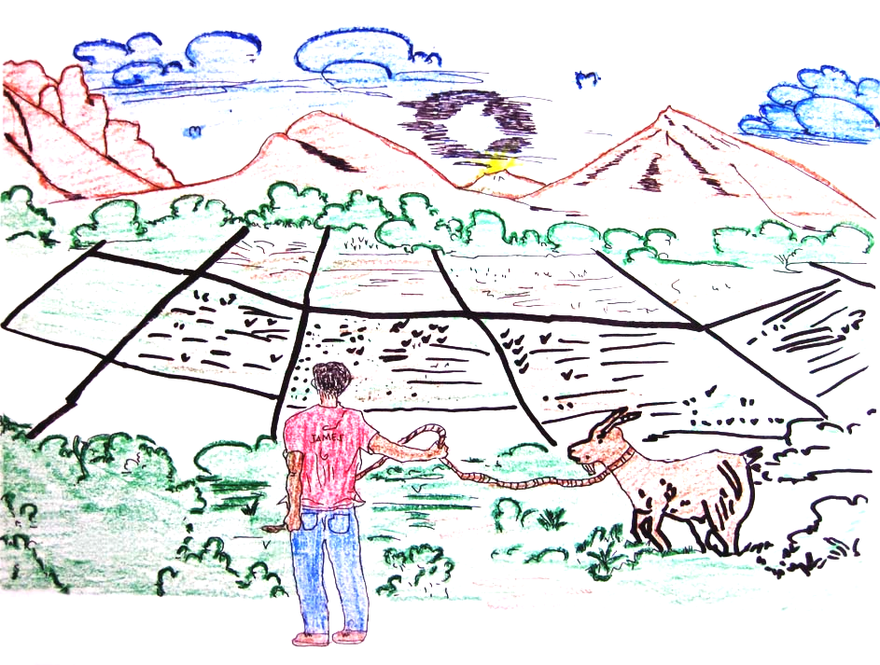
3
Gidaa niya kini sa kasagbotan aron makakaon ug labas nga sagbot.
4
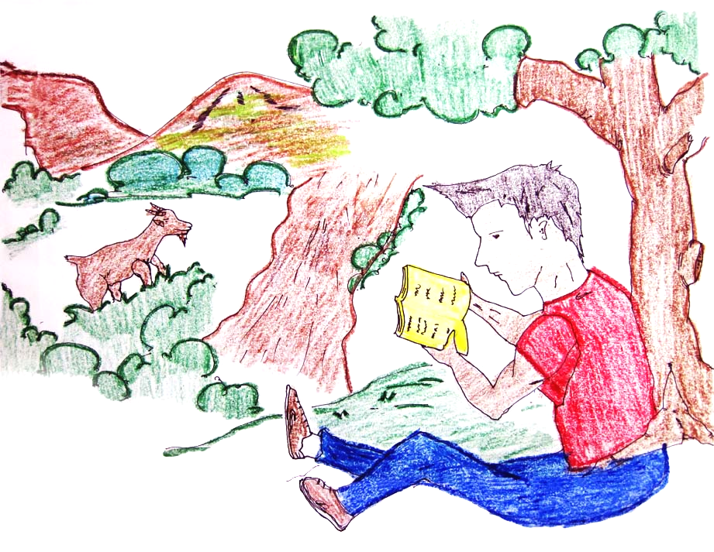
5
Samtang gabantay siya gabasa sab siyag libro ug gatuon sa iyang leksiyon.
6
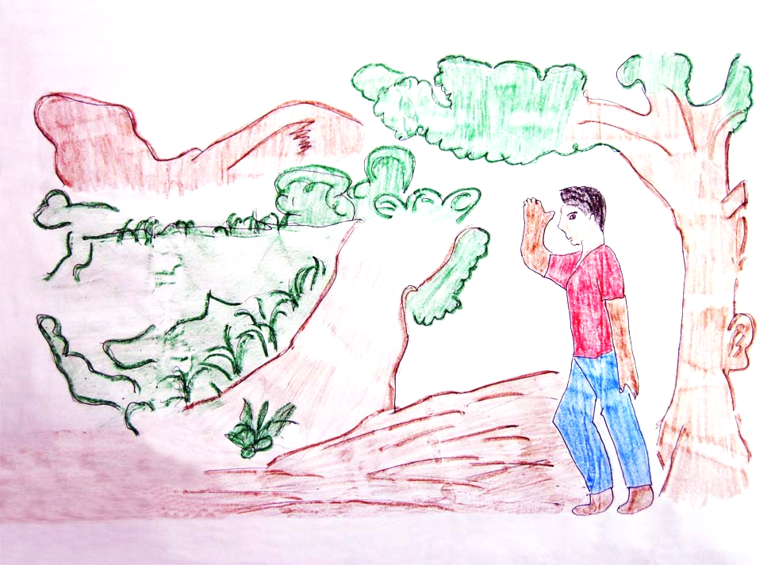
7

Taud-taud iyang nasayran nga wa na ang kanding.
8
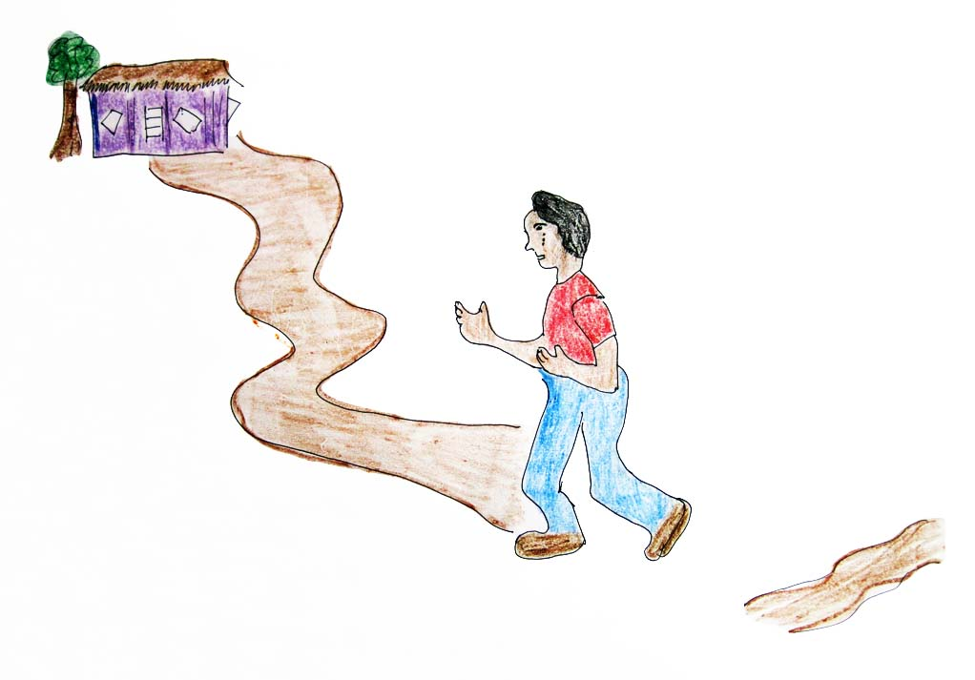
9

Nagdagan nga naghilak siya pauli sa ilang balay.
10
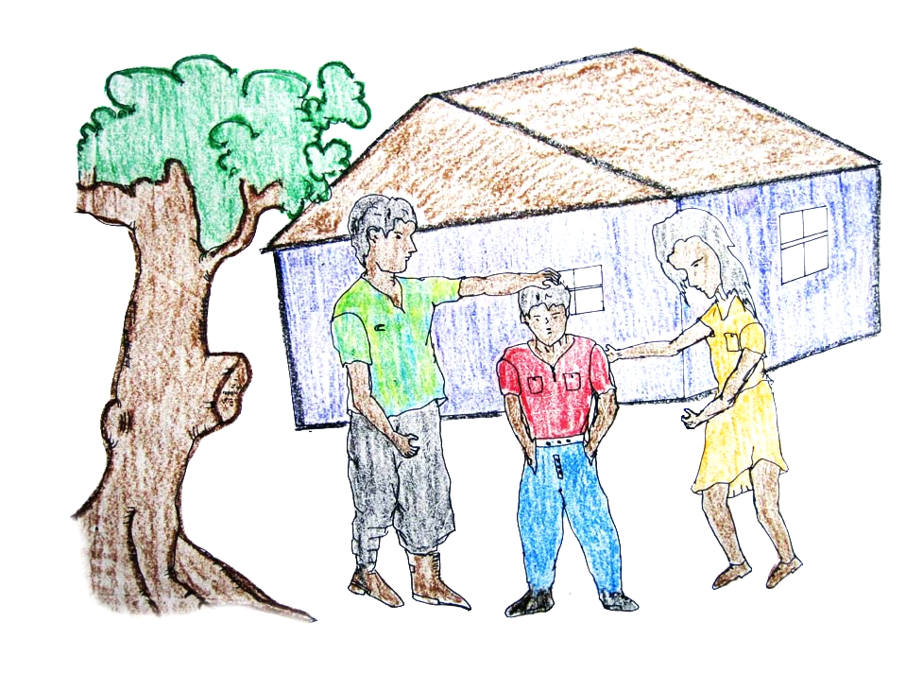
11

Gipahibao niya ang natabo sa iyang ginikanan.
12
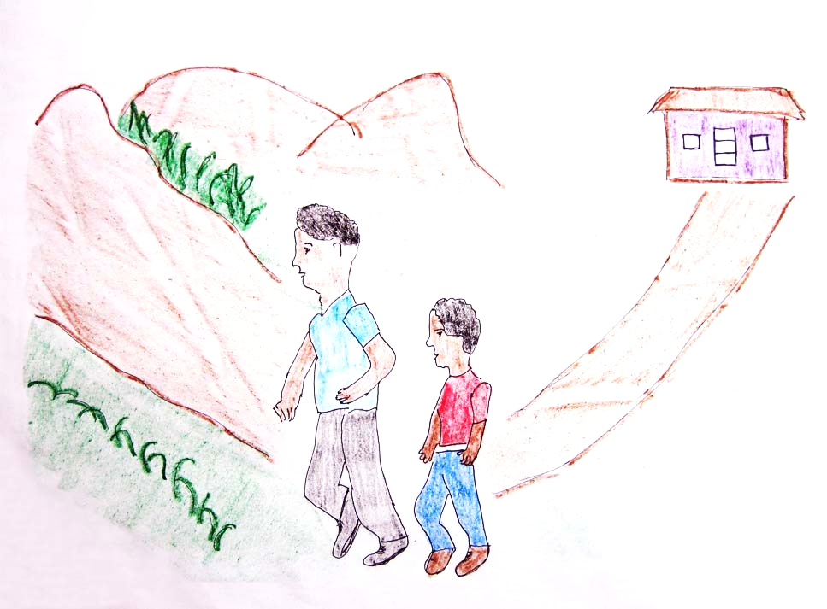
13

Kuyog sa iyang amahan, mibalik sila sa bukid aron sa pagpangita sa kanding.
14
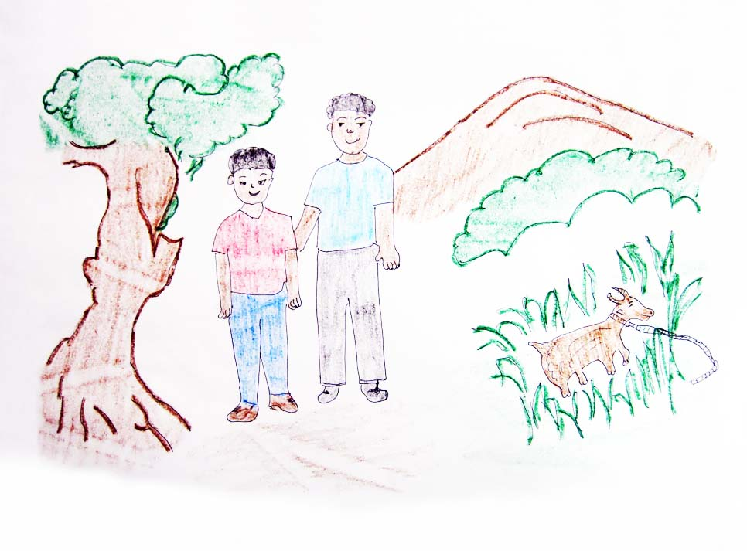
15
Ug nalipay sila nga nakita nila ang kanding.
16
The Goat of Pedro
- There was a child named Pedro, and he woke up early in the morning to tend his goat.
- He brought this to the greenfields so it can eat fresh grass.
- While watching his goat, he was reading book and studying his lessons.
- Meanwhile, he noticed that the goat was missing.
- He cried while running home.
- He told his parents about what happened.
- Together with his father, they went to the greenfields to look for the goat.
- At last, they were happy to see the goat again.
17

