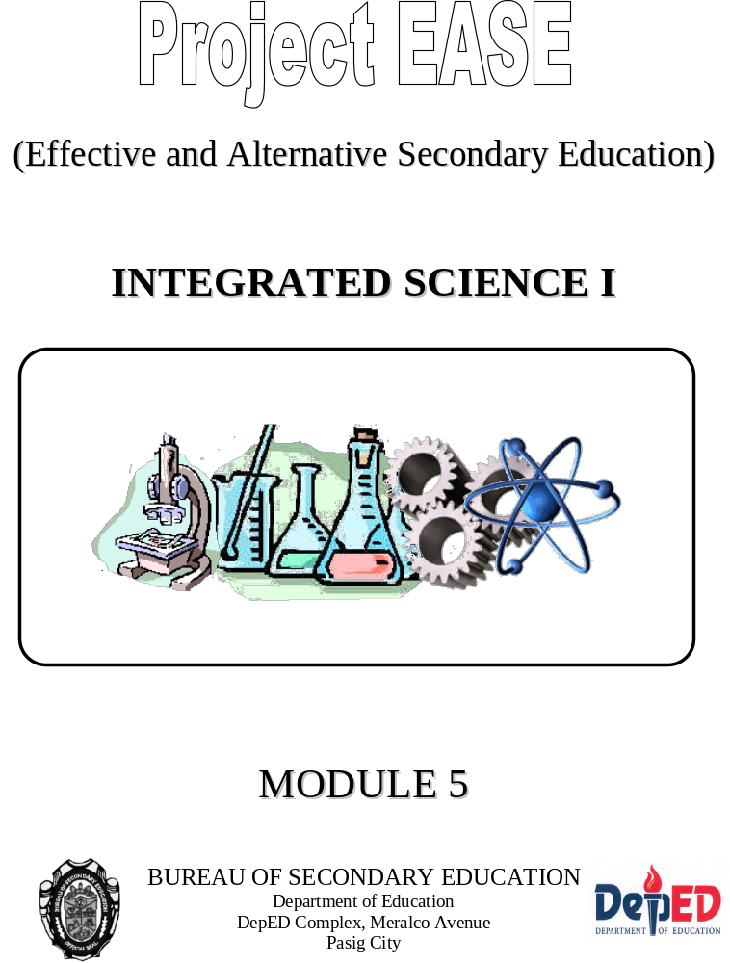

Module 5

Matter Around Me


What this module is about

Have you been to the sari-sari store lately? Did you notice the different items that you can buy from the store? Can you name some of them? Yes, there are candies, canned goods, softdrinks, wine, eggs, tissue paper, toothbrush, diapers, toothpaste, shampoo and many more. In science, we call all these items as MATTER.

Do you know that there are a lot of things that you can learn about matter? In fact, this module is designed to help you in defining matter and in classifying different kinds of matter. It also aims to guide you in determining the changes that matter undergoes and in identifying its characteristics. So, don’t miss this rare opportunity – read and have fun in learning the following lessons:

  - Lesson 1 - What is Matter
  - Lesson 2 - Classifying Matter According to its Phases
  - Lesson 3 - Substances and Mixtures
  - Lesson 4 - Changes Around Us


What you are expected to learn

After going through this module, you should be able to:

- define matter;
- cite examples of matter;
- classify matter as solid, liquid or gas based on its observable characteristics;
- differentiate substance from mixture and give examples of each;
- classify substances as element or compound;
- differentiate between metal and non-metal based on their observable properties;
- describe physical and chemical changes;
- identify evidences of chemical change;
- give examples of physical and chemical changes in daily life; and
- infer that energy is involved in physical and chemical changes.

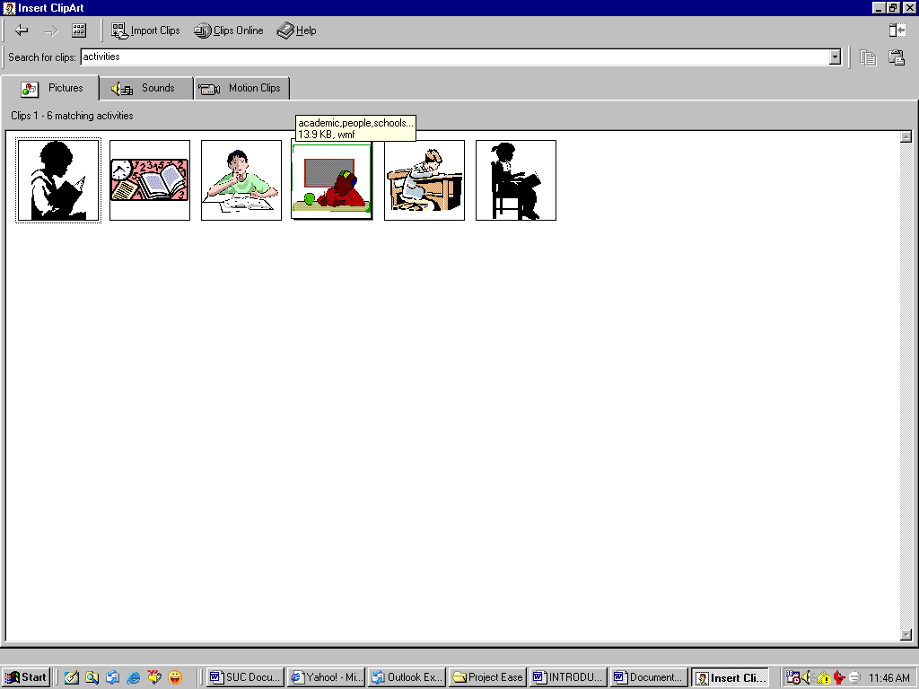
How to learn from this module

I know that you are already excited to get started, however, there are some tips that you have to remember

- Take the pre-test before proceeding to the lessons. The test could give you an idea of how much time should you allot to each lesson.
- Read the instructions carefully and follow the precautionary measures.
- Before doing the activity, make sure that all the materials needed are already prepared.
- Perform the simple activities before reading the discussions.
- Don’t forget to answer the Self-Tests. Compare your answers with the keys to correction.
- If you are not sure of the meaning of some words used in this module, feel free to consult the dictionary.
- Answer the post-test so that you will know how much you have learned from the lessons.

Happy Reading!


What to do before (Pretest)

Choose the best answer and write the letter of your choice on the space provided before each number.

_____1. Which of the following is an example of matter?
- fire C. heat
- sound D. energy

_____2. Of the phases of matter, which has the strongest attractive forces?
- solid
- liquid
- gas
- all of the above

_____3. Galvanized iron, which is commonly used for roofing, is made up mostly of iron metal. Which of the characteristics of metal makes it an appropriate roofing material?
- It is shiny.
- It has high density.
- It can be hammered into sheets.
- It can be drawn into fine wire.

_____4. Seawater is a mixture. Which of the following best describes the components of seawater?
- They are chemically combined.
- They have no definite proportion.
- They combine in a fixed ratio by mass.
- They cannot be separated by physical means.

_____5. Gold is to element while _____ is to compound.
- ethanol C. aluminum
- rubbing alcohol D. muriatic acid

_____6. Which does not belong to the group?
- table salt
- mayonnaise
- salt solution
- halu-halo

_____7. Using the table below, which materials do you expect to sink in water?

Material | Density (g/mL)
Aluminum | 2.7
Concrete | 2.3
Cork | 0.24
Gasoline | 0.68
Ice | 0.92
Iron | 7.8
Mercury | 13.6

- concrete, cork, ice
- iron, ice, aluminum
- gasoline, cork, ice
- concrete, mercury, aluminum

_____8. Which is a chemical change?
- boiling water
- souring of milk
- chopping of wood
- melting of ice cream

_____9. Rusting of iron is a chemical change. All phase changes are physical changes.
  - Both statements are true.
  - Both statements are false.
  - The first statement is true while the second is false.
D. The second statement is true while the first is false.

_____10. Jeff placed some mothballs inside the cabinet. After some days, the mothballs disappeared. What happened to the mothballs?
A. It sublimed.
- It evaporated.
- It reacted with air inside the cabinet.
- It was dissolved by water present in air.



Key to answers on page 26

If your score is

9-10 Very Good! You may still read the module but you are already knowledgeable with the topics that we are to discuss.

7-8 Good! Go over the items that you find difficult and then you may proceed to the lessons in this module that you don’t understand.

0-5 Don’t worry about your score. This module is designed for you to understand all about matter. So, what are you waiting for? Start your journey. Turn to the next page.

Lesson 1 What is Matter?

Look around you. What are the things that you see? Below are some items that could be in your surroundings at the moment. I want you to go over the list and encircle the items that are around you.

THINGS AROUND ME

Flower notebook shoes glass

Paper pencil/ballpen plate

Spoon/fork table chair

Window door dog

What do you think are common to all the items in the list? To help you answer this question, think about these….

.

Is the paper heavy or light? What about the plate, is it heavy or light? Is the table heavy or light?….





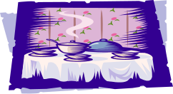

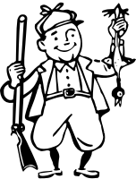

You are right! The table is the heaviest of the three objects while the paper seemed to be the lightest. On the other hand, the plate may not be as heavy as the table but it is not as light as the paper. What does these indicate? It means that objects or things around us may be light or heavy which could simply mean that these things have mass.

Now, using your paper and pencil, trace the paper. Trace also the notebook and the plate. Take a closer look at the drawings.

What have you noticed? Does each one occupy space? You are right! Objects occupy space. In science, space occupied is referred to as volume.

Can you trace the table? Perhaps not. It would be difficult to trace the table because it is too big. How are we going to show then that the table also occupies space?

Why don’t you do this?

Go to where the table is. Can you stand on the space where the table is located?

Of course not. Why? You simply cannot take the position of the table because the table occupies space and so are you. It would be just like sitting on a chair where another person is seated.

Materials that occupy space and have mass are regarded as MATTER. The flower, plate, notebook and all the other objects/things in the “THINGS AROUND ME” are examples of matter. Can you cite other examples of matter?

Did you know that?

Matter is anything that occupies space and has mass

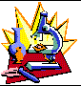
What you will do
Self-Test 1.1

Since you are now familiar with what matter is, list at least 15 other examples of matter.

Examples of Matter

1. 11.
2. 12.
3. 13.
4. 14.
5. 15.
6.
7.
8.
9.
10.

Key to answers on page 26

Lesson 2 Classifying Matter According to Its Phases

As what we have learned in Lesson 1, matter is anything that has mass and occupies space. From this description, we could say that all the stuff in the universe are considered as examples of matter. As such, dealing with matter would mean dealing with enormous materials.

Due to the wide variety of examples of matter, scientists recognized the need to classify them. How is matter classified? To give you an idea on how samples of matter are grouped together, why don’t you do Activity 2.1?

What you will do
Activity 2.1

If you were working in a supermarket, which of the following items would you place in the same shelf?

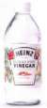
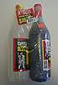

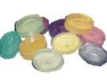
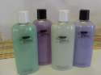
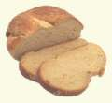
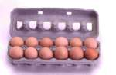
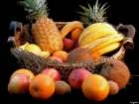
Pictures of soap, shampoo, conditioner, soy sauce,
vinegar, bread, milk, eggs, oranges, grapes, apples…

How did you group the materials? Check if your groupings are the same as mine.

Shelf 1  (Fruits) | Shelf 2  (Food) | Shelf 3  (Seasoning) | Shelf 4  (Personal Hygiene)
Oranges, apples and grapes | Bread, milk and eggs | Vinegar and soy sauce | shampoo, conditioner and soap

What is your basis in grouping the given materials? Materials with the same characteristics should be grouped together. In the same way, the numerous samples of matter are classified based on properties similar to them.

Solid, Liquid and Gas

Matter can be classified according to its phases namely: solid, liquid and gas. A chair and a plate are solids while water and soy sauce are liquids. On the other hand, air inside the balloon is an example of gas.

Let us analyze the properties of each phase of matter.

You are right! They have definite shape.

Now, observe carefully the water and soy sauce. Get two containers. Then, pour water in one container and soy sauce in the other.

Then, pour water in one container and soy sauce in the other.

What did you notice? Water and soy sauce take the shapes of their containers. Thus, we can say that the shape of the liquid is dependent on the shape of the container.
Did you ever ask yourself why balloons have different shapes? Some are elongated; others are spherical or even heart-shaped.

.

This is so because gases also assume the shape of the container.

Thus, we could say that solids have definite shape while liquids and gases have no definite shape since they just take the shape of their containers. The table below further differentiates the three phases of matter in terms of their other characteristics.

 | SOLID | LIQUID | GAS
Volume | Definite | Definite | Indefinite
Arrangement of Particles | Closely-packed | Far apart | Widely separated
Motion of particles | Slow | Moderate | Fast
Attractive forces | Very strong | Strong | Weak
Compressibility | Very Difficult | Difficult | Easily
Density | High | High | Low

To further help you imagine how the particles of the different phases are arranged, let us do Activity 2.2.

What you will do
Activity 2.2

Materials Needed: corn kernels, match box

What to do:
1. Fill the match box with corn kernels. Shake the box.

Describe the movement of the kernels in the box.
_______________________________________________________________________________________________________________________________________________________________________________________

Of the phases of matter, which arrangement of particles does it resemble?
_____________________________________________________________

2. Empty the box. Then put 20 corn kernels in it. Shake the box.

Describe the movement of the kernels in the box.
_______________________________________________________________________________________________________________________________________________________________________________________

Of the phases of matter, which arrangement of particles does it resemble?
_____________________________________________________________

3. This time, just place 3 corn kernels in the box and then shake.

Describe the movement of the kernels in the box.
_______________________________________________________________________________________________________________________________________________________________________________________

Of the phases of matter, which arrangement of particles does it resemble?
_____________________________________________________________

Key to answers on page 26

What conclusion can you make from the results of Activity 2.2. Right! The characteristics of the phases of matter can be explained by the arrangement of their particles.

What you will do
Self-Test 2.2

  - Classify the following as solid, liquid or gas.
    - stone
    - oxygen
    - tree
    - mayonnaise
    - mango juice

  - How will you explain the differences in the motion of particles of the phases of matter?

  - Can you describe why solids and liquids have high densities while gases have low densities?

Key to answers on page 26

Lesson 3 Substances and Mixtures

In Lesson 2, we have classified matter according to its phases: solid, liquid and gas. But then there are other ways of grouping matter together. The diagram below shows how matter is classified according to its composition.

Matter
can be
classified into

Substances Mixtures

Elements Compound Homogeneous Heterogeneous

Based on the diagram, matter can be classified into substances and mixtures. Water, salt, sugar and iron nail are some examples of substances. Whereas, sugar solution, salt solution, halu-halo and mayonnaise are examples of mixtures. Using these examples, how can we differentiate substances from mixtures? To help you answer this question, let us proceed to Activity 3.1.

What you will do
Activity 3.1

Reminder: Please read the procedure carefully before starting with the activity. Don’t forget to answer the guide questions.

Materials Needed: water, table salt, two glasses, spoon and casserole

What to do:
1. Pour water into the glasses.
2. Label the glasses as glass A and glass B.
3. Put a pinch of salt in glass A and then stir.
4. Put one tablespoon of salt in glass B.

Compare the appearance of glass A and glass B. Are their appearance the same?
________________________________________________________________________________________________________________________________________________________________________________________________________________________________________________________________________________

5. Pour the contents of glass A into the casserole and then heat. Continue heating until the mixture dries up. Observe.

Can you describe the substance that is left on the casserole?
________________________________________________________________________________________________________________________________________________________________________________________________________________________________________________________________________________

If you are going to heat the contents of glass B, will you be able to recover the same substance that you have recovered from glass A? Can you name the substance? ________________________________________________________________________________________________________________________________________________________________________________________________________________________________________________________________________________

6. Clean the casserole, then put a little amount of water in it. Heat the water. Observe.

Guide Question: What do you think is happening to water while you are heating it?
________________________________________________________________________________________________________________________________________________________________________________________________________________________________________________________________________________

Caution: Be careful when heating substances. Do not heat substances not included in the procedure. Do not leave the casserole while it is being heated.

Let us discuss what you have discovered in Activity 3.1. Upon mixing salt and water through stirring, can you still see the particles of salt? If not anymore, why not? The salt dissolves in water. Therefore, the water that is originally in the glass is no longer pure water but is already a physical combination of salt and water, which is called salt solution.

Characteristics of Mixtures

Is the mixture in glass B also a salt solution? Yes, it is a salt solution as well. Notice that even if glass B contains more salt than glass A, the appearance of both mixtures is the same. What does this mean? It means that the components (in this case, salt and water) of mixture can be present in any amount or in any proportion.

Let us now move on to the other parts of the activity. What happens to the salt solution as it is being heated? After sometime, the mixture starts to dry up. Eventually, the liquid component of the mixture disappears and what is left in the casserole is a powdery white substance.

Can you name the white substance that is left in the casserole? Your guess is as good as mine. Yes, it is the table salt. So, what did you manage to do with the salt solution when you exposed it to heat? You have actually separated the components of salt solution. The liquid component, which is water, undergoes the process of evaporation. What is evaporation? It is a change in the phase of matter from liquid to gas. Such change in phase can only happen if energy (just like heat!) is involved.

From the discussion, what are the important characteristics of mixture that you have learned?
First, mixture is a physical combination of two or more pure substances (Recall that salt and water are examples of pure substances).

Second, the components of mixture can combine in any amount or proportion.

Third, since a mixture is just a physical combination of two or more substances then it follows that it can as well be separated by ordinary physical processes e.g. evaporation.

.

Fourth, the properties of the components of mixture are retained in the mixture. To explain this further, why is the color of salt solution colorless? It is because the water is colorless. Why is it that the salt solution is salty? It is because of the salt. Thus, this would mean that the characteristics of the components of the mixture are retained in the mixture.

Read More About…..

Do you know that a more suitable physical process is being used in separating the components of salt solution? To find out more about the physical processes being used in separating components of mixtures, check out your school library. Read, learn and have fun!

Substances: Element or Compound?
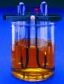
How are substances different from mixtures? Unlike mixtures, substances cannot be separated by ordinary physical means. For instance, the components of water cannot be separated by just heating it. Recall, what happened to water when you heated it. The water evaporated. When water evaporates, its phase changes but the composition is still the same.

How can we separate the components of salt and water? Since the components of salt and water are combined chemically, these can be separated by electrolysis, which is a chemical process. Salt is composed of sodium and chlorine while water is made up of hydrogen and oxygen. Sodium, chlorine, hydrogen and oxygen are elements.
Fig. 3.1 Electrolysis Set-up

What are elements? Elements are pure substances. Go back to Figure 1 showing how matter is classified according to composition. Notice that pure substances can be grouped further into elements and compounds. Salt and water are compounds. On the other hand, the components of compounds are elements. Compound, unlike mixture, is a chemical combination of two or more elements thus they cannot be separated by ordinary physical processes.

What about elements? Can elements be broken down into simpler substances? I am so sorry to disappoint you but elements cannot be separated by physical or even by chemical processes. Why? Because element is the simplest form of matter!

Below is the periodic table of elements. As you can see the elements are arranged according to increasing atomic number. To date, there are already 116 elements. Seventy-five percent of the elements are metals while the rest are nonmetals and metalloids.
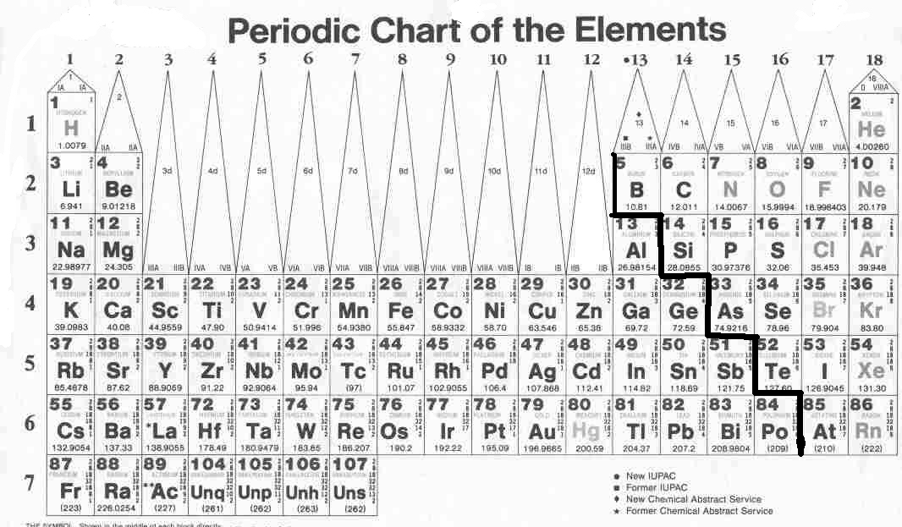

Take a closer look at the periodic table. Can you see the lines that look like a ladder? Good! Now, remember that elements to the right of the ladder are nonmetals while those to the left of the ladder are metals. Those elements that are in the ladder are identified as metalloids. Metalloids have the characteristics of both metals and nonmetals.
Fig. 3.2 Periodic Table of Elements

What are the characteristics of metals that can be used to differentiate them from nonmetals? Iron nail is a metal while activated carbon (charcoal) is a nonmetal. Obviously of the two, iron will be a better conductor of electricity than charcoal. Whereas, charcoal is brittle which is in contrast to the hardness of metals.
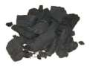
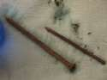

Fig. 3.3 Charcoal and Iron Nail

Now, examine your incandescent lamp. What can you see at the center of the bulb? There is what we call a filament. Do you know that the filament is a metal? Notice that the filament is a very thin wire. Why is this so? Because metals are ductile. Ductility is the ability of metals to be drawn into wire. Aside from that, metals are malleable. Malleability is the ability to be hammered into sheets without breaking.

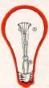

Fig. 3.4 An incandescent bulb

Generally, metals are in the solid phase (with the exception of Mercury, which is the only metal in the liquid phase) thus we could expect metals to have high densities. It should be remembered though that different substances have different densities. And that density can be used as one of the bases in determining a certain substance since this property is inherent in the substance. Below are the densities of some common metals.

Element | Density (g/mL)
Aluminum | 2.7
Iron | 7.8
Mercury | 13.6

Notice that the densities of the metals are higher than 1.00 g/mL, which is the density of water at standard conditions. Will you expect the metals to float or sink in water? You are right! The metals (those listed above) will sink in water!

What you will do
Self-Test 3.1

    - Classify the following as a pure substance or a mixture.
      - ice
      - pineapple juice
      - vinegar
      - soft drinks
      - wine

    - Classify the element as a metal, nonmetal or a metalloid.
      - Calcium (Ca)
      - Argon (Ar)
      - Silicon (Si)
      - Lithium (Li)
      - Sulfur (S)
Note: Letters in the parentheses are symbols of the elements.

    - Differentiate between substance and mixture.

    - Cite the characteristics of metals and nonmetals.

Key to answers on page 27

Lesson 4 Changes Around Us

Many changes are happening around us. These changes may either be physical or chemical. Physical changes are changes in matter that are characterized by changes in size, shape, physical appearance or phase. To know more about this type of change, let us perform Activity 4.1. The activity takes a closer look at some common physical changes in our environment

What you will do
Activity 4.1

Materials Needed: ice, two glasses, sugar, old newspaper, clay

- Crumple the old newspaper and then cut it into small pieces.
Is the crumpled paper still the old newspaper? ______________________
Did you change the composition of the newspaper when you cut it into pieces? ____________________________________________________

- Get some clay. Mold it into different shapes.
Did you change the composition of the clay when you molded it into different shapes? _____________________________________________

- Put some ice in a clean glass. Examine it every 3 minutes for half an hour.
Describe what happens to the ice. __________________________________

- Place a pinch of salt in a glass of water.
What happens to the salt? ________________________________________

Let us discuss your observations in Activity 4.1. As what you have noticed, the following changes have happened in the different parts of the activity: (A) There was a change in the size and shape of the old newspaper. (B) There was a change in the size and shape of the clay. (C) There was a change in the phase of matter. From solid, it turned into liquid. (D) There was change in the phase of salt. From solid, it turned to liquid. Thus, the observations suggest that changes in matter described in Activity 4.1 are all physical changes.

Remember also that all phase changes are just physical changes. It therefore follows that the processes of evaporation, condensation, melting, sublimation, freezing and deposition are just physical changes.

On the other hand, chemical change involves a change/alteration in the composition of matter thus it is further characterized by the formation of a new substance. Let us perform Activity 4.2, to enable us to further understand chemical changes.

What you will do
Activity 4.1

Materials Needed: vinegar, baking soda, match, piece of paper (a small one!), glass, spoon

- Half fill the glass with vinegar. Then, place one tablespoon of baking soda. Observe what happens.

Describe what happens when vinegar was mixed with baking soda.
____________________________________________________________________________________________________________________________________________________________________________________________________________

- Note: Please do this outside your house and in an open space. Kindly burn the small piece of paper.

Describe what happens to the paper.
____________________________________________________________________________________________________________________________________________________________________________________________________________

Let us discuss the results of the activity. In Part A, vinegar did not dissolve the baking soda. There was actually a chemical change that happened between the two that resulted to the formation of some new substances. One of the substances is carbon dioxide gas. Notice that the composition of carbon dioxide is not the same as vinegar and baking soda. This indicates that the change resulted to a change in the composition and as such, it could be identified as a chemical change.

How do we know that carbon dioxide is produced? Did you observe the formation of bubbles? The bubbles indicate that a gas is being evolved. Evolution of gas is one of the signs or evidences of a chemical change.

Part B involves burning of paper. Notice that after burning, you no longer have the paper. What you have are ashes! Is the composition of ashes the same as paper? No, they are not the same! Thus, burning of paper is a chemical change.

Other evidences of chemical change include production of heat and light and these are observed in the burning of paper.

What you will do
Self-Test 4.1

Direction: Write A if the physical change involves a change in phase and
B if the physical change involves a change in physical appearance.

_____1. Melting of ice cream
_____2. Drying of clothes
_____3. Chopping of wood
_____4. Dissolving coffee granules in hot water
_____5. Slicing of bibingka

Self-Test 4.2

  - Cite at least five examples of chemical changes that are happening around us.
  - Name five examples of physical change that are part of our daily life.

Key to answers on page 28

The changes in matter that we have discussed will not actually happen if energy in not involved. For instance, evaporation of water will not occur unless heat is involved!

Self-Test 4.3

Can you think of any change in matter that does not involve energy?

Key to answers on page 28


Let’s summarize

I hope you had a great time reading this module. More importantly, I also hope that you have learned key concepts regarding matter. And to help you remember the concepts that we have discussed, I have summarized them for you.

- Matter is anything that has mass and occupies space.

- Because of the numerous samples of matter, scientists recognized the need to classify them.

- Matter can be classified according to phases namely: solid, liquid and gas.

- The table below differentiates the phases of matter in terms of some general characteristics.

 | SOLID | LIQUID | GAS
Shape | Definite | Indefinite | Indefinite
Volume | Definite | Definite | Indefinite
Arrangement of Particles | Closely-packed | Far apart | Widely separated
Motion of particles | slow | Moderate | Fast
Attractive forces | Very strong | Strong | Weak
Compressibility | Very Difficult | Difficult | Easily
Density | High | High | Low

- The diagram below shows the classification of matter according to composition.

Matter

can be classified

Substances Mixtures

Element Compound Homogeneous Heterogeneous

- Mixture is a physical combination of two or more substances while compound is a chemical combination or two or more elements.

- Substances are further classified into elements and compounds.

- Element is the simplest form of matter since it cannot be separated into simpler substances.
Characteristics of Metals | Characteristics of Non-metals
They are malleable. | They are soft and brittle.
They are ductile. | They are not malleable.
They possess luster. | They are not ductile.
They are good conductors of electricity. | They are good insulators.
- Physical changes are changes in matter that are characterized by changes in size, shape, physical appearance or phase.

- Drying of clothes, melting of ice cream, boiling of water and sublimation of mothballs are some of the many examples of physical changes that are happening around us.

- Chemical change involves a change/alteration in the composition of matter thus it is further characterized by the formation of a new substance.

- Formation of bubbles, formation of precipitate and production of heat and light are some of the evidences of chemical change.

- Rusting of iron, tarnishing of silver utensils, souring of milk and spoilage of food are some of the many examples of chemical changes that are happening around us.

- Changes in matter will not actually happen if energy is not involved. For instance, evaporation of water will not occur unless heat is involved!

Posttest

Direction: Choose the letter that best answers the question or completes the statement.

_____1. Which is not an example of matter?
- Radio C. Sound
- Television set D. Fire

_____2. Of the phases of matter, which has the weakest attractive forces?
- Solid C. Gas
- Liquid D, None of the above

_____3.Gold is considered to be the best metal for jewelry because it ____________.
- is soft C. is not brittle
- is expensive D. does not corrode

_____4. Rubbing alcohol is a mixture. Which of the following best describes the components of rubbing alcohol?
- They are chemically combined.
- They are present in definite proportion.
- They combine in a fixed ratio by mass.
- They can be separated by physical means.

_____5. Which does not belong to the group?
- Tin C. Alcohol
- Water D. Acetone

_____6. Which of the following is a substance?
  - Wine C. Orange juice
  - Steam D. Bronze

_____7. Using the table below, which materials do you expect to float in water?

Material | Density (g/mL)
Aluminum | 2.7
Concrete | 2.3
Cork | 0.24
Gasoline | 0.68
Ice | 0.92
Iron | 7.8
Mercury | 13.6

A. concrete, cork, ice
B. iron, ice, aluminum
C. gasoline, cork, ice
D. concrete, mercury, aluminum

_____8. Which is an example of chemical change?
- mixing coffee granules and hot water
- dissolving salt in water
- melting of ice cream
- souring of milk

_____9. Burning wood is a chemical change. Change in phase characterizes physical change.
A. Both statements are true.
B. Both statements are false.
C. The first statement is true while the second is false.
  - The second statement is true while the first is false.

_____10. Evaporation is a phase change from
- solid → gas C. liquid →solid
- liquid→gas D. gas→liquid

Key to answers on page 28

Key to Answers

Pretest
    - A
    - A
    - C
    - B
    - A
    - A
    - D
    - B
    - A
    - A

Self-Test 1.1

- Toys, cabinets, curtains, bed, bed sheets and many others
- As long as the object/thing listed has mass and occupies space, it is an example of matter.

Activity 2.2

      - Motion of corn kernels is very slow or vibratory.
It resembles the solid phase.

      - Motion of corn kernels is slow.
It resembles the liquid phase.

      - Motion of corn kernels is fast.
It resembles the gaseous phase.

Self-Test 2.2

1.
    - solid
    - gas
    - solid
    - liquid
    - liquid

  - The difference in the motion of particles of the phases of matter could be best explained by the arrangement of their particles.

  - Density can be calculated by dividing mass over volume. If the particles of solid, liquid and gas are to occupy the same space, it could be expected that the number of particles in the solid phase are greater as compared to the number of particles in the liquid and gaseous phase. Given such situation, it could be inferred that the mass of solid is greater than that of the two other phases. And since the volume is the same for the three phases, then it could be expected that the quotient of the mass over volume is greatest in solid and least in gases. Therefore, the densities of solids are higher than liquids and gases.

Self-Test 3.1

1.
  - pure substance
  - mixture
  - mixture
  - mixture
  - mixture

2.
  - metal
  - non-metal
  - metalloid
  - metal
  - non-metal

3. Compound, which is a pure substance, is a chemical combination of two or more elements while mixture is a physical combination of two or more substances. Unlike substances, the components of mixtures can be present in any proportion.

4.
Characteristics of Metals | Characteristics of Non-metals
They are malleable. | They are soft and brittle.
They are ductile. | They are not malleable.
They possess luster. | They are not ductile.
They are good conductors of electricity. | They are good insulators.

Self-Test 4.1
    - A
    - A
    - B
    - A
    - B

Self-Test 4.2

  - Answers may vary. Probable answers are: ripening of mango, rusting of iron, souring of milk, tarnishing of silver utensils, cooking of meat.
  - Answers may vary. Probable answers are: mixing of the ingredients in baking a cake, dissolving sugar in water, melting of ice, evaporation of water, sublimation of mothballs

Self-Test 4.3

Changes in matter, whether physical or chemical, are always accompanied by energy.

Post-test

1. C
2. C
  - D
  - D
  - A
  - B
  - C
  - D
  - A
  - B

-End of Module-

References

Apostol, J.A. et.al. (2000). Worktext in Physical Science. Quezon City: Milson’s Publishing.
Chang, R. (2005). Chemistry. New York :McGraw Hill.
Gebelein, C. G. (2001) Chemistry and our world. USA: WCB Wm. C. Brown Publishers

